

**Sri Lanka Institute of Information Technology**

**Online Super Market Management**

**Project Proposal**

**Information Technology Project (IT2080)**

**2020**

**KDY_2020_WD02**

**Submitted by:**

**Submitted to:**

Ms. Chathurika Pinnaduwage

…………………………..

(Supervisor’s signature)

23/10/2020

# Declaration

We declare that this project report or part of it was not a copy of a document done by any organization, university any other institute or a previous student project group at SLIIT and was not copied from the Internet or other sources.

**Project Details**

|  |  |
| --- | --- |
| Project Title | **Online Super Market Management** |
| Project ID | **KDY_2020_WD02** |

**Group Members**

|  |  |  |
| --- | --- | --- |
|  |  |  |
|  |  |  |
|  |  |  |
|  |  |  |
|  |  |  |
|  |  |  |
|  |  |  |
|  |  |  |

# Abstract

This project is an Online Supermarket System designed to the client “UDS Super” which is located at Kandy, Sri Lanka. This system is designed in such a way that the client could keep track of all aspects of the business process such as **Suppliers**, **Stock**, **Human** **Resource**, **Customers**, **Orders**, **Payment**, and **Delivery** under one centralized system efficiently.

Moreover, the system maintains a proper record of all aspects of the organization and enables report generation ensuring the possibility to review business performances and to keep track of the business statistics. The system also helps in reduction of manual operations ensuring flawless and accurate business activities.

So, the overall system provides solution to the problem statements, thus making the business process efficient and easy.

# Acknowledgement

We would like to express our sincere gratitude for all those who helped us throughout in completing this project successfully.

A special gratitude to Sri Lanka Institute of Information Technology for taking measures to provide their guidance in starting the project, constant supervision and support amidst this pandemic and also a special thanks goes to Ms.Chathurika Koswatte, the lecturer in charge and Ms.Chathurika Pinnaduwage, the supervisor in charge of the group for their continuous guidance throughout this project.

A special gratitude goes to the Manager of UDS super Mr. Arafath Najeem for giving us this opportunity and spending his valuable time on behalf of this project. A special thanks goes to our colleagues who willingly helped us with their gained knowledge.

# Table of Contents

Table of Contents

Declaration 2

Abstract 3

Acknowledgement 4

Table of Contents 5

1. Introduction 6

1.1 Problem Statement 6

1.2 Product Scope 7

1.3 Project Report Structure 9

2. Methodology 10

2.1 Requirements and Analysis 10

2.2 Design 12

Supplier Management 12

Stock Management 16

HR Management 22

Customer Management 26

Order Management 34

Delivery Management 40

Payment Management 44

2.3 Implementation 49

Supplier Management 49

Stock Management 57

HR Management 68

Customer Management 82

Order Management 94

Delivery Management 111

Payment Management 120

2.4 Testing 133

3. Evaluation 138

3.1 Assessment of the project results 138

3.2 Lessons Learned 138

3.3 Future Work 139

4. Conclusion 140

Appendix A: Design Diagrams 141

Appendix C: Selected Code Listings 143

# Introduction

## Problem Statement

The client has already dealt with many other web-based application systems but, is unsatisfied as the client expectation has not been fulfilled completely! Keeping track of suppliers, stock, orders, payments, loyal customers, deliveries and offers provided is being a daily challenge for the company.

Major drawback of the company is that the information related to employees; mainly the employee salary which includes the OT, and the reduction of EPF & ETF which are calculated and managed manually causes less efficiency in the business institution process and thus leads to unavoidable human errors.

When considering the customers, the current system of this business institution does not have any proper unique ways to differentiate the loyal/ privileged customers from their usual customers. Recognizing and prioritizing such customers is an essential process in the present marketing arena.

Even though the business organization has been able to facilitate the installment type payment method for their customers, still the system fails to organize and record the installment type schemes in a proper way.

Though the business organization provides the door to door delivery option for their customers, it is essential to record all the delivery details including the related customer’s information and also the details of the staff who has been involved in the current delivery which ultimately reduces the hesitation between the customers and the business institution.

According to the client, the present system does not provide a proper record on the maintenance of the stocks, mainly the count on the available stocks and the stocks which must be restored frequently. If this tends to happen regularly the system will have to face a failure in their stock management system.

Generation of manual monthly and yearly reports regarding the business process, tend to contain errors thus creating chaos in the day to day business processes. In addition, managing the duplication of data entry and fraudulence due to the possibility of data access by any employee of the company becomes a huge challenge in the day to day business activity thereby having a need for an automated system which can manage all aspects of the business sector in a more efficient manner.

## Product Scope

After analyzing the requirements of the client and being noted about the day to day problems faced by the company, as a team the web-based application was designed in such a way to prevent and overcome all the problem statements addressed by the client adding some extra value to fulfill the functional and non-functional requirements of the entire system efficiently.

The system gives an ideal solution for the problems addressed by the business, by separating the functionality management into seven individual sectors such as Supplier Management, Stock Management, Customer Management, HR Management, Order Management, Payment Management and Delivery Management which ensures that all aspects of the system are equally analyzed and regulated in order to reduce errors and increase system efficiency.

The system is assessed in terms of two main users; Administrator and Customer. With concern to the problem statement, the administrator and user privileges are analyzed thoroughly to provide a well secured system access providing timely information. The user is privileged to handle their profile according to their needs and is facilitated to perform any timely changes in their profile in few simple steps. The user is also benefited to carry out online shopping with the aid of loyalty points.

The system is designed in such a way that the HR management is completely automated along with the presence of the facility for the user to manipulate the OT, leave, EPF, ETF, Month end salary corresponding to a particular employee in a well-organized manner.

More priority has been given in providing a good user experience to the customer during the online shopping process. Order management is handled in such a way that the customer finds it very convenient to place their day to day orders with facilities such as rapid product search with sorted category of products, cart facilities for the user to add and remove products according to their priority and order summary confirmations thus providing a personalized and good online shopping experience.

Payment Mgt sector of the system is developed providing more concern to the security and accuracy of the product. Customer payment is facilitated to be made as installments and as one-time payment depending on the customer priority and the products they purchase. The system also has added value to payment enabling electronic fund transfer making the transactions easy. As the business focuses mainly on the customer and business relationship, it has been enhanced further by managing to provide various offers in fixed time periods on products in the store.

Further adding value to the system, Delivery Mgt facilitates the customer to get their orders delivered at the required time and at the required destination in a well-organized manner. Delivery staffs are assigned through the system ensuring that all the orders reach the customer in a well-organized manner.

To ensure that the business process is available constantly, Stock Mgt is handled considering 2 aspects of the business as warehouse management and store management respectively. Necessary steps are followed to ensure error free stock entries and preventing data duplication. In the aim of carrying out the business process without any stock deficit, stock reorder levels are assessed from time to time ensuring administrator is notified at the right time regarding stock re shelfing and stock deficit.

Good supplier and business relationship are aimed to be managed as a part of Supplier Mgt. Keeping track of the active supplier details and details of cash transactions related to the supplier helps the user gather evidence regarding business transactions. It also helps the user make better business choices as the qualitative and timely goods produced by the suppliers play a vital role in running the business process successfully.

Both the administrator and the customer are facilitated to insert, update, delete and search necessary data according to their priority while being instructed precisely to ease the daily business processes. Necessary steps has also been implemented to generate automated reports regarding the various sectors of the company, thus enlightening the owner of the business to take better decisions in spite of the betterment of the business process in future activities .Ultimately, immense effort has been put forward to implement the system such that major manual processes of the system are partially/completely transformed into automated processes to ensure that the system makes the business process flexible, error free and convenient where the owner is privileged to view all business sectors merely as one centralized system.

## Project Report Structure

The project report is partitioned into five main chapters illustrating the software development lifecycle of the supermarket system developed for "UDS super", where the first chapter provides a brief introduction of the product designed with reference to content such as the problems within the existing system and how the team have designed the product in order to overcome the problem statements.

Methodology which is the vital phase followed throughout the project progress including the phase of analyzing the product requirements, design, implementation, and testing are elaborated under the second chapter of the report. Design phase is illustrated using high level design diagrams such as use case diagrams, activity diagrams and sequence diagrams accompanied with the GUI implemented for individual functionalities whereas the implementation phase provides a brief idea about the choice of DBMS, programming language, platforms and tools used in order to implement the system in a productive and user-friendly manner.

Chapter three provides a brief idea about the final evaluation of the End Product addressing the lessons learned at the end of the product completion and the future work to be carried to enhance the product quality.

The latter part of the report consists of the conclusion, references, and appendices. The design diagrams illustrating the system behavior as a whole and as individual working functionalities, individual test results and additional code listings are attached to the appendix as three sections namely A, B and C, respectively.

# Methodology

## Requirements and Analysis

As the initial step after confirming the client to whom the product is to be developed for, as the team decided to visit the client’s business workplace, to discuss and gather information about the client’s requirements on the system to be developed. During the client meeting, the basic idea of the business environment the client is dealing with was analyzed, and interaction of the team and the top-level employees currently working in the business was facilitated. Requirements were gathered using three methods;

* Interviews
* Observations
* Brainstorming

After the interview sessions with the client and the department heads in the business, a deep and quick understanding about the client’s requirements were obtained. For this purpose, the client permitted the team to observe and experience the current working system of the company. This facilitated more understanding about the client’s requirements and the limitations the existing system had. As mentioned above a brainstorming session was held to clarify all doubts about the new system to be developed. Finally, the requirements were confirmed and clarified, thus moving on to the documentation of the requirements.

**Functional Requirements**

Functional requirements describe the behavior of the system as it relates to the system functionality,

* All customers are applicable to gain discounts for their purchases through the system and customers with loyalty points should be able to gain more benefits.
* Customers should be able to see Item availability based on a selected category.
* Offers, New arrivals, coming soon products should be visible to the users.
* The client-side development should be user friendly
* Payment modes can be cash on delivery and card payments (Credit and debit)
* Installment based payments are only limited for purchasing household items.
* Administrator should be able to view the availability of products.
* The system should be able to handle the HR related functionalities.
* The system should be able to record staff over time, leave and half day deductions and calculate month end salary of employees.
* At the end of month, staffs’ total Salary, EPF and ETF should be shown as a summary for viewing.
* Offers are applicable for selected items and orders.
* Delivery Charges are calculated based on the location and the net total amount of the order.
* Supplier payment is made via cash and cheque.
* The overview or summary of supermarket should be displayed in the home page to give an insight of the supermarket at the beginning before login.

**Non-functional Requirements**

**Security**

Security was a major issue that the client had put forward during the requirement gathering phase. Since there were many users and user levels who access the same database throughout the system, the system had to restrict users accessing unauthorized information.

**Performance**

Since the system deals with all kinds of functionalities related to customers, staffs, suppliers etc. the system should have a good performance level.

**Recoverability**

If there is a necessity the system should be able to recover relevant deleted data at any required time.

**Reliability**

The system is supposed to satisfactorily perform the task for which it was designed or intended, for a specified time in the client’s business environment.

## Design

### Supplier Management

#### Use Case Diagram

#### Activity Diagram

#### Sequence Diagram

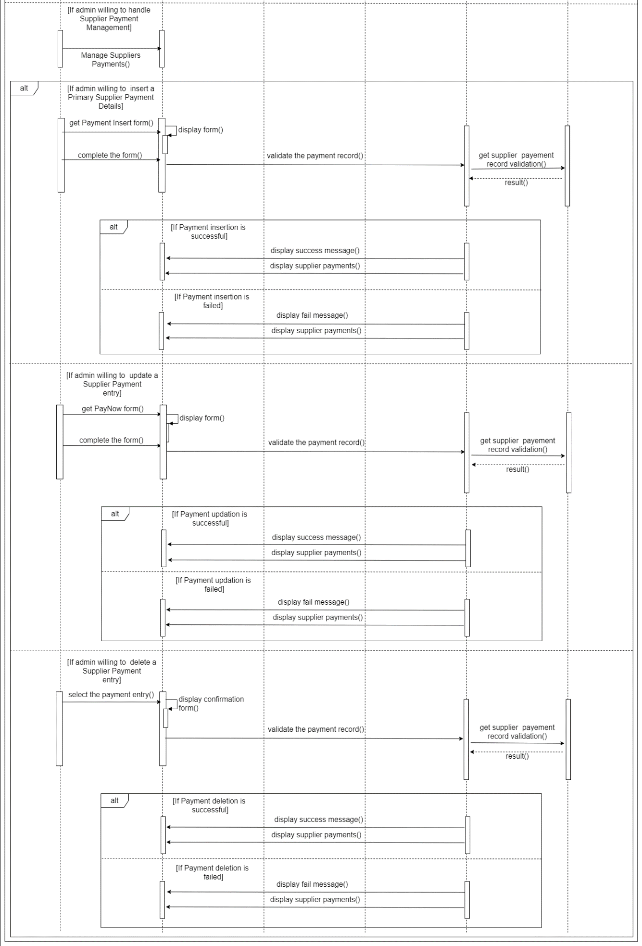

### Stock Management

#### Use Case Diagram

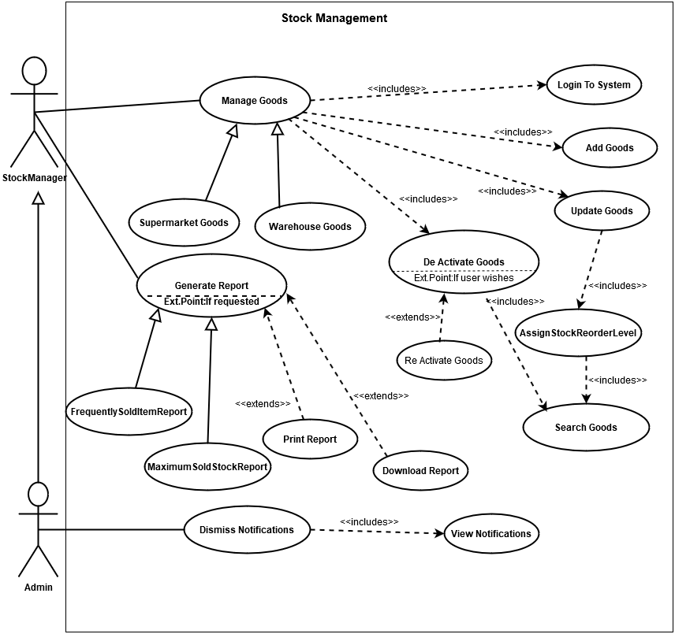

#### Activity Diagram

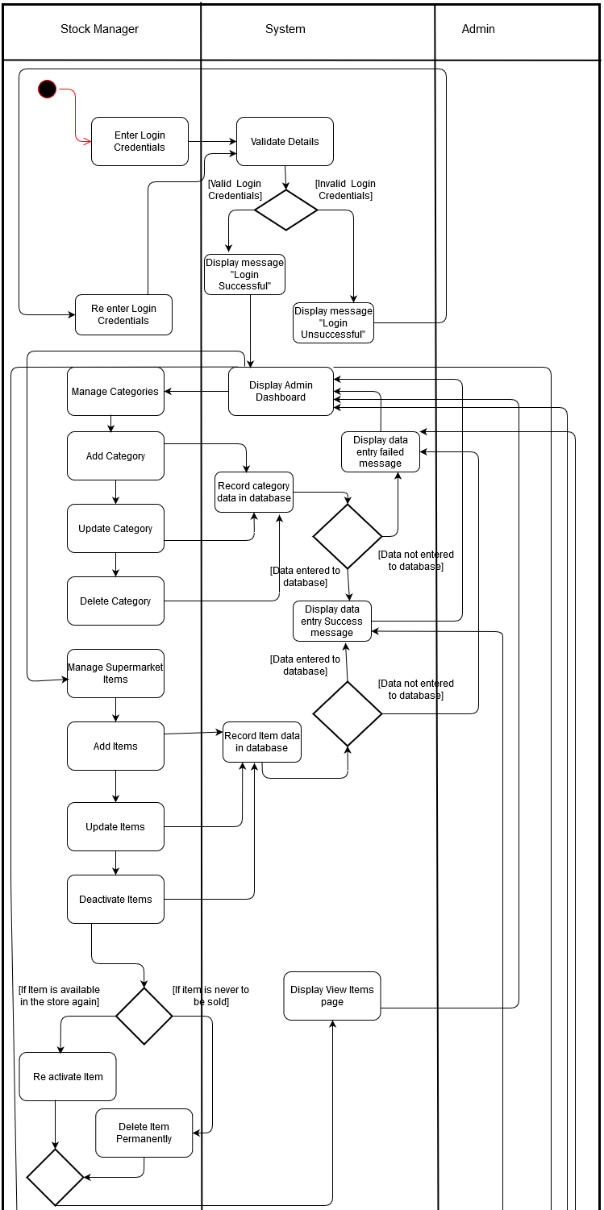

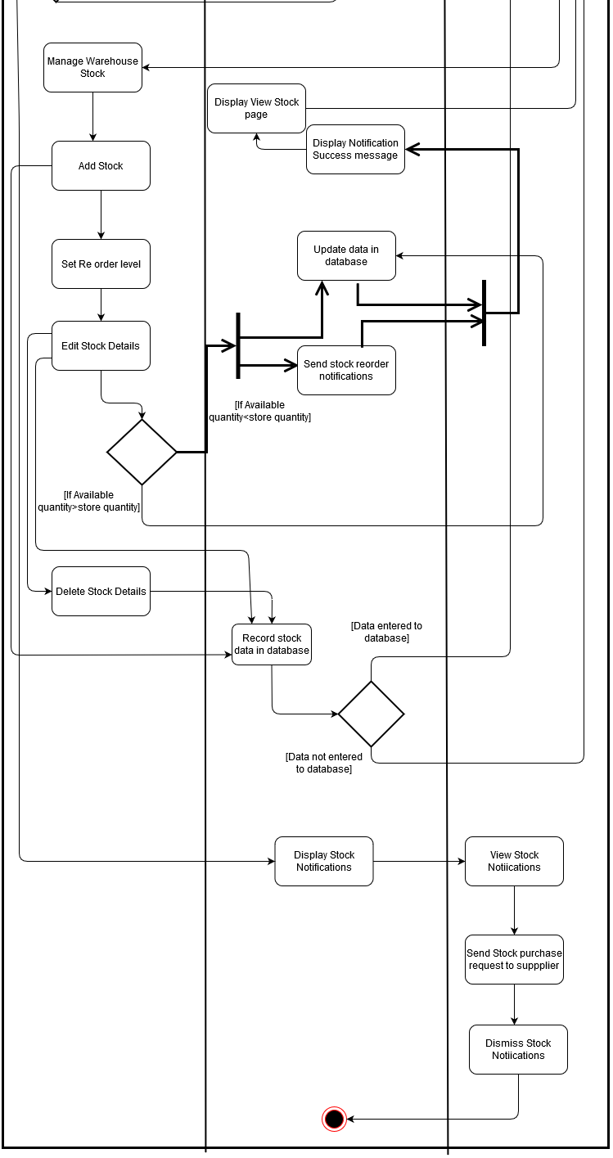

#### Sequence Diagram

***Category***

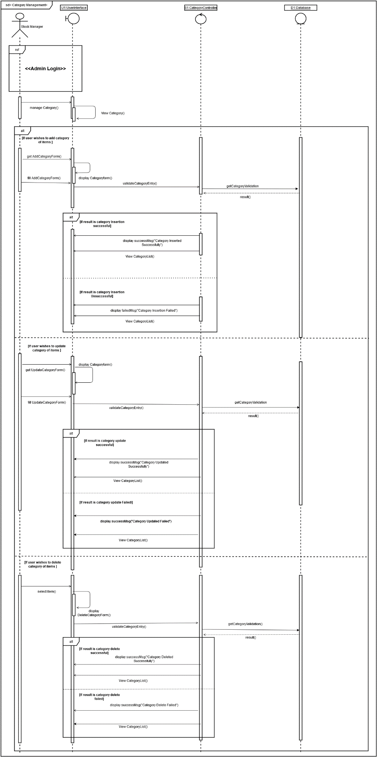

***Item***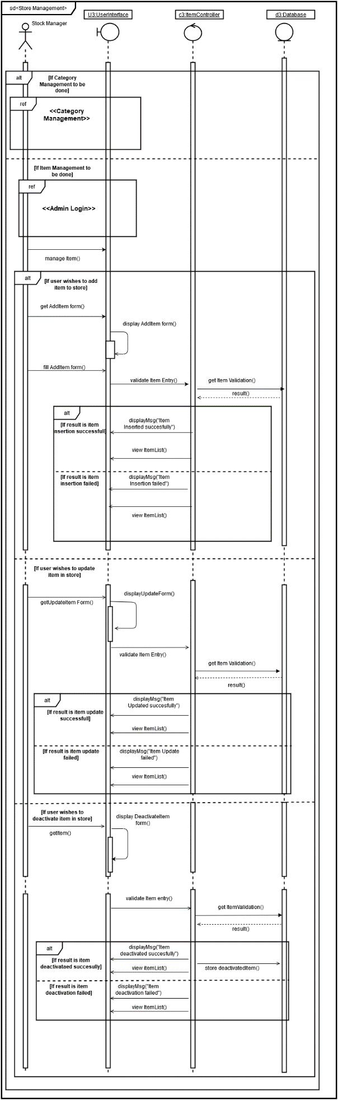

***Stock***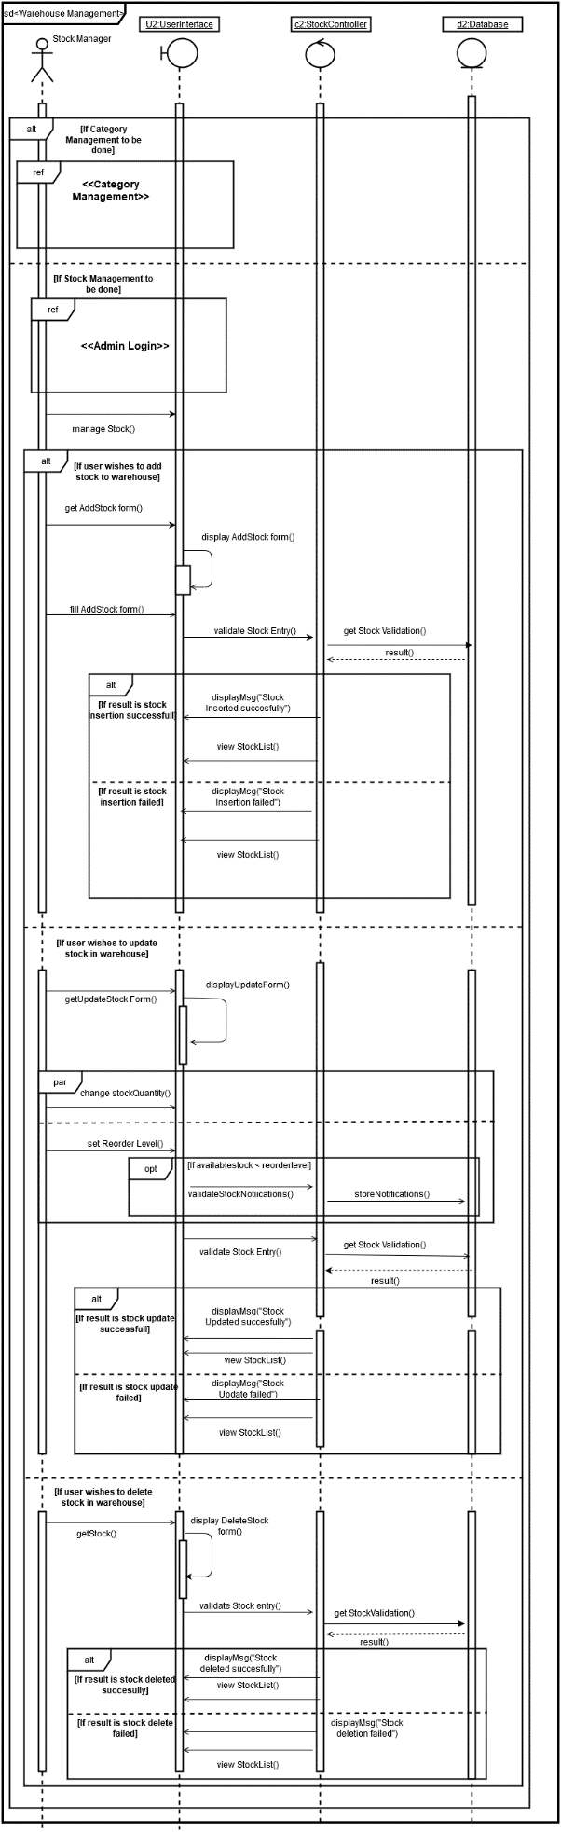

### HR Management

#### Use Case Diagram

#### Activity Diagram

#### Sequence Diagram

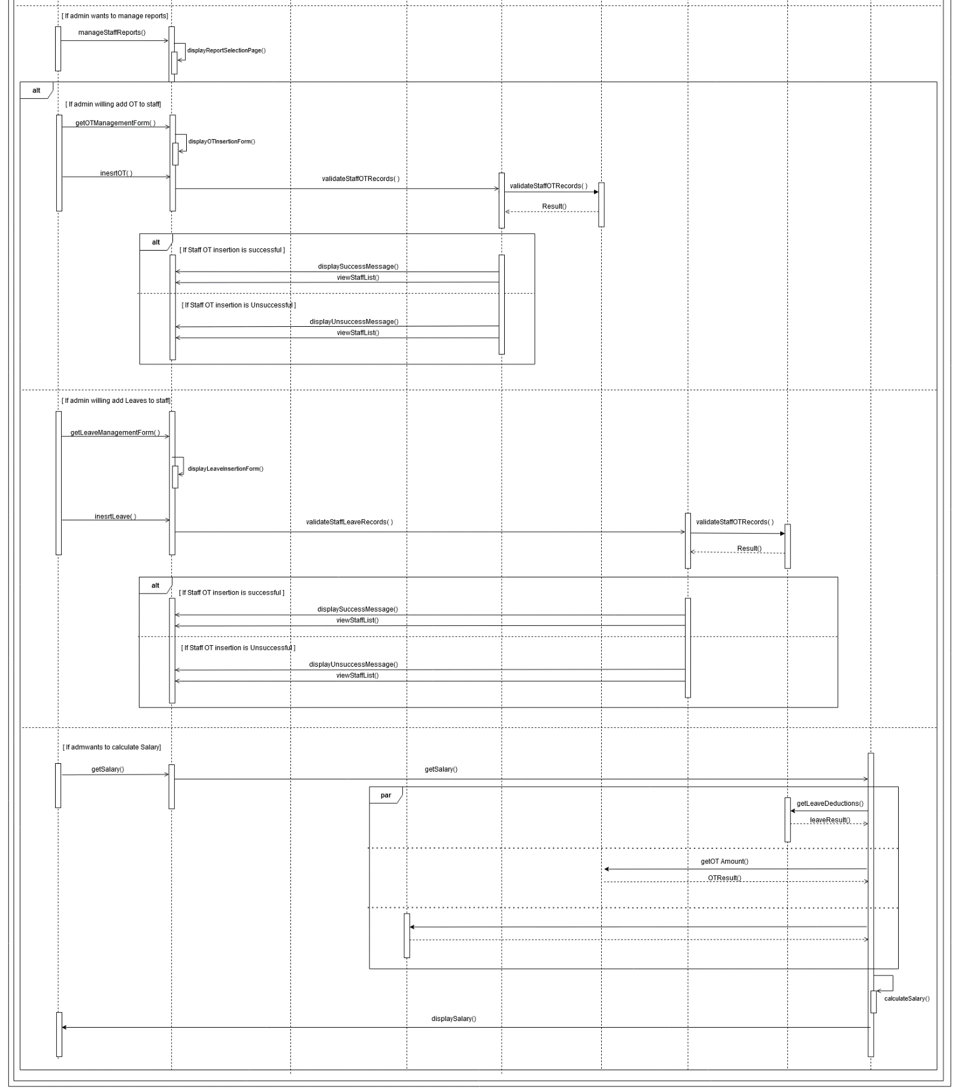

### Customer Management

#### Use Case Diagram

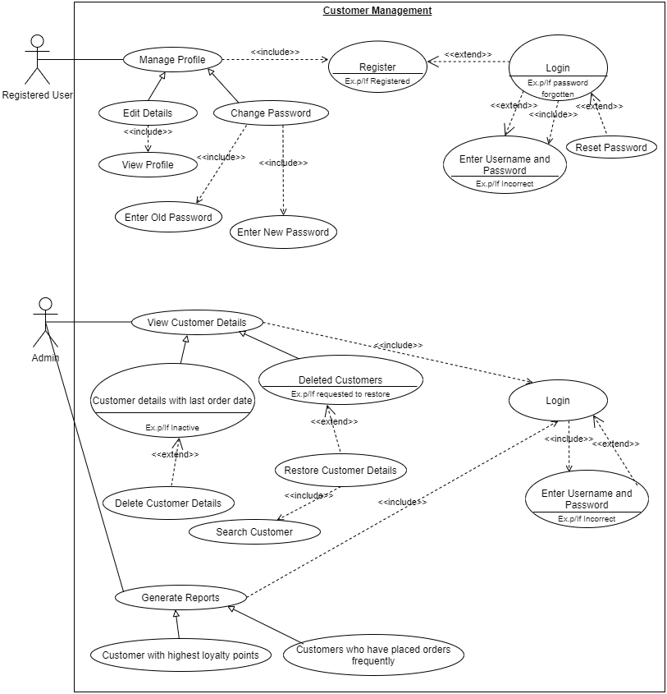

#### Activity Diagram

***Customer***

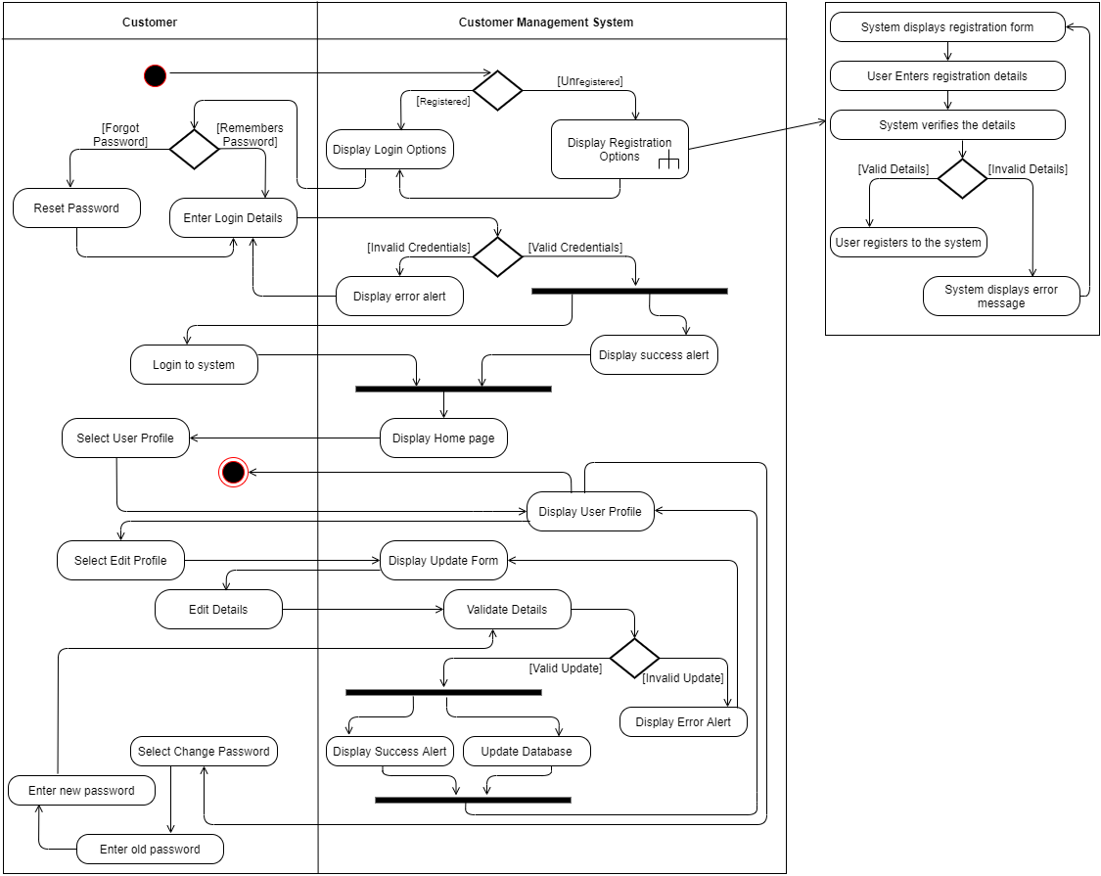

**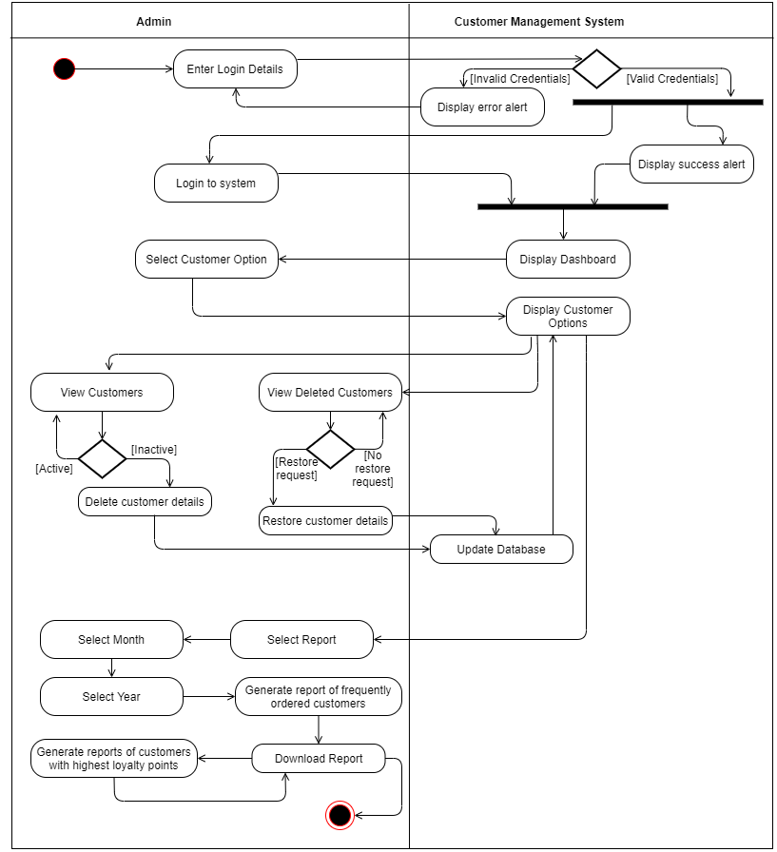*Admin***

#### Sequence Diagram

***Register***

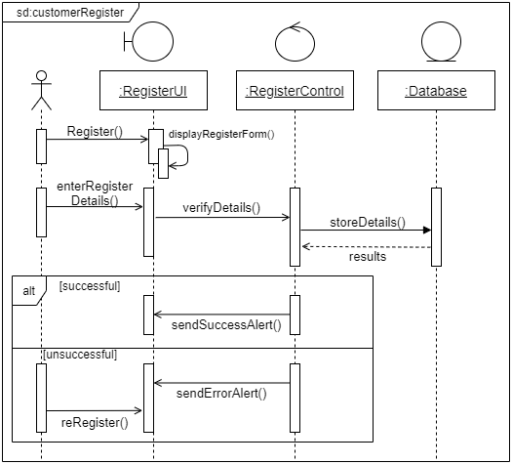

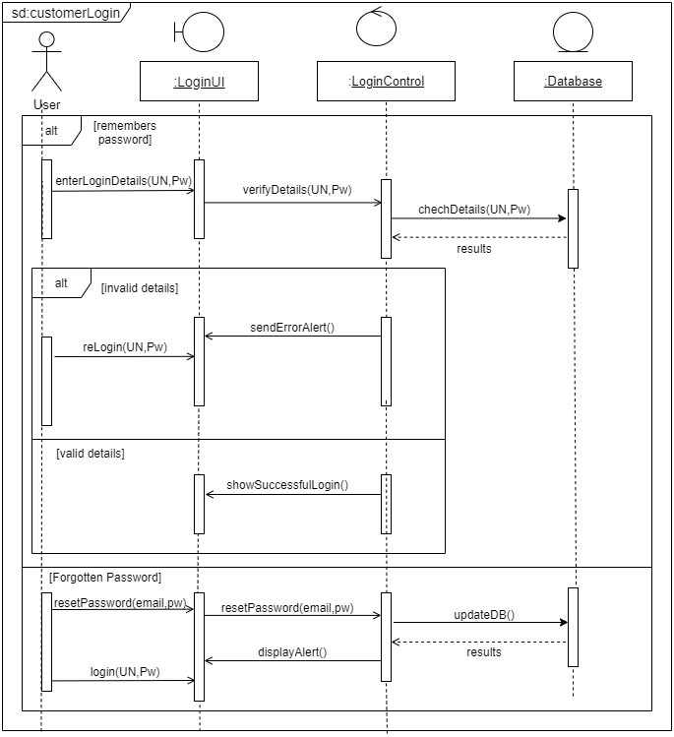***Login***

***Customer Management***

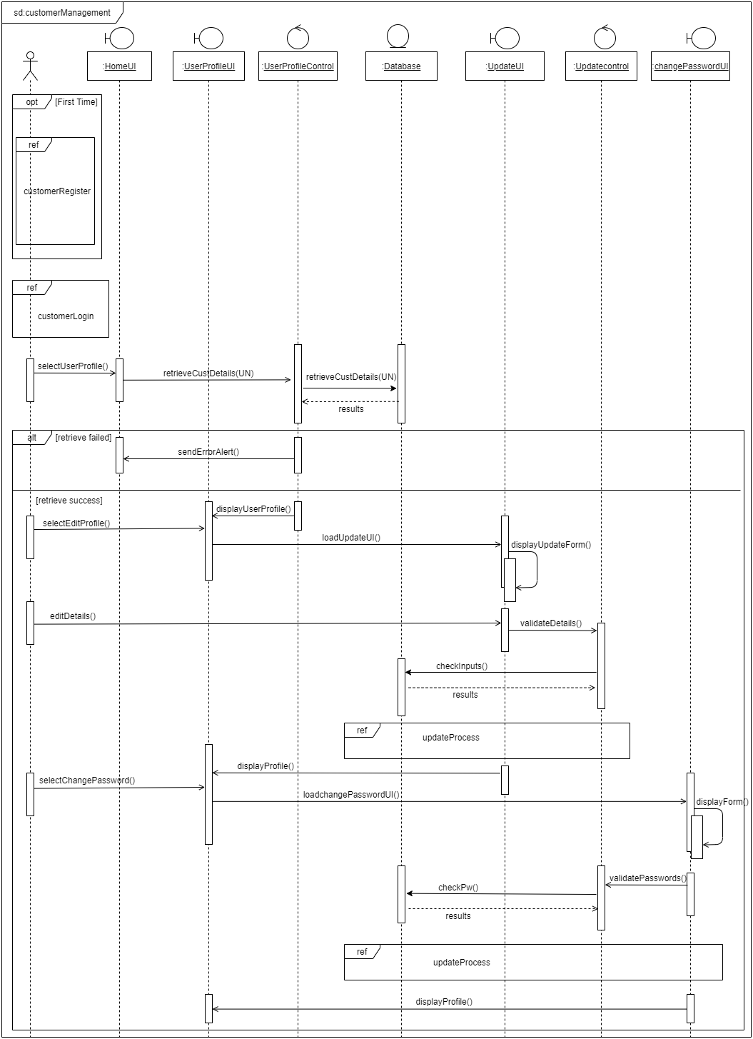

***Customer Update Process***

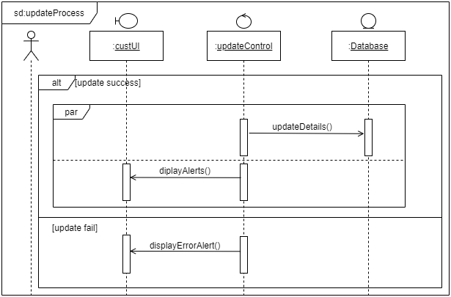

***Admin login***

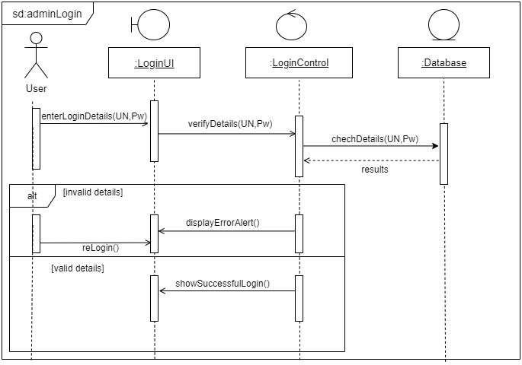

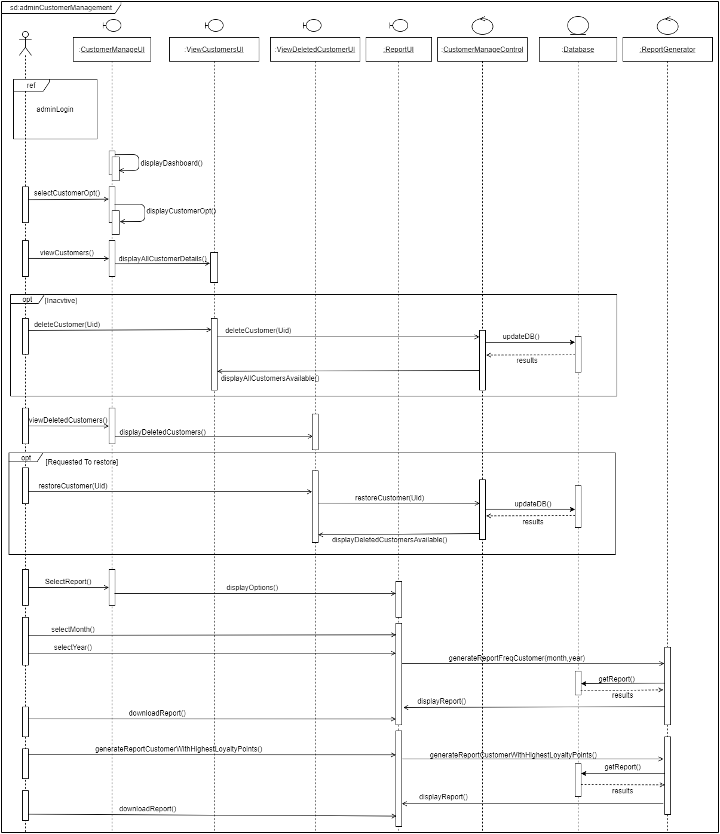***Admin* *Sequence***

### Order Management

#### Use Case Diagram

#### Activity Diagram

***Customer***

***Admin***

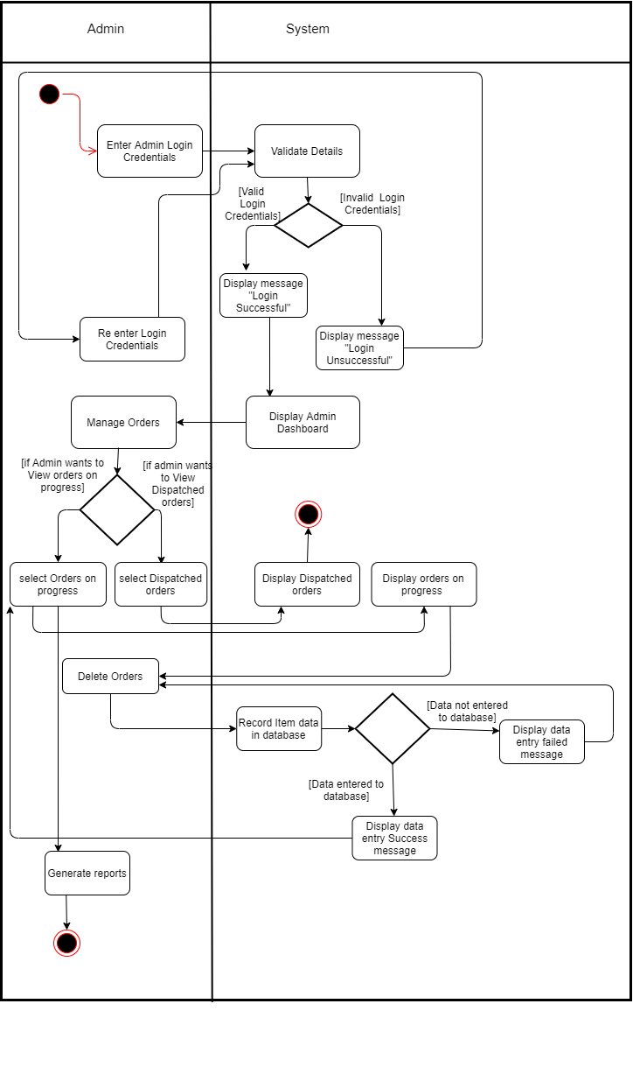

#### Sequence Diagram

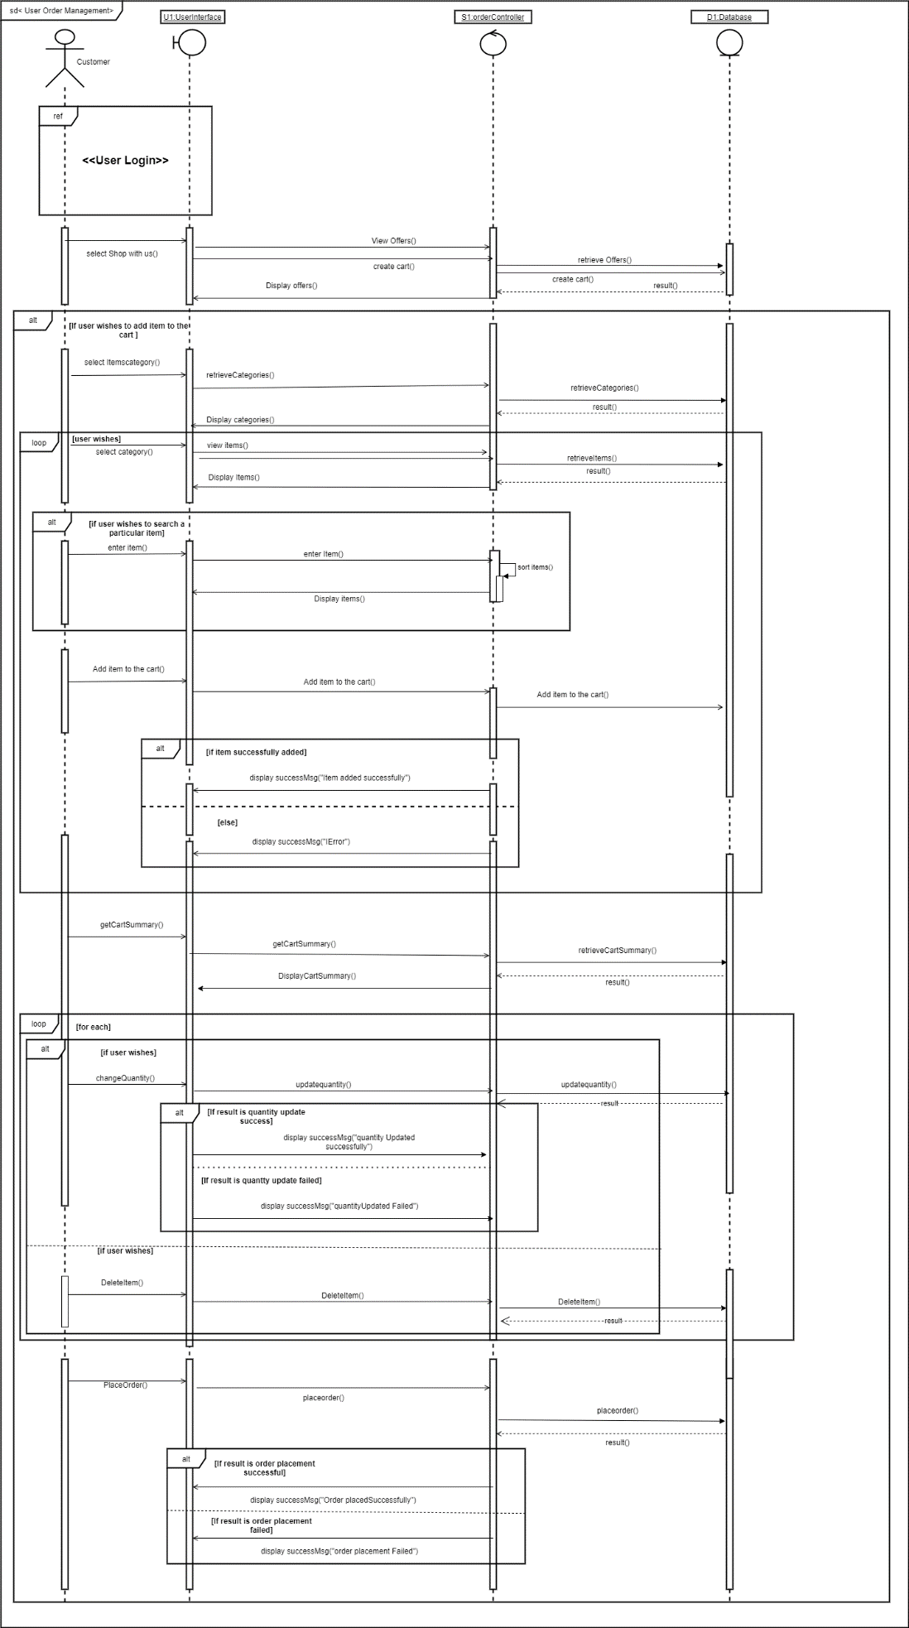

***Place Order***

**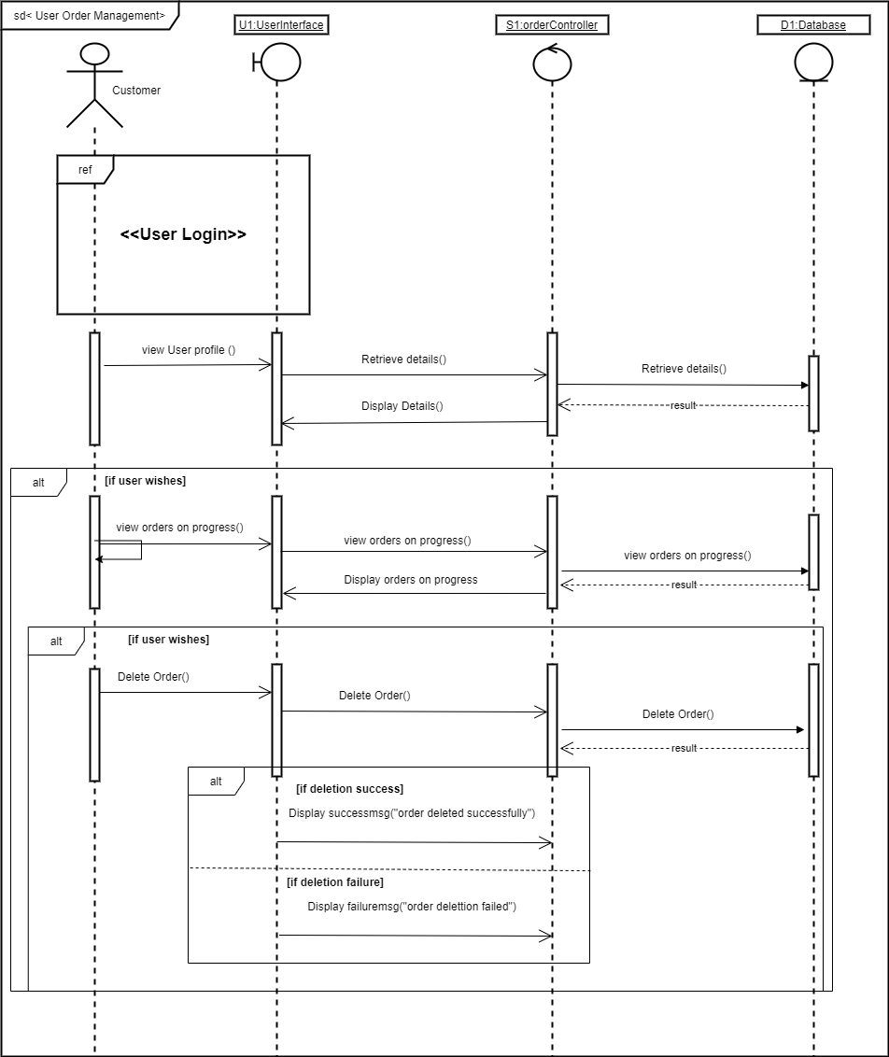*Cancel Order***

**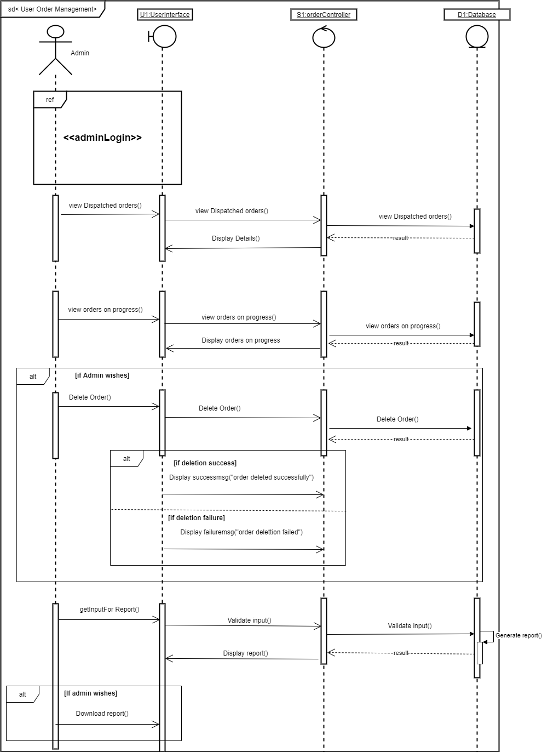*Admin***

### Delivery Management

#### Use Case Diagram

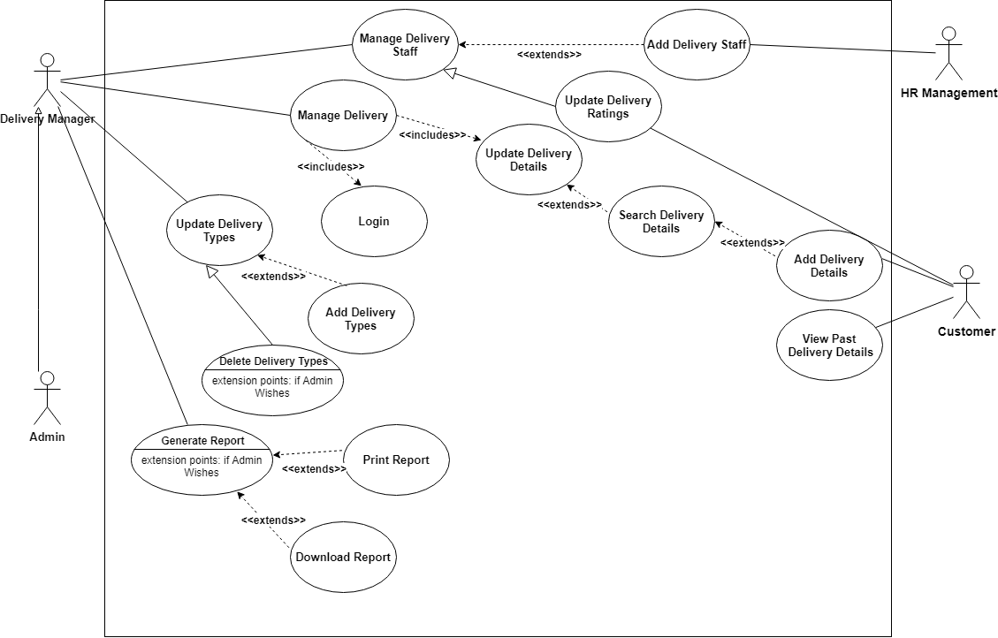

#### Class Diagram

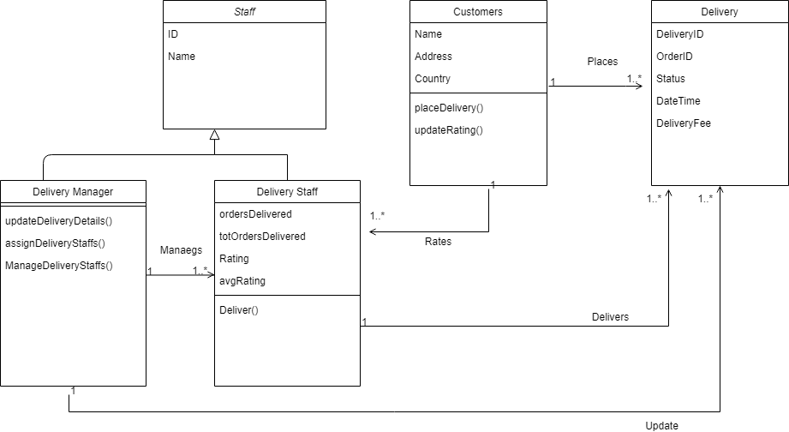

#### Sequence Diagram

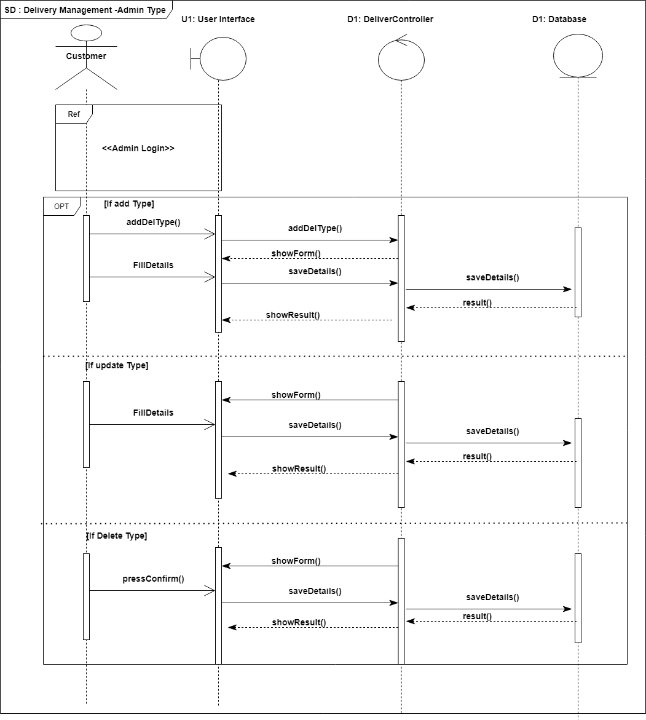

### Payment Management

#### Use Case Diagram

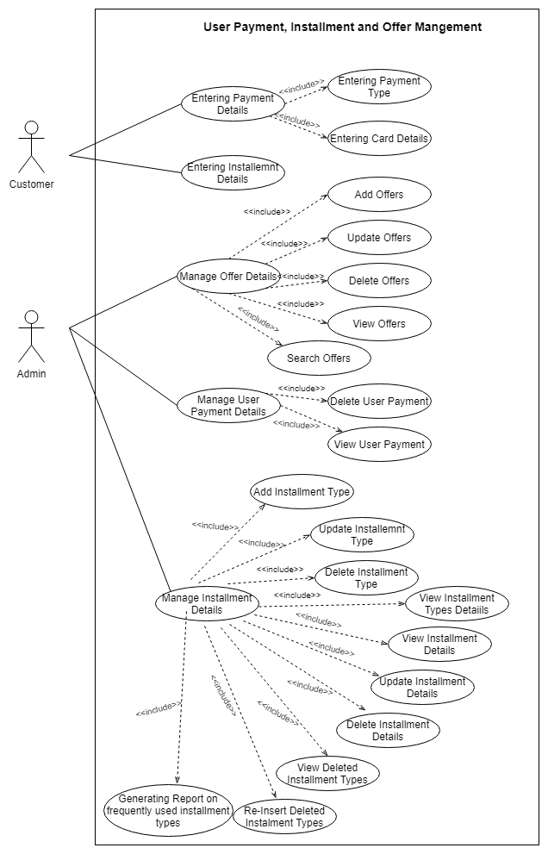

#### Activity Diagram

#### Sequence Diagram

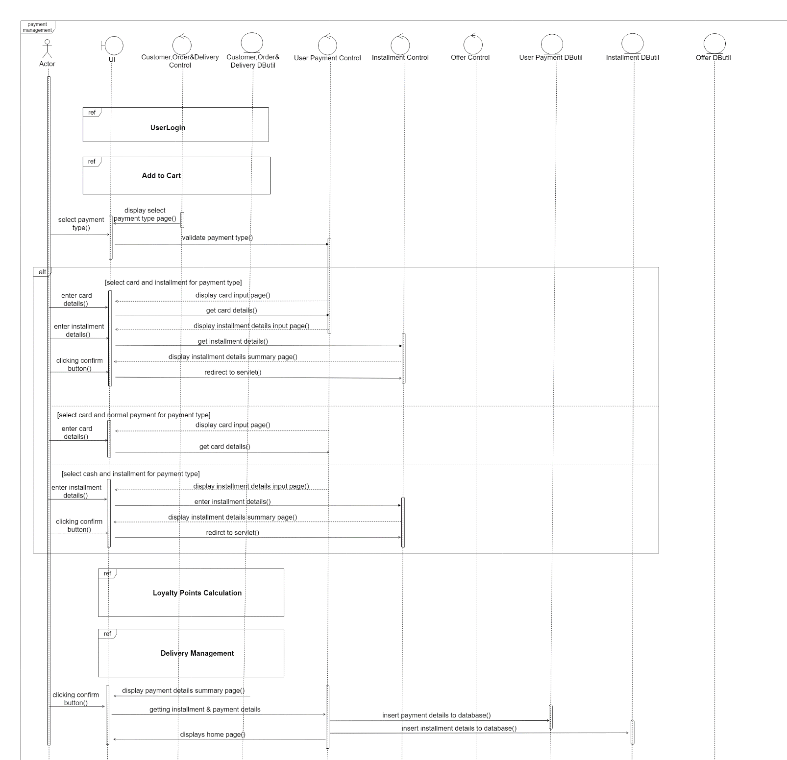

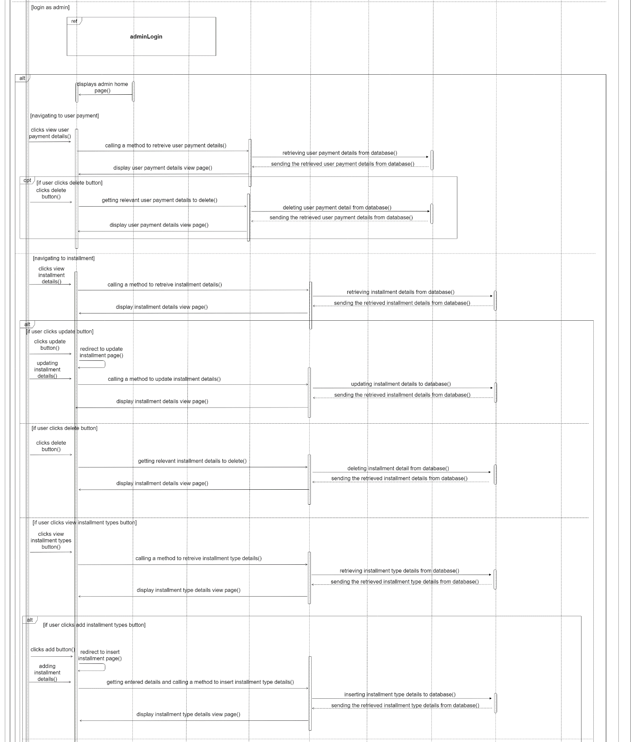

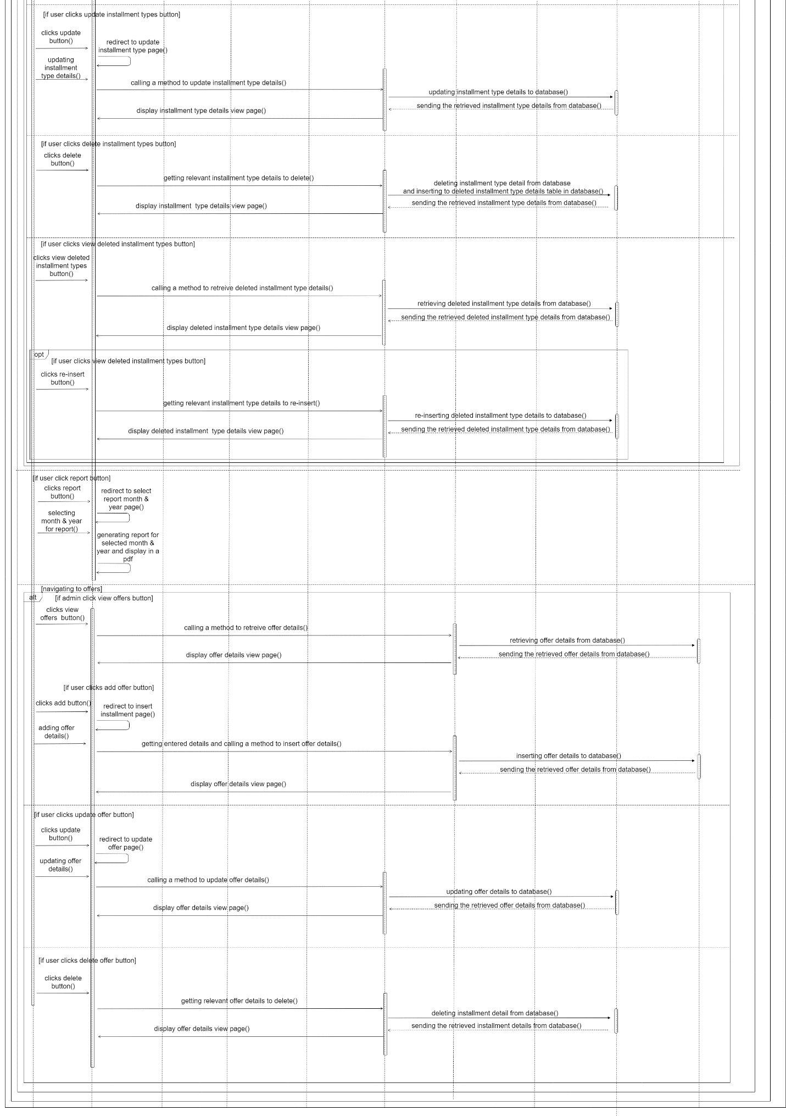

## Implementation

### Supplier Management

**1 . Registering a new supplier**

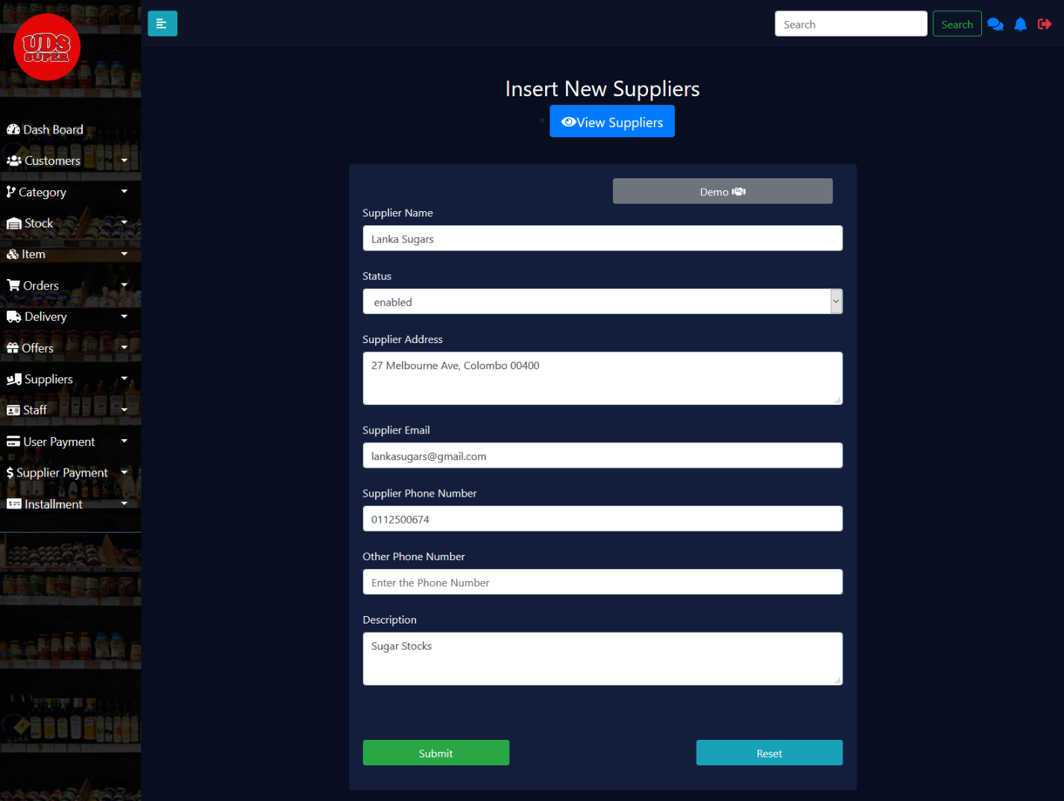

Figure 1

In our UDS supermarket system, a new supplier must be inserted through this registration page. Here we record the supplier’s name, address, email, contact number, description (if any specific information’s to be recorded) and additionally the status. Which will be initially set up to ‘enabled’.

**2 . View the details of all the suppliers**

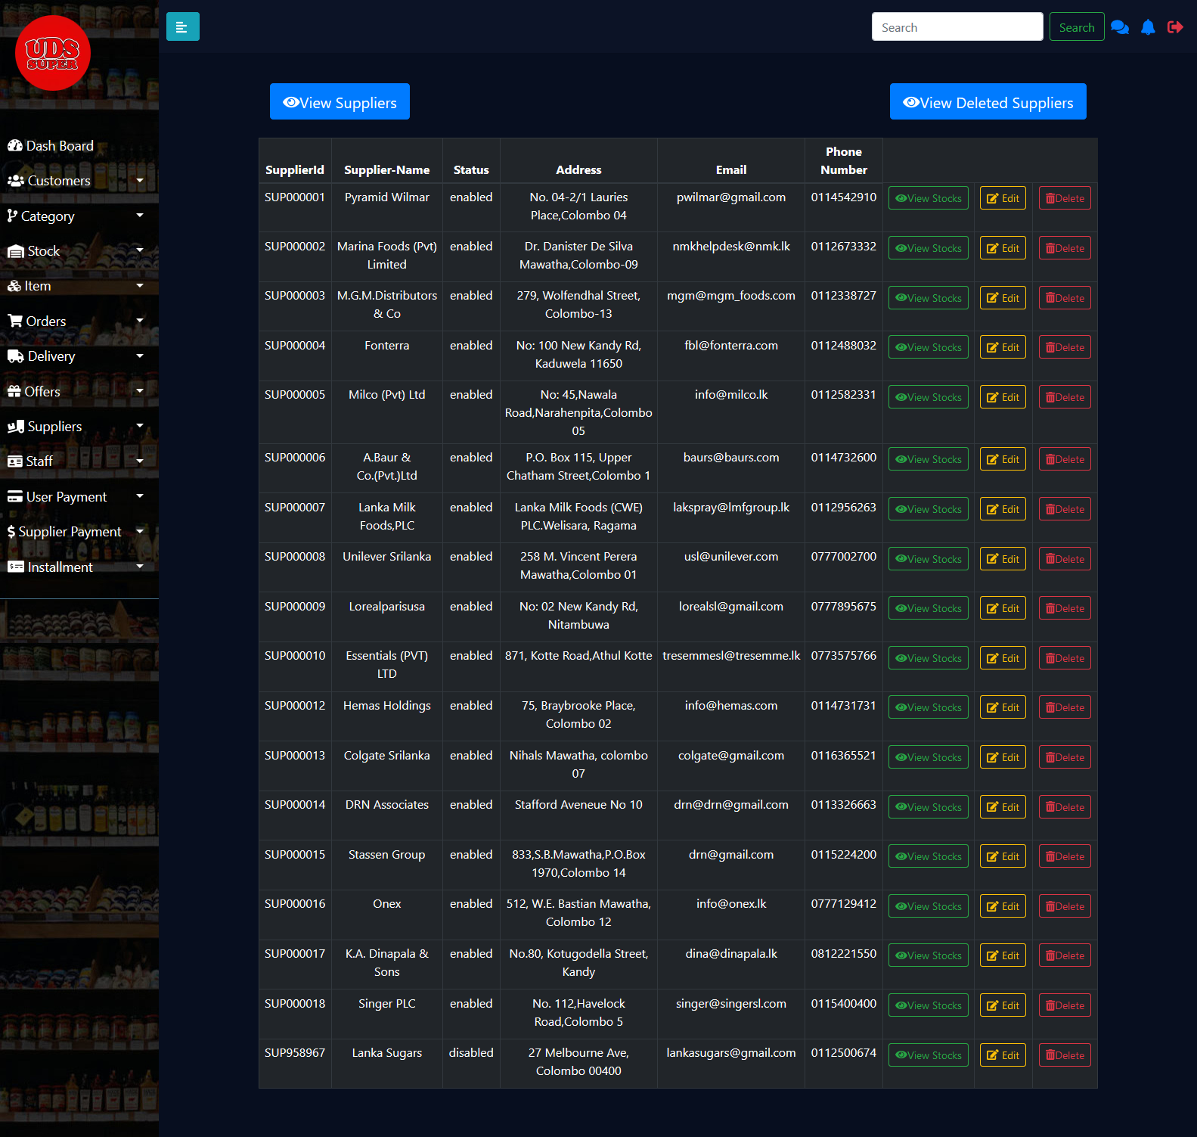

Figure 2

After a successful registration process, the system will direct admin to this page, where the admin can view all the details of the suppliers. And also, the search function (Search by supplier name) is also implemented in this page. Here the admin can view the stocks supplied by all the suppliers, can edit the supplier details and also can delete that supplier.

**3 . View the stocks supplied by a specific supplier**

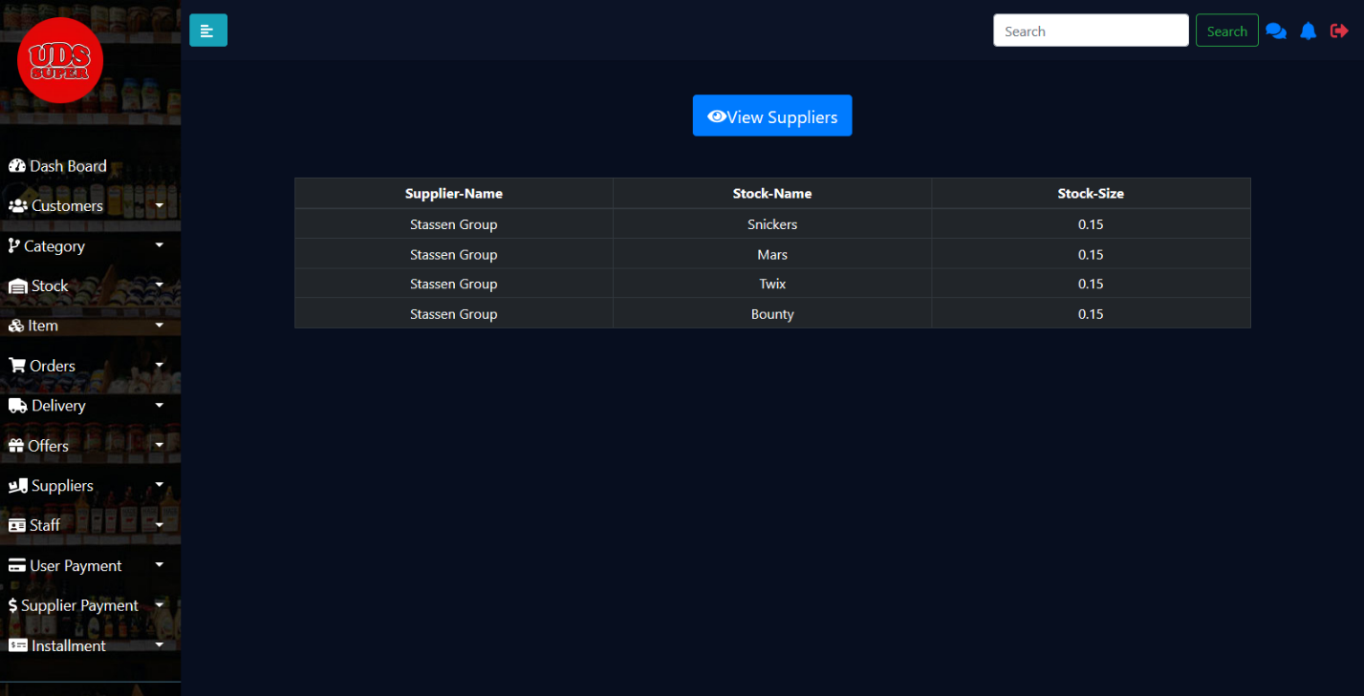

Figure 3

In this page the admin can view all the stocks supplied by a certain supplier. And this page will be helpful for the admin in any urgent causes.

**4 . View the deleted supplier**

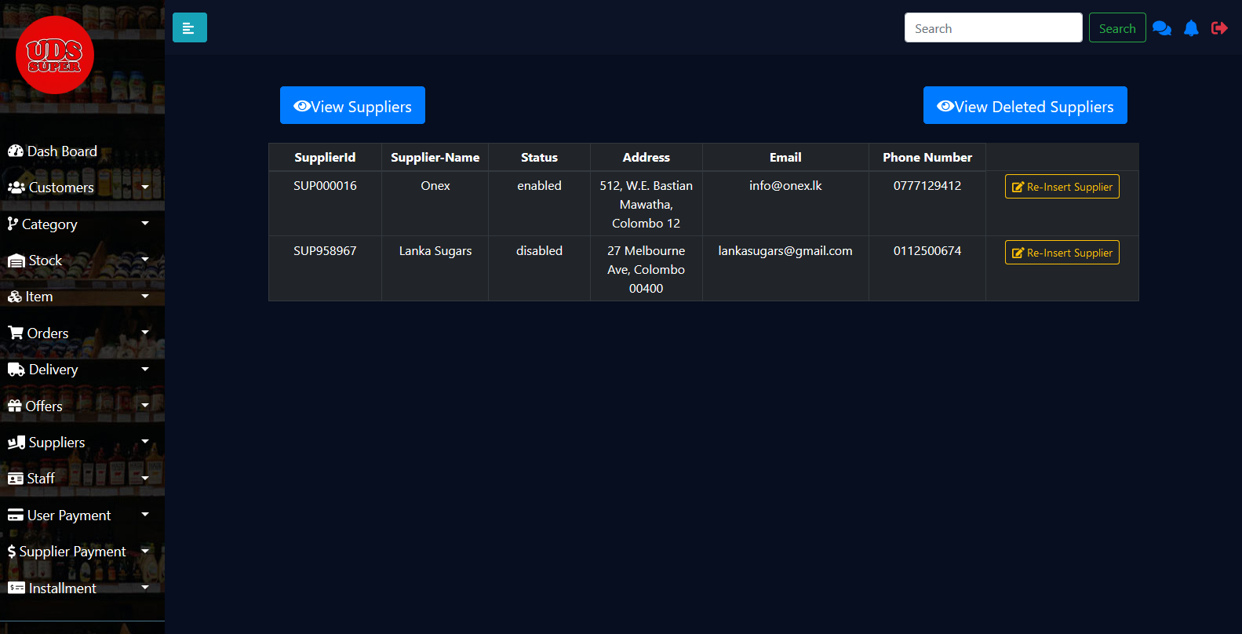

Figure 4

After deleting a certain supplier, that supplier entry will be inserted into another alternate table using triggers. The reason behind having this alternate table is that, in future if we need the service of a deleted supplier then the admin has to just ‘Re-Insert’ the supplier, so that the system avoids another registration process for the same supplier whom we registered earlier.

**5 . Supplier Report**

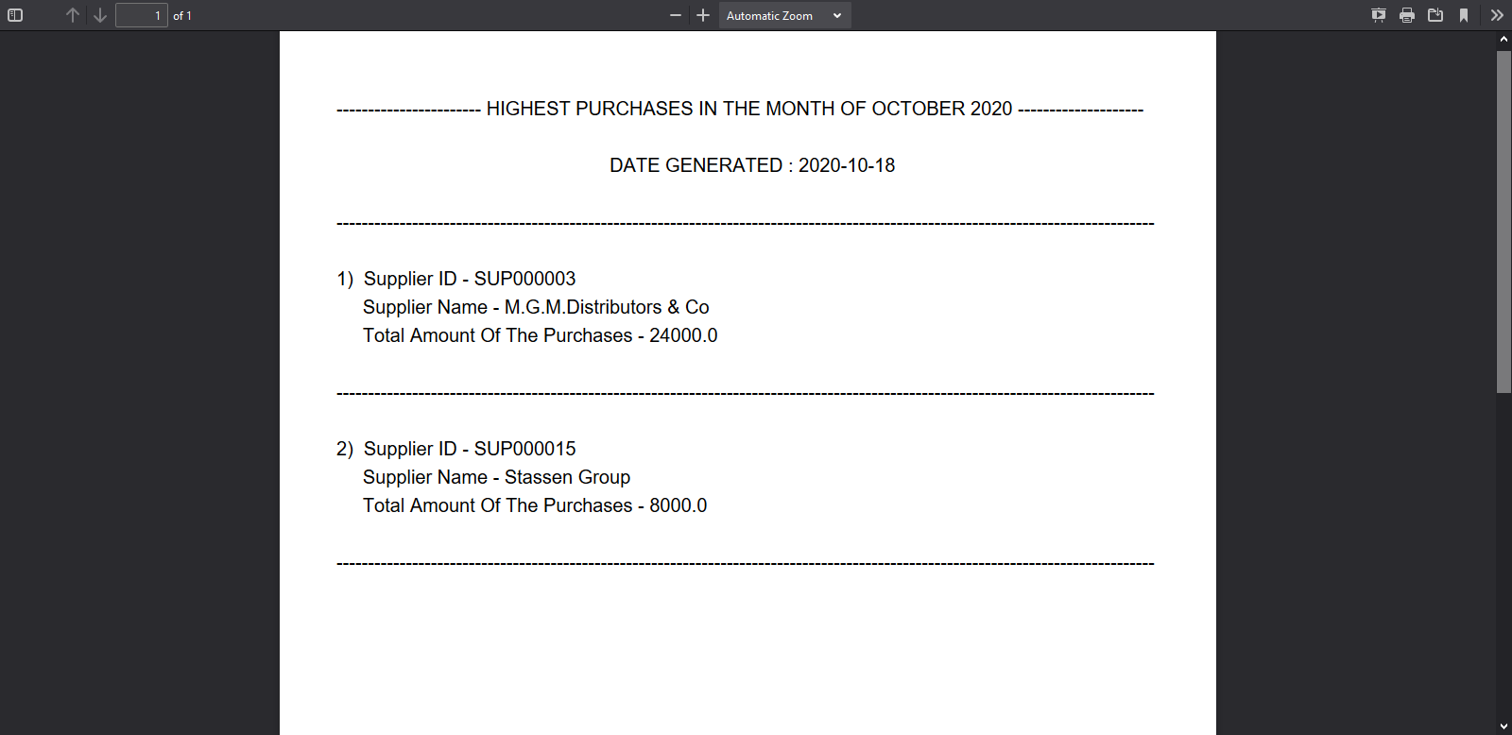

Figure 5

At the end of a certain month the admin can generate a report regarding the top suppliers from whom the highest purchases have been done in that specific month. The report contains the date, supplier ID, name and the sum of the total purchases done during that specific month.

**Supplier Payment Management**

**6 . Inserting the primary records regarding a payment for a certain stock supplied on a certain month.**

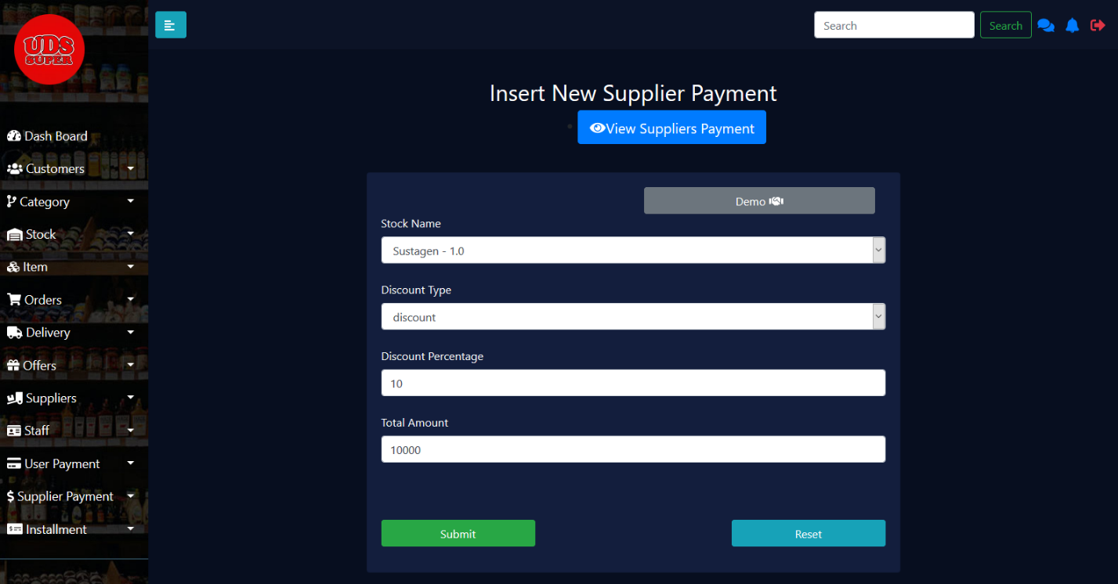

Figure 6

The primary records such as the, discount type, discount percentage and the total amount for a certain stock supplied on a certain month are recorded in this insertion page.

**7 . Recording the details of a completed payment**

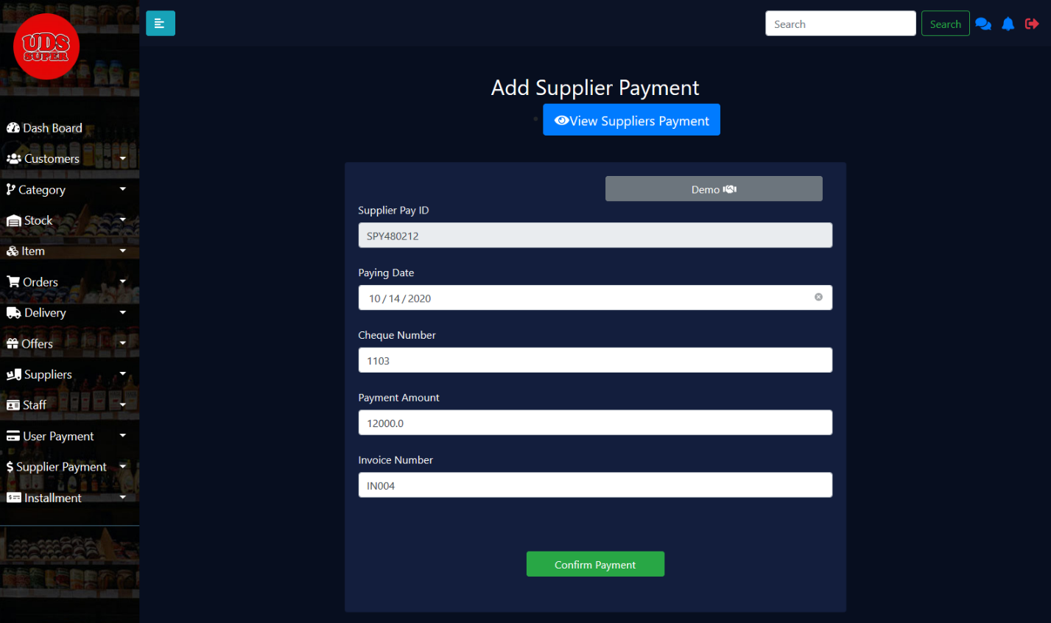

Figure 7

After recording the primary details, the admin can record the details of a certain payment which has been completed recently. The reason behind this record updation is that, when multiple payments are done for a certain stock supplied on a certain month then the record must be updated frequently, so this process can be done using this page.

**8 . Viewing the supplier payments**

Figure 8

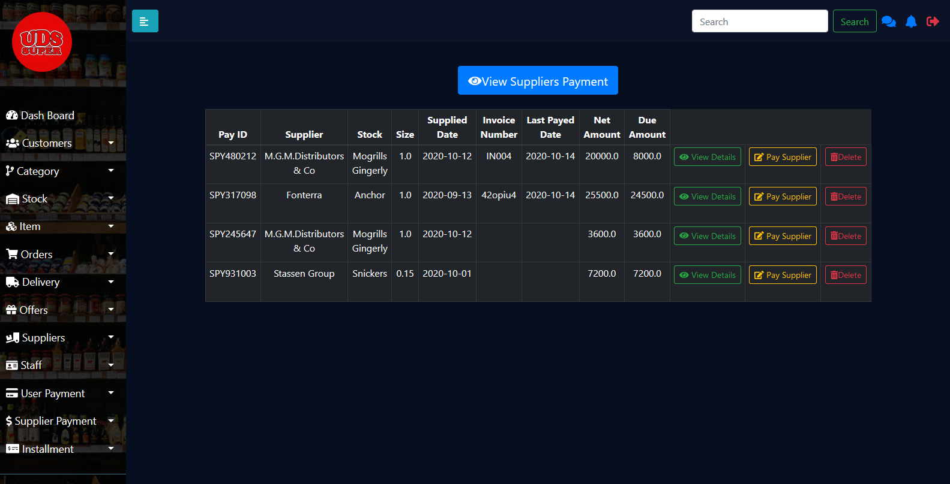

In this page the admin can view the payments done for the suppliers in respective months for the respective stocks supplied during that month. Here the admin can search any payment using the supplied date. The net amount and the due amount are being calculated and displayed here.

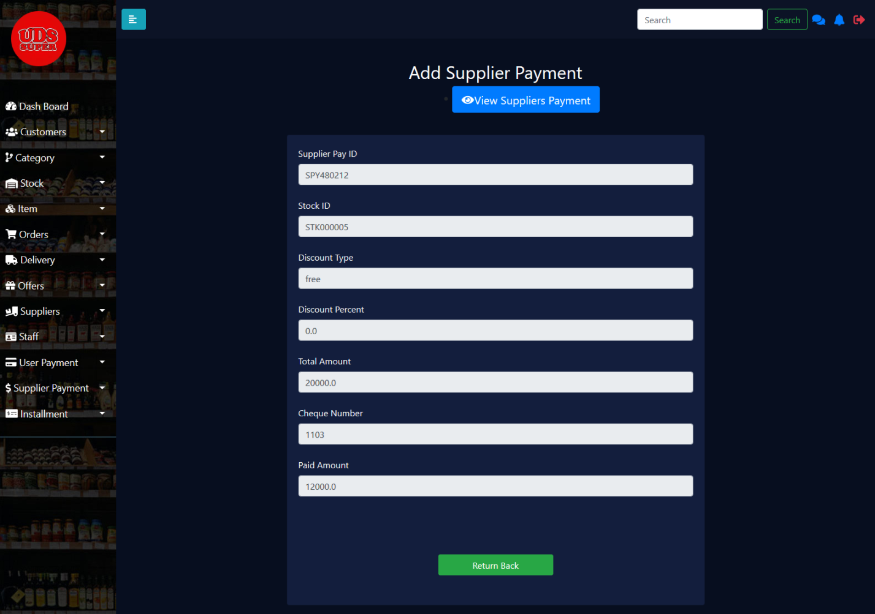**9 . Viewing a specific payment detail**

Figure 9

Admin can view the additional payment details such as the payment ID, stock ID, discount type, discount percent, total amount, cheque number(if exist) and the paid amount for a certain stock supplied on a certain month.

### Stock Management

**Category Insertion**

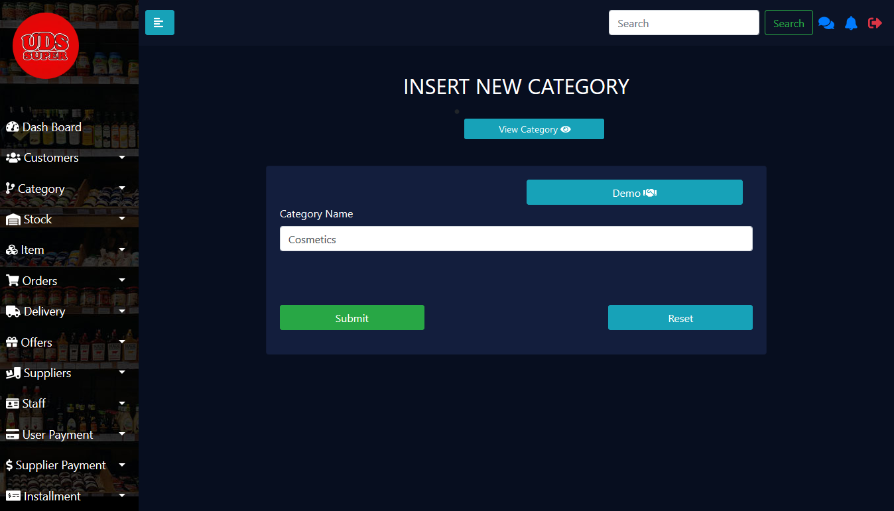

Figure 10

The above GUI facilitates the user to **add the category of items** in the store from time to time.

**View & Manage Category**

Figure 11

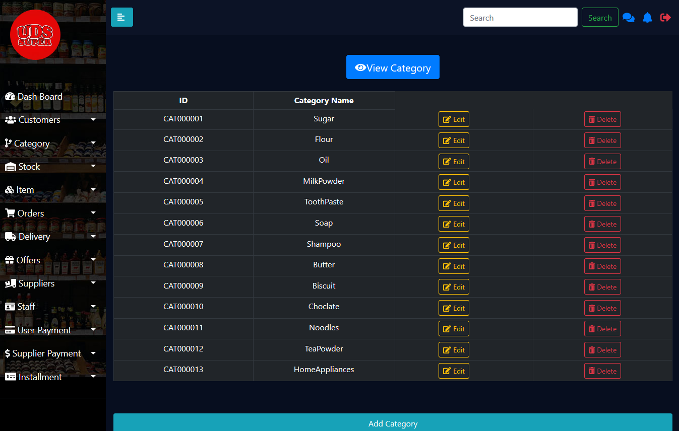

This interface enables user to view category of items by **searching** them with the category name and proceed with the **edit** and **delete** functions.

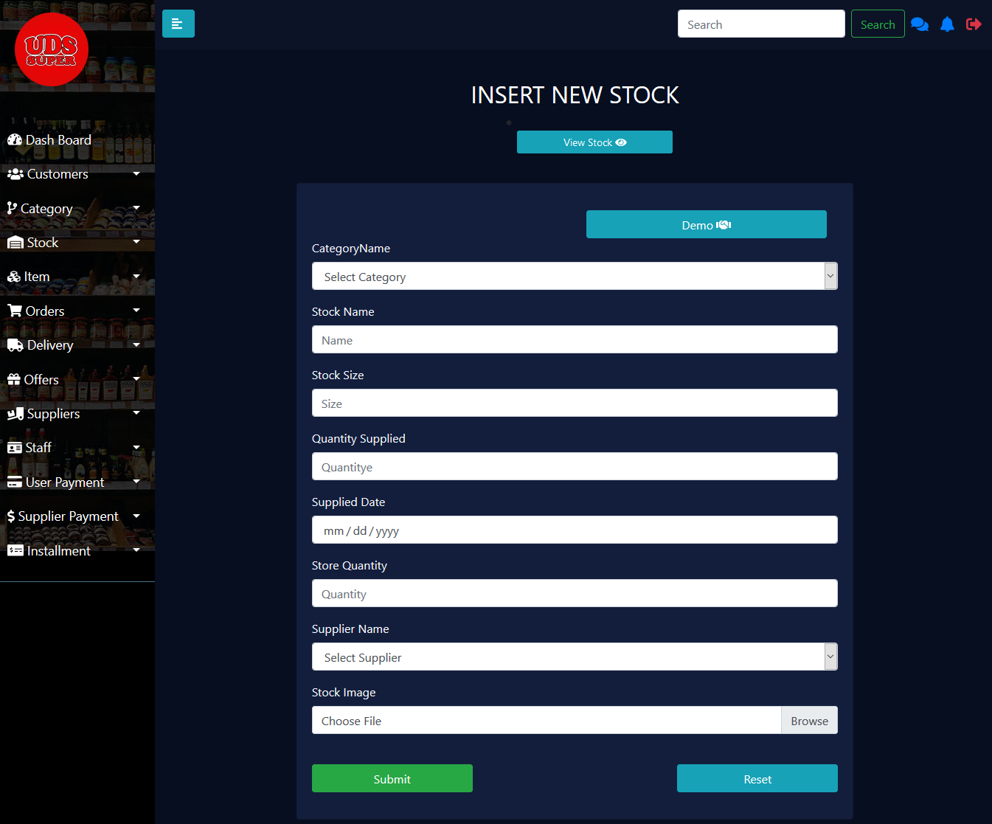**Stock Insertion**

Figure 12

This interface facilitates user to **insert new stock** to the warehouse by adding details such as name of stock, size, category, quantity supplied to warehouse, supplied date, quantity sent to store, stock image and supplier name.

**Stock Update**

Figure 13

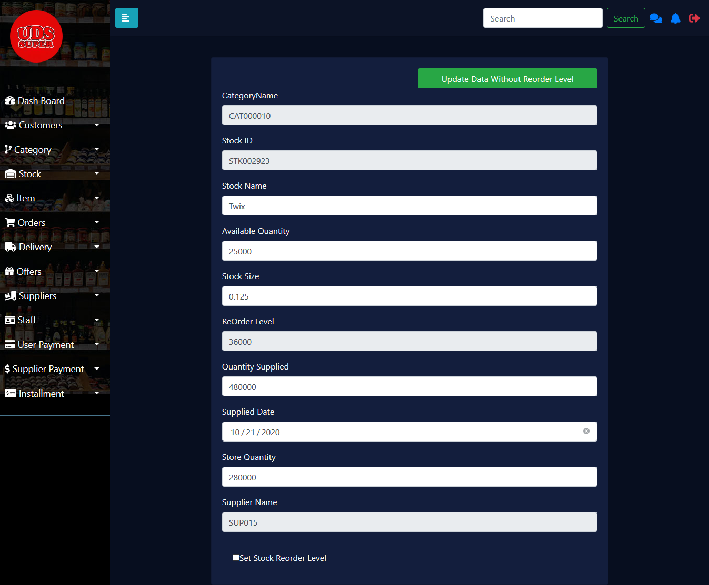

This interface ensures to provide the facility to **update the stock** in warehouse by providing two alternatives. The user can either update the stock along with **setting the reorder level** or else the user can update the stock details without setting the reorder level.

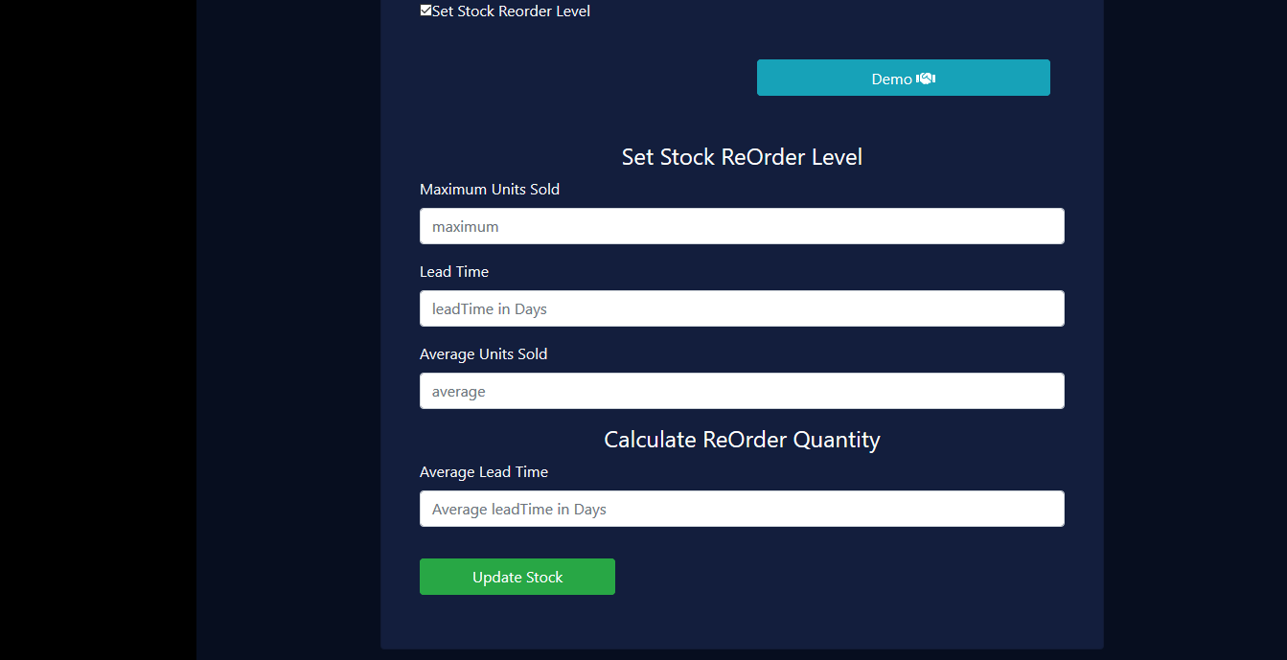**Assigning Stock Reorder Level**

Figure 14

Through this interface the user could set the reorder level of a stock based on the demand of a particular stock. When proceeding the logic behind this the following concepts were taken into consideration

Reorder level – The point at which a stock purchase should be made.

Lead Time – The time taken for a product to reach the warehouse upon making a request to the supplier.

Safety stock – The stock amount that helps to maintain an uninterrupted flow of goods despite fluctuations in demand of products.

Reorder quantity – The stock quantity that should be purchased when reorder level is reached.

Calculations: - Safety Stock = (Maximum Sold Units – Average Sold Units) * Lead Time

Reorder Level = (Maximum Sold Units * Lead Time) + Safety Stock

Reorder Quantity = Average Sold Units * Average Lead Time

**Stock Report**

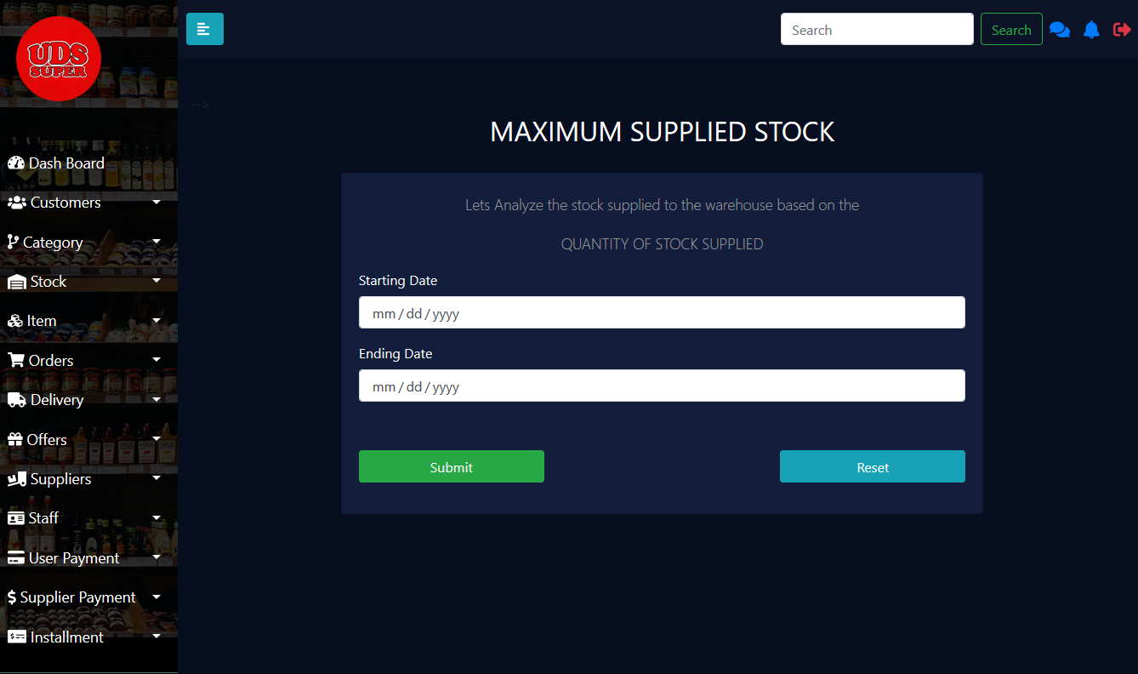

Figure 15

The above interface provides the facility for the user to enter time period that the user wishes to **generate a report** in order to analyze the maximum sold stock for the needed time period.

**View & Manage Stock**

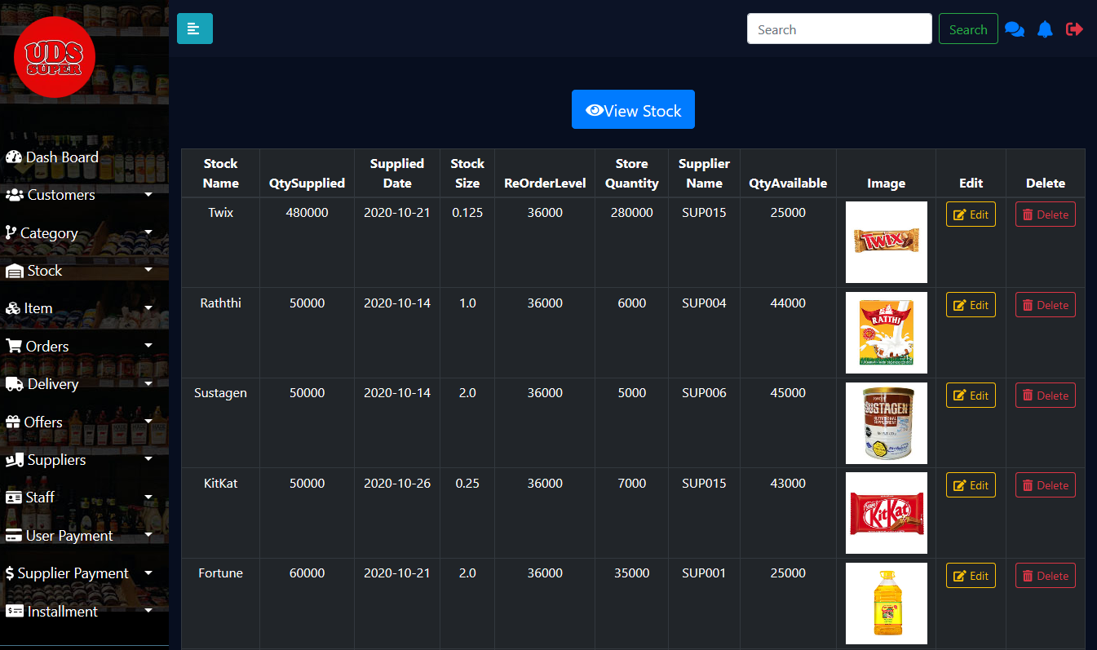

Figure 16

This interface enables user to view stock of items by **searching** them with the stock name and proceed with the **edit** and **delete** functions.

**Item Insertion**

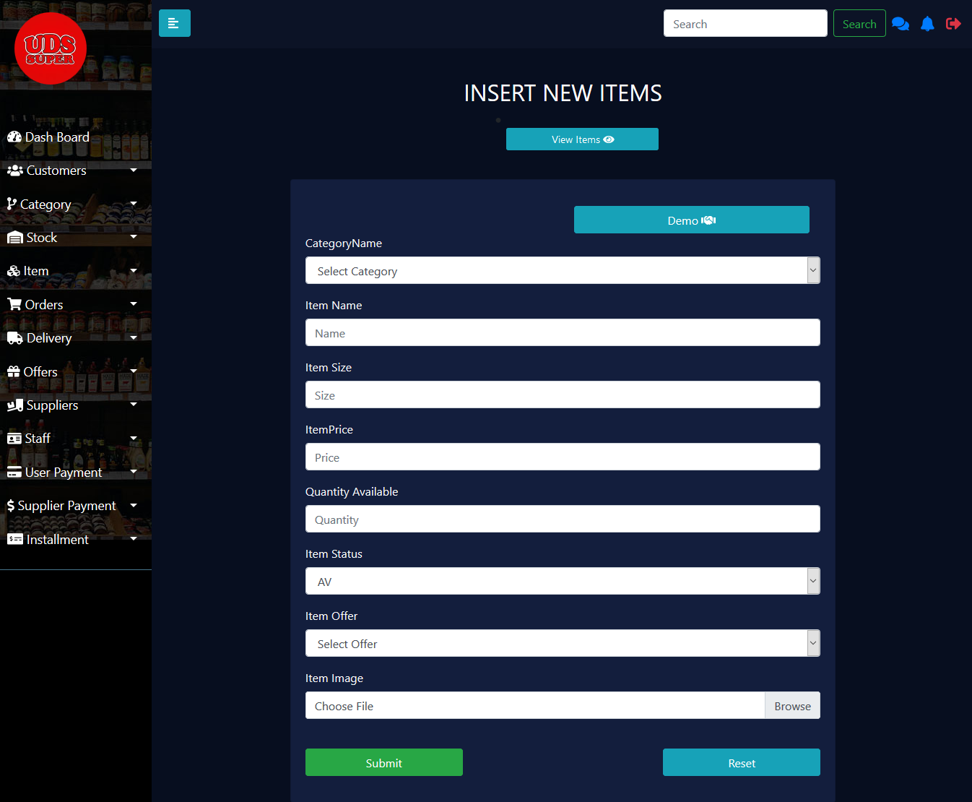

Figure 17

This interface facilitates user to **insert new items** to the store by adding details such as name of item, size, price, quantity available in store, item status, offer applicable to the item and item image.

**View and Manage Items**

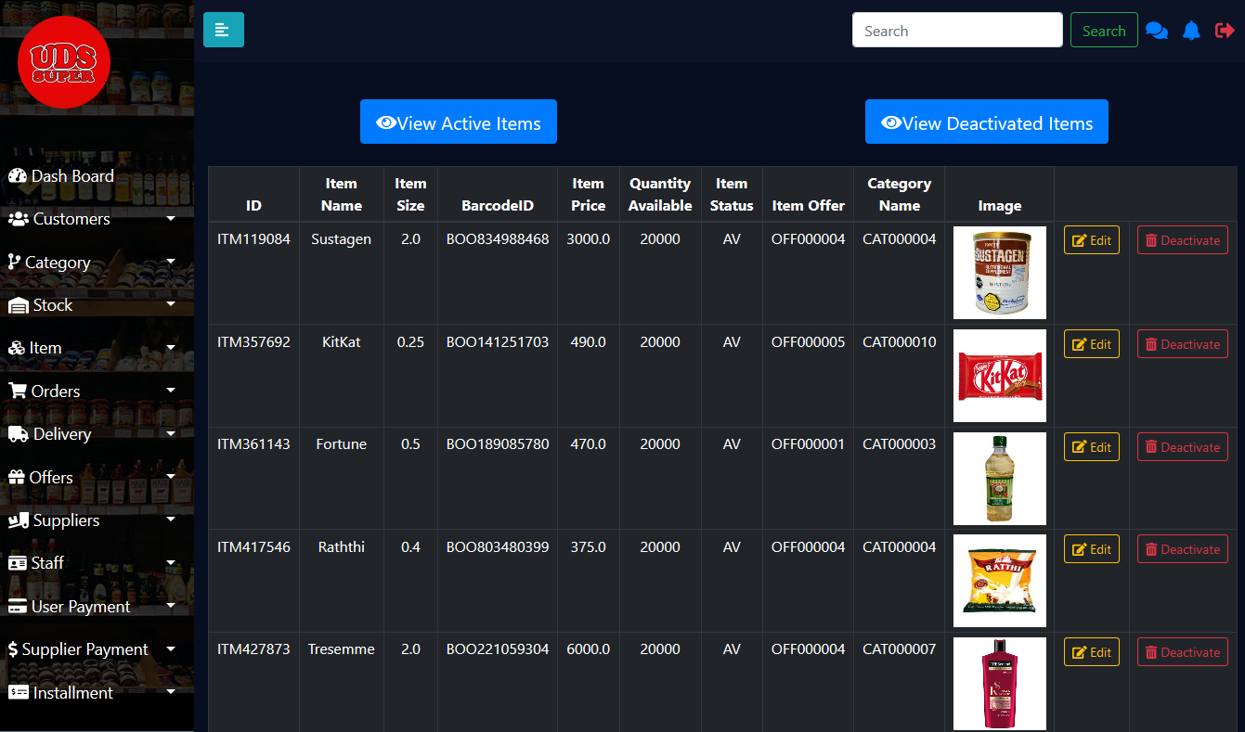

Figure 18

This interface enables user to **view active items** and **deactivated items** of the store by **searching** them with the item name and proceed with the **edit** and **delete** functions.

**Item Report**

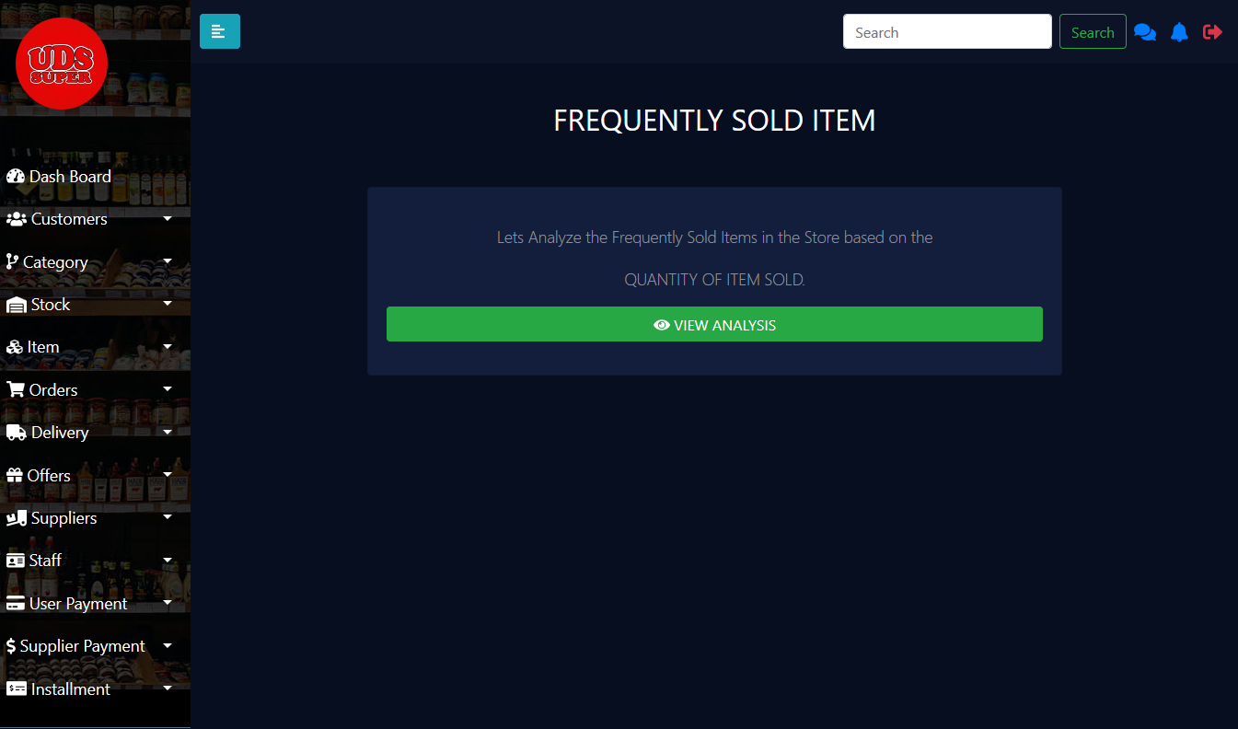

Figure 19

The above interface provides the facility for the user to analyze the frequently sold items in the store.

**Stock Notifications.**

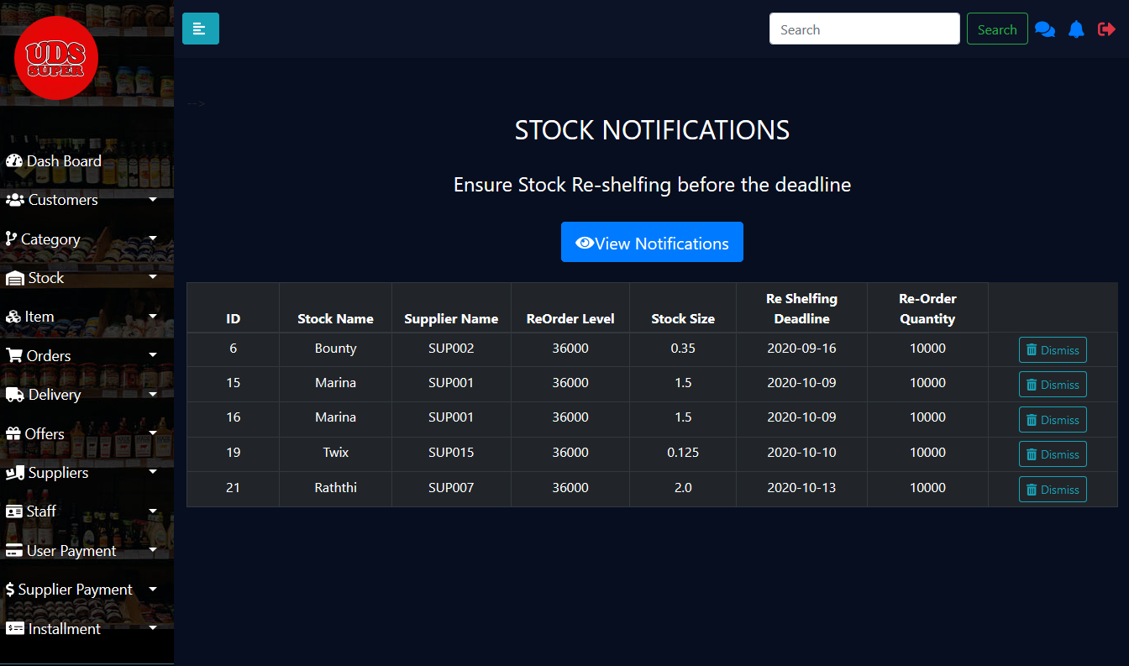

Figure 20

This interface enables user to **view notifications** of stock that should be re shelfed and provides the ability to **search** any notification details and **dismiss it**.

### HR Management

1. **Insert Staff**

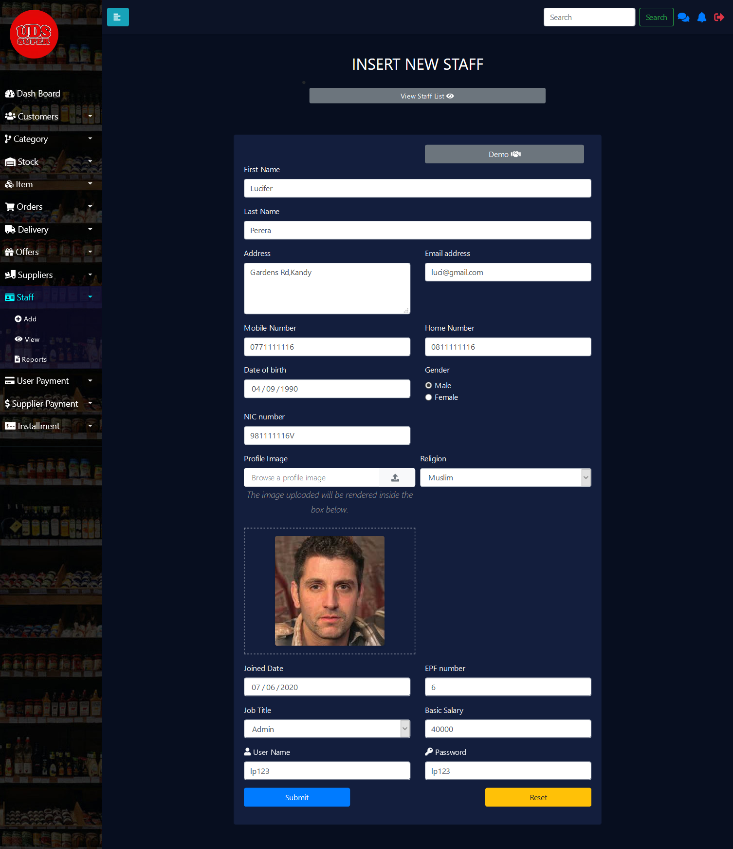

Figure 21

By clicking the staff menu and Add sub-menu in the sidebar this page can be viewed. This is the employee registration page of the system here the necessary details of the employees will be entered to the form and stored in the Database after clicking the submit button.

1. **Staff List**

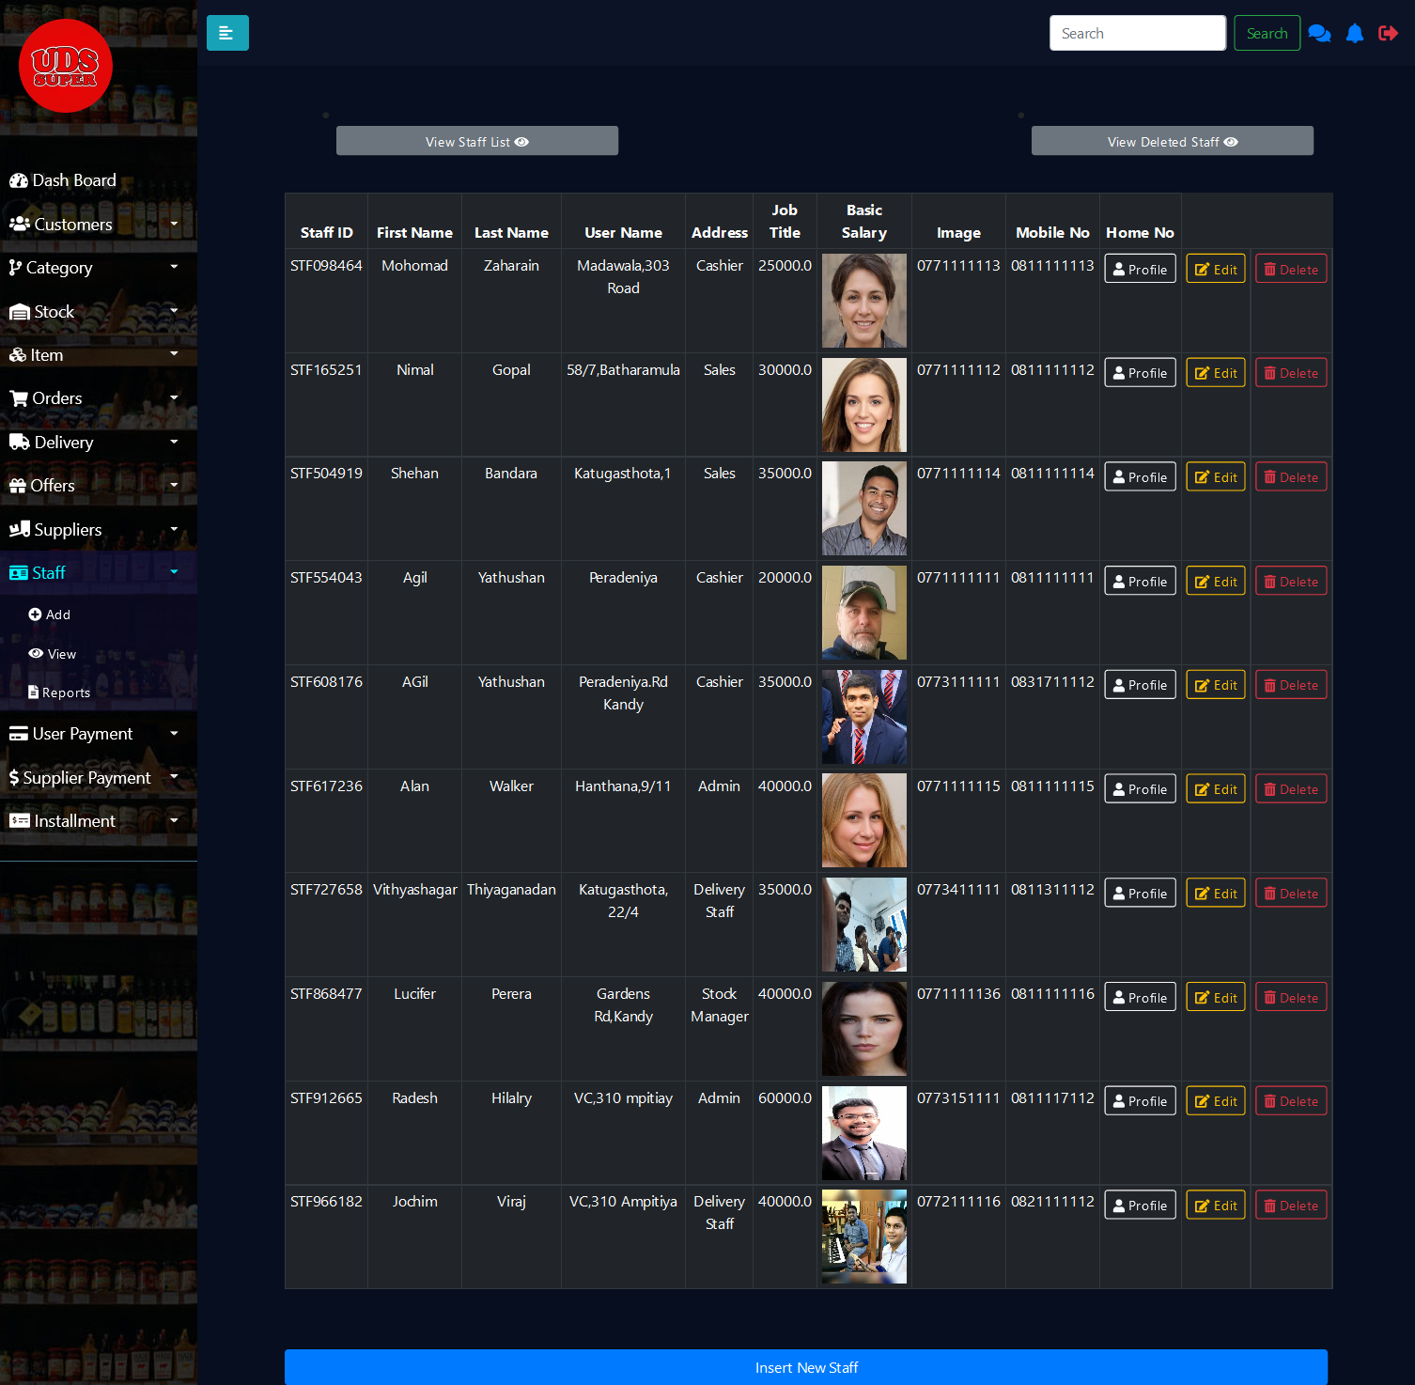

Figure 22

By clicking the view staff list button or the view sub-menu under the staff in the sidebar, the admin can view all the employees who are currently registered in to the system and this table displays some of the important details of the employees. There are three buttons Profile, Edit and Delete at the right corner of the table. The profile button will navigate to the profile (Staff Profile) page of that particular employee. Edit button will navigate to the edit employee information (Staff Update) page and the delete button will navigate to the view employee delete information page (Staff Delete).

1. **Staff Profile**

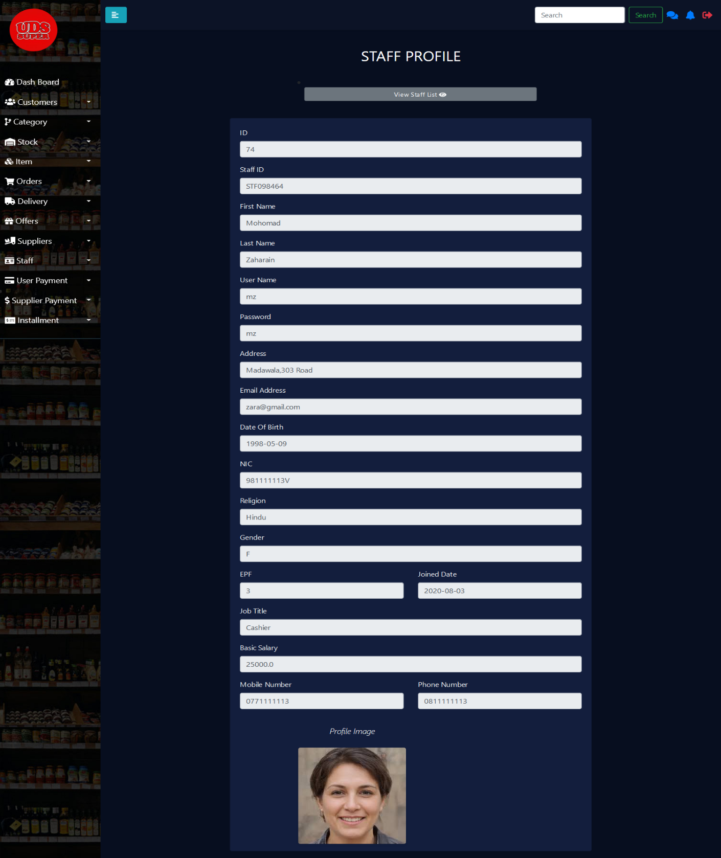

Figure 23

This is the staff profile view page here additional information such as joined date, birthdate, etc.. Which were not displayed in the staff list table page can be viewed if necessary.

1. **Staff Update**

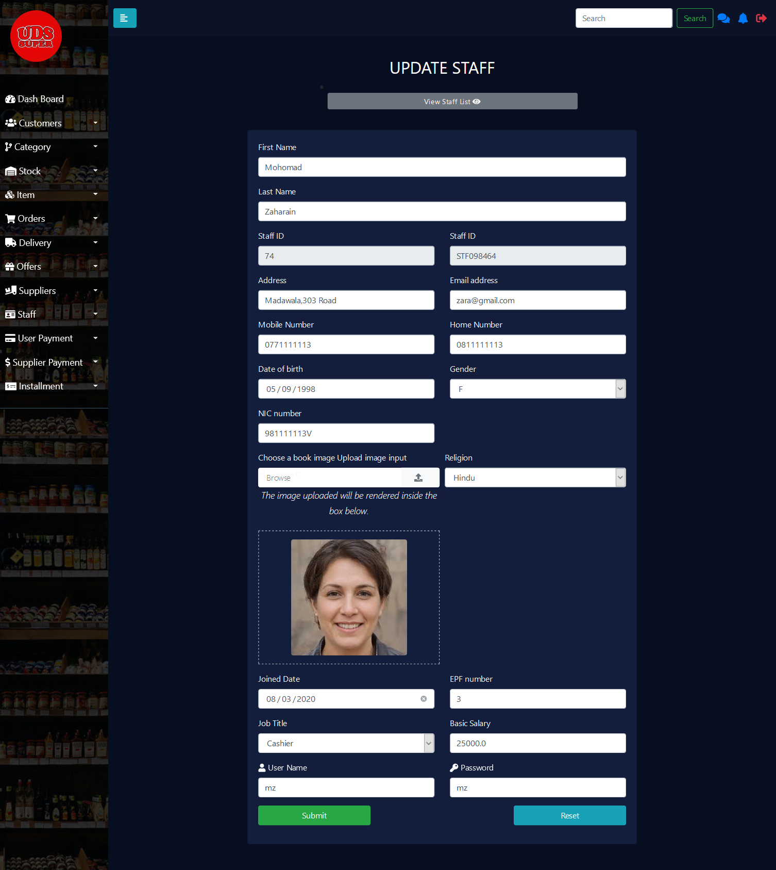

Figure 24

By clicking the update button, the staff list table, the admin can navigate to this page. Here an employee’s details can be updated if necessary and by clicking the submit the details can be updated to the database.

1. **Staff Delete**

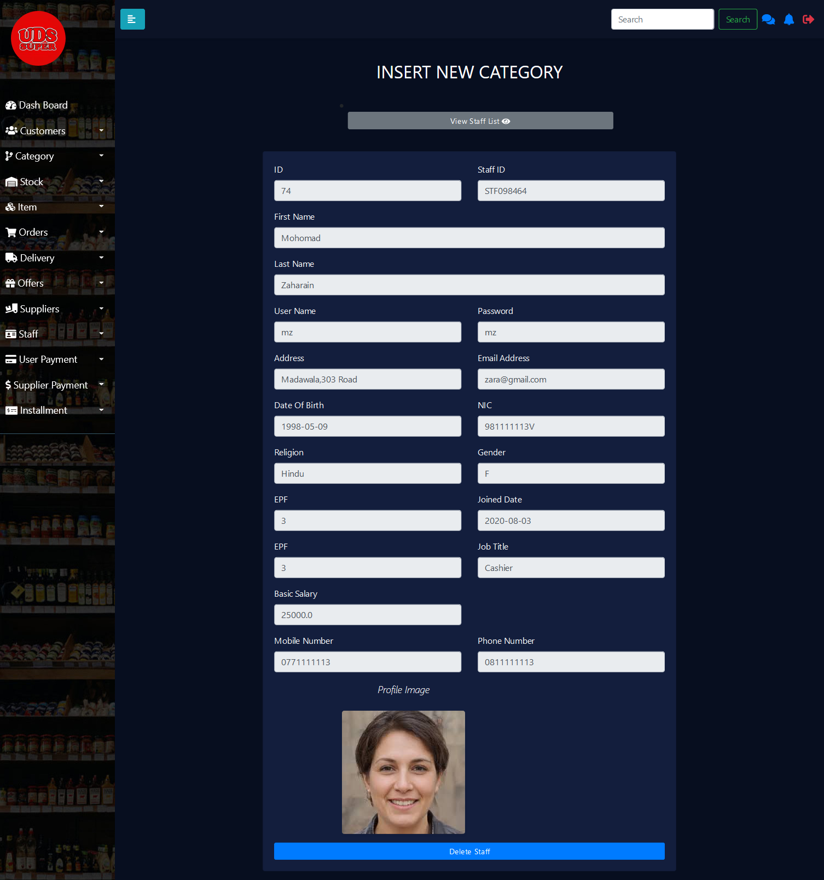

Figure 25

By clicking the delete button which is in the staff list table the admin can navigate to this(StaffDelete) page. Here the admin can verify the details of the staff to be removed and by clicking the Delete Staff button the details can be removed from the staff table. The details which are removed will be stored in another table using a trigger.

1. **Staff Delete List**

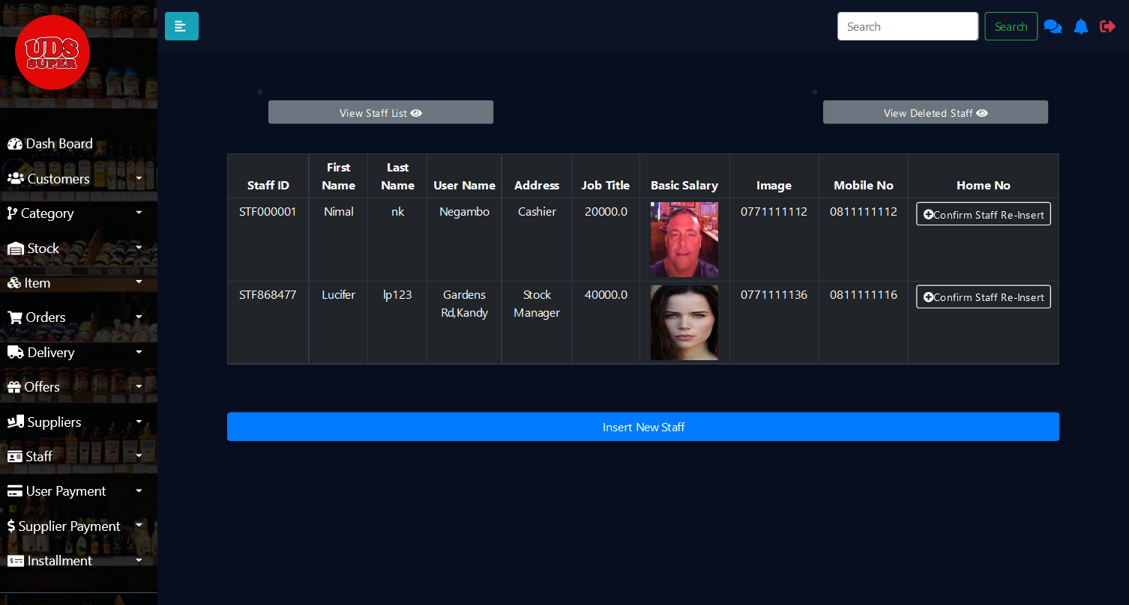

By clicking the view delete staff button the admin can view all deleted staff or the details of the staff who have already resigned. If any resigned staff who was registered to the system rejoins to the shop there is no need to register again to the system but by just clicking the confirm-re insert button the staff details can be inserted back to the working staff table.

1. **Confirm Reinsert**

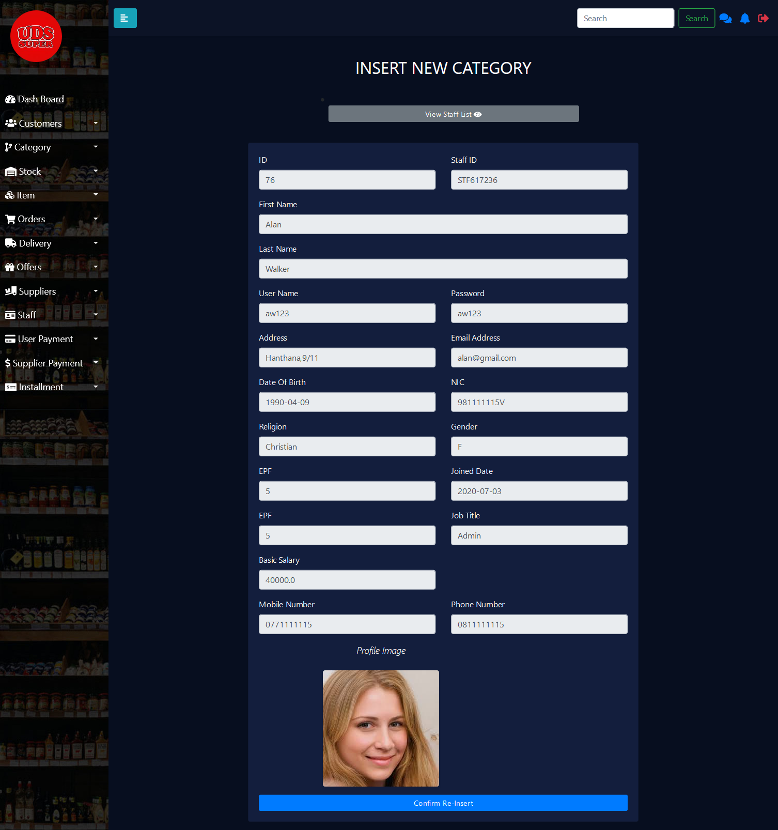

Figure 26

After clicking the confirm staff Re-insert button which was at the deleted staff list table the admin can view this page, here all the details of the relevant staff will be displayed before reinsertion. After the admin has verified the details by clicking the Confirm Re-insert button the details will be inserted to the staff table.

1. **Salary Dashboard**

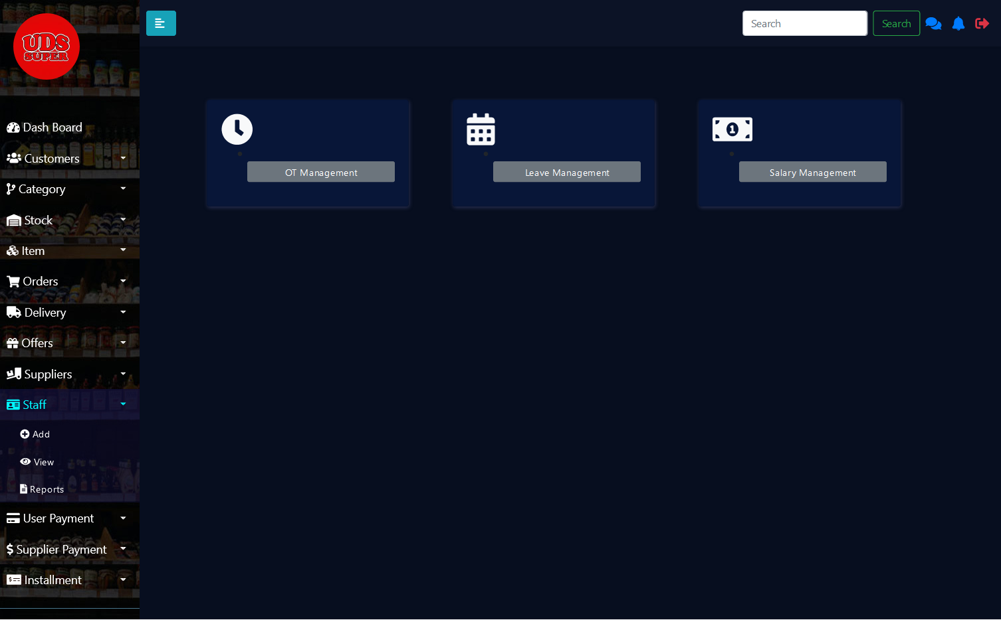

Figure 27

This page (Salary Dashboard) can be viewed by clicking the Reports sub-menu which is under the staff menu in the sidebar. The page displays three buttons OT Management, Leave Management and Salary Management. By clicking the OT Management button the admin can navigate to the OT insertion page, by clicking the Leave Management button the admin can navigate to the Leave insertion page and by clicking on the Salary Management table the admin can navigate to the View Salaries page.

1. **Staff OT Insert**

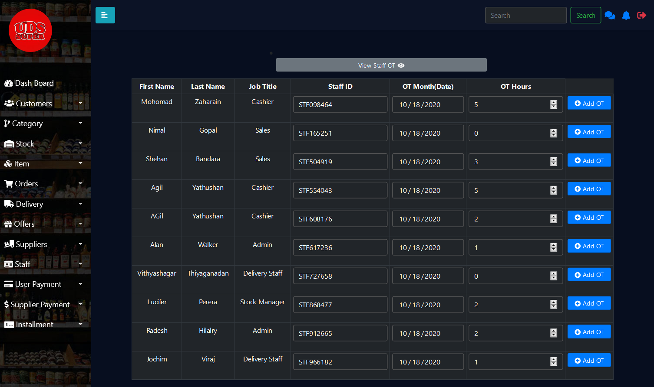

Figure 28

By clicking the OT management button in the Salary Dashboard page, the admin can view this page. Here for a staff the admin can add OT hours for a particular date. By clicking the View Staff OT button which is at the top of the page the admin can navigate to the View staff OT List page.

1. **Staff OT List**

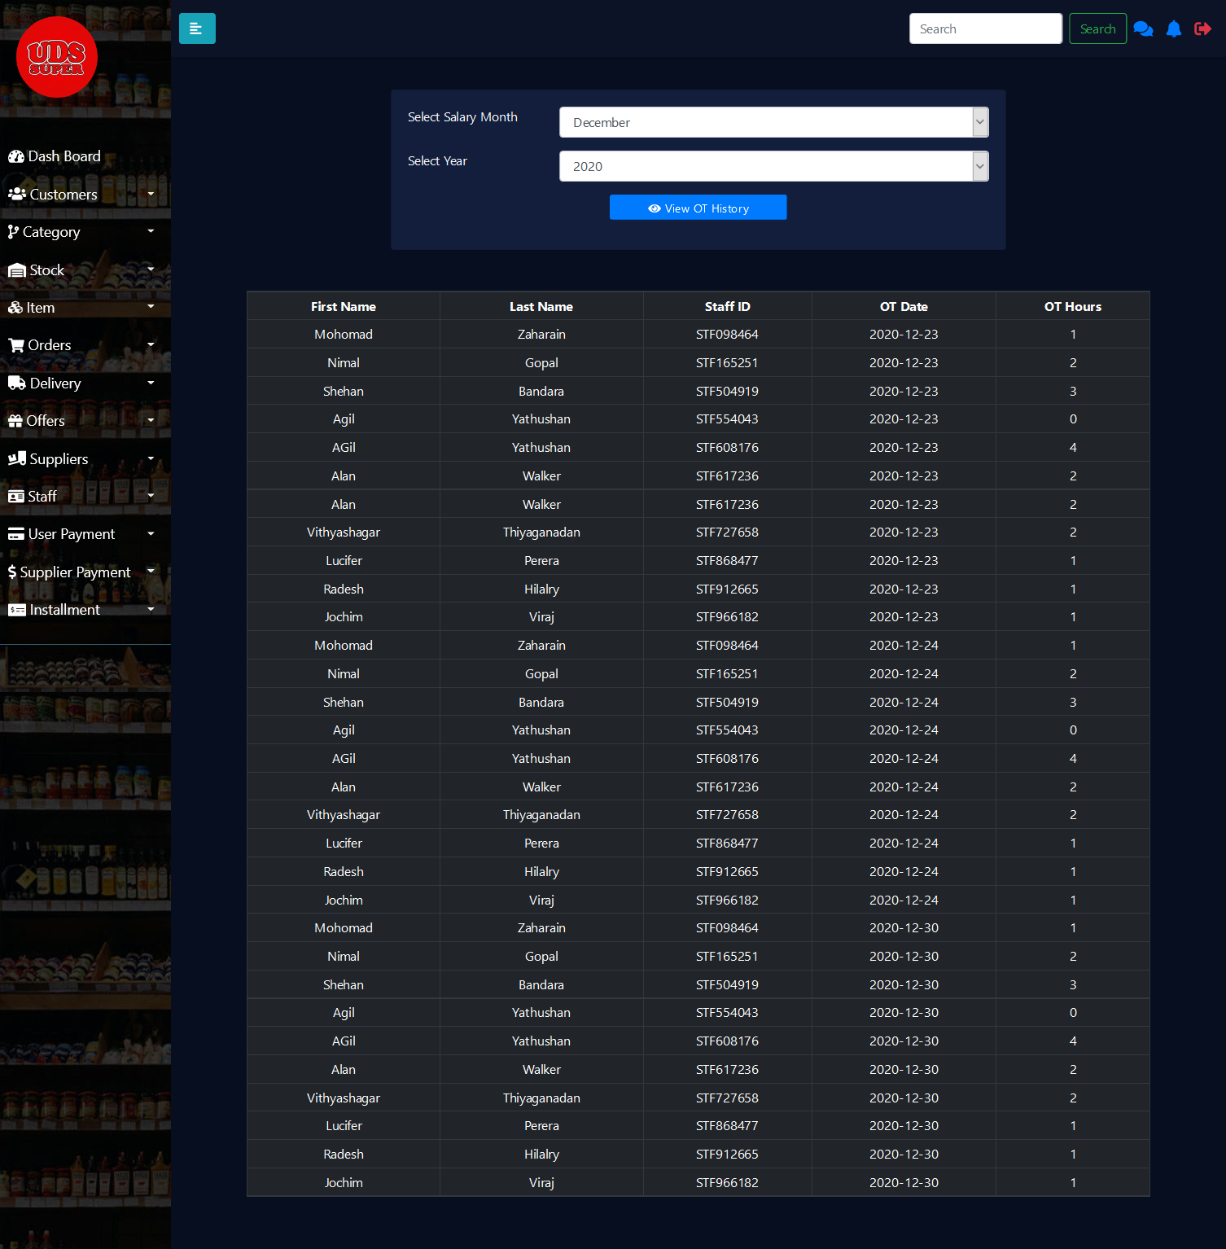

Figure 29

This is the Staff OT List page here by selecting the month and the year the admin can view the OT history details of the employees of a particular month. Here the OT hours are orderly displayed by date along with the staff information.

1. **Staff Leave Insert**

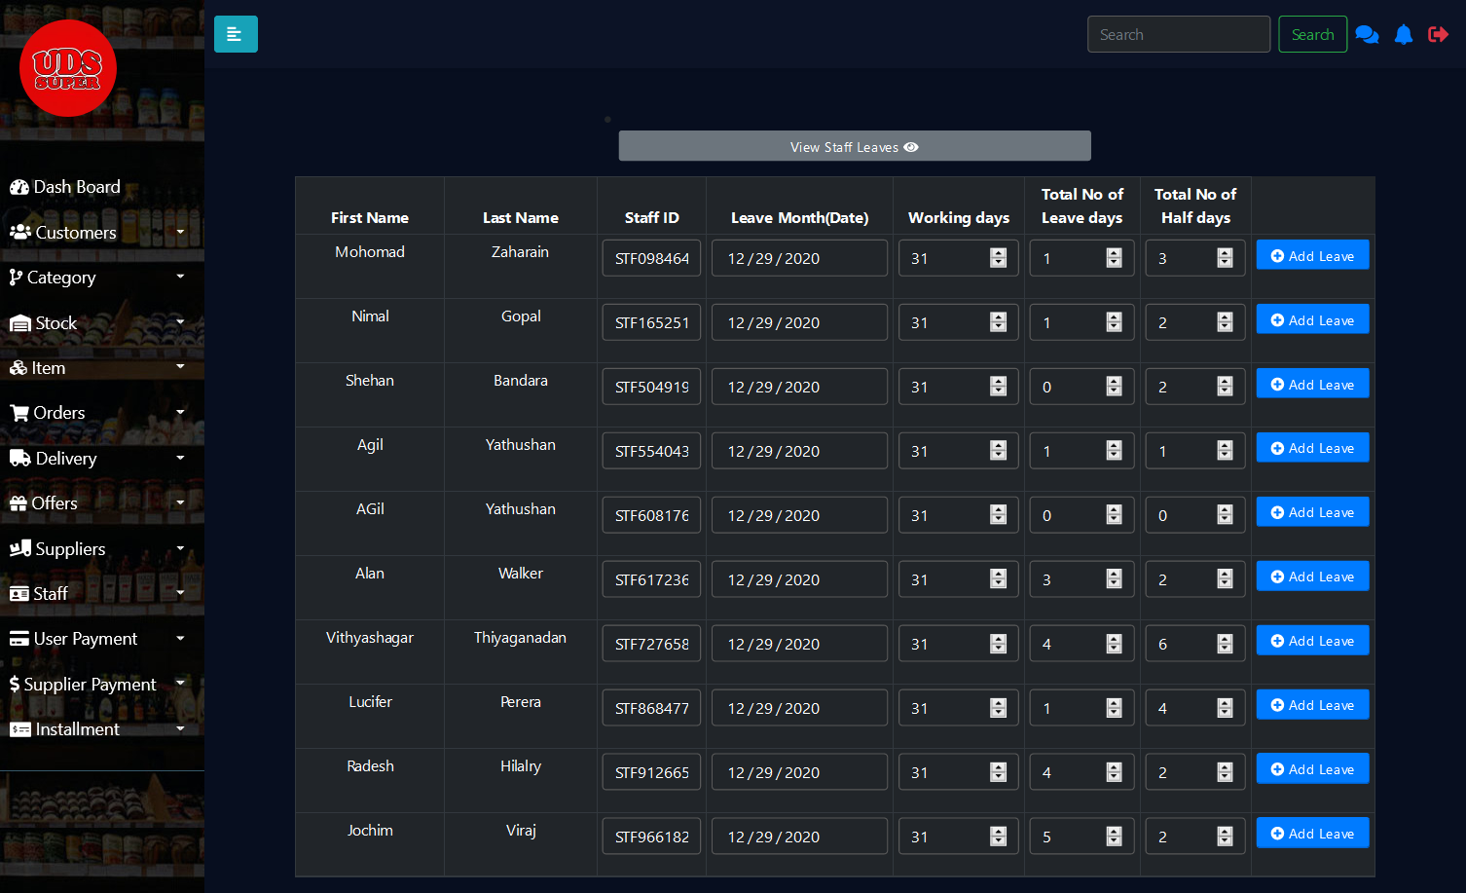

Figure 30

By clicking on the Leave Management button in the Salary Dash Board page the admin can navigate to this page here the admin can insert a leave or leaves on particular staff by inserting the total no of working days of the month, total no of leave days and the total number of half days. By clicking the View Staff Leaves button the admin can navigate to the Staff Leave List page.

1. **Staff Leave List**

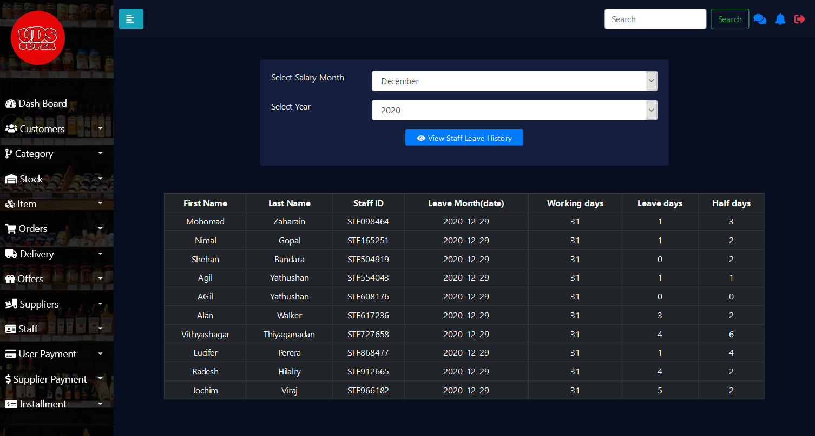

Figure 31

By clicking the View Staff Leaves button the admin can navigate to this page (Staff Leave List). Here by selecting the month and year the admin can view the Leaves and half days of employees in a particular month.

1. **Salary**

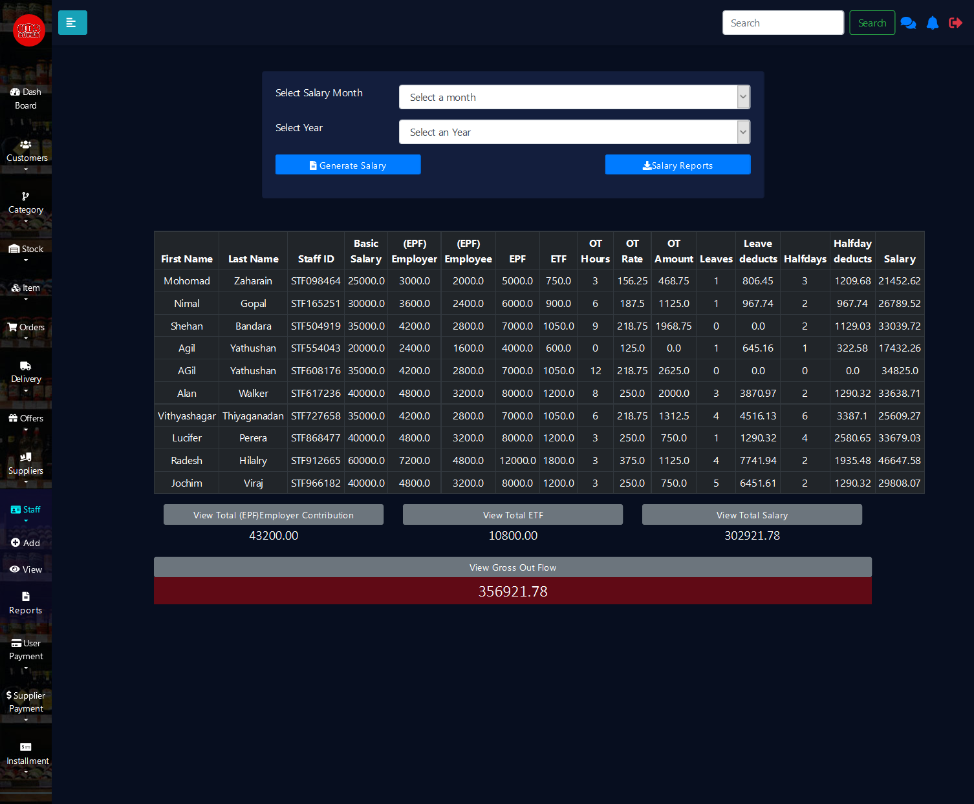

Figure 32

By clicking the Salary Management button which is at the Salary Dashboard page the admin can view this page. Here the admin can view all information related to the month end salary. By clicking the Salary Report button, the admin can navigate to the Salary Report Page.

1. **Salary Report**

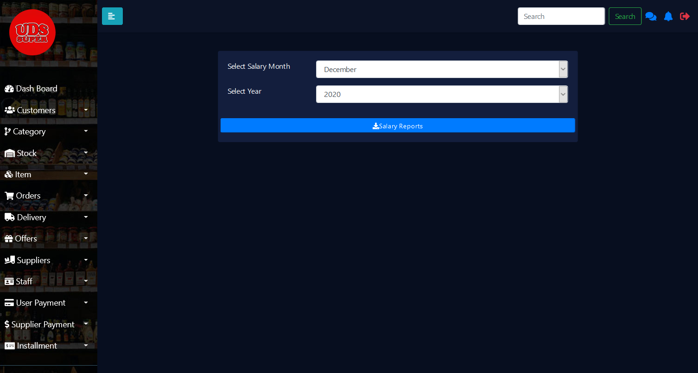

Figure 33

In this page by selecting the month and year the admin generates the month end salary report.

1. **Salary Report pdf**

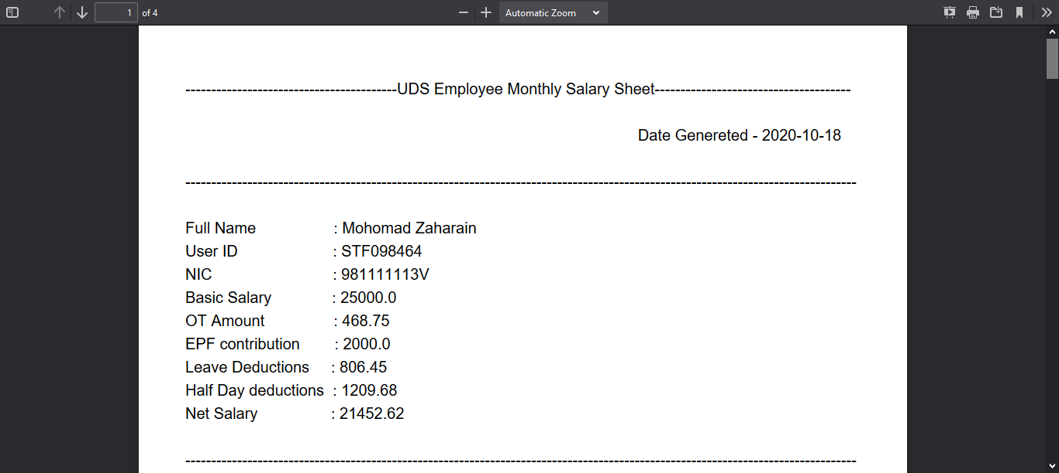

Figure 34

This is the downloadable salary report page.

### Customer Management

1. 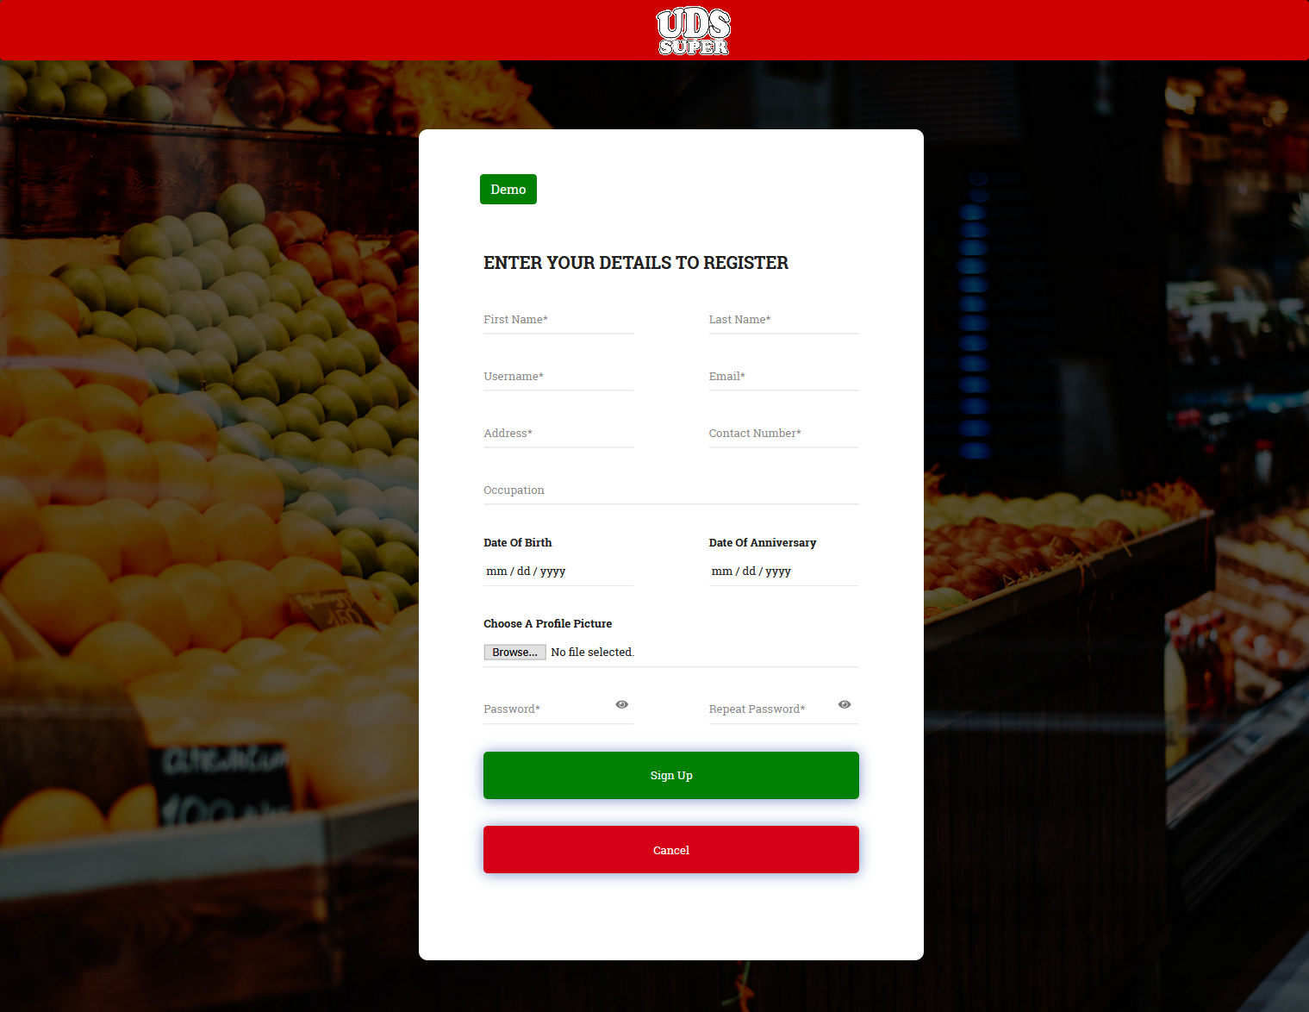**Customer Registration Interface**

Figure 35

This represents the customer registration interface which is necessarily required in order to shop online. All customers registering online is considered to be loyalty customers, considering the fact that any supermarket system stores a customer detail only if the customer is a loyalty card holder. In order to register, the customer is required to provide the requested details and will be unable to register with the same username, email and contact number. The results of the process will be indicated using alerts and on success it will redirect to login page after the display of alert.

1. 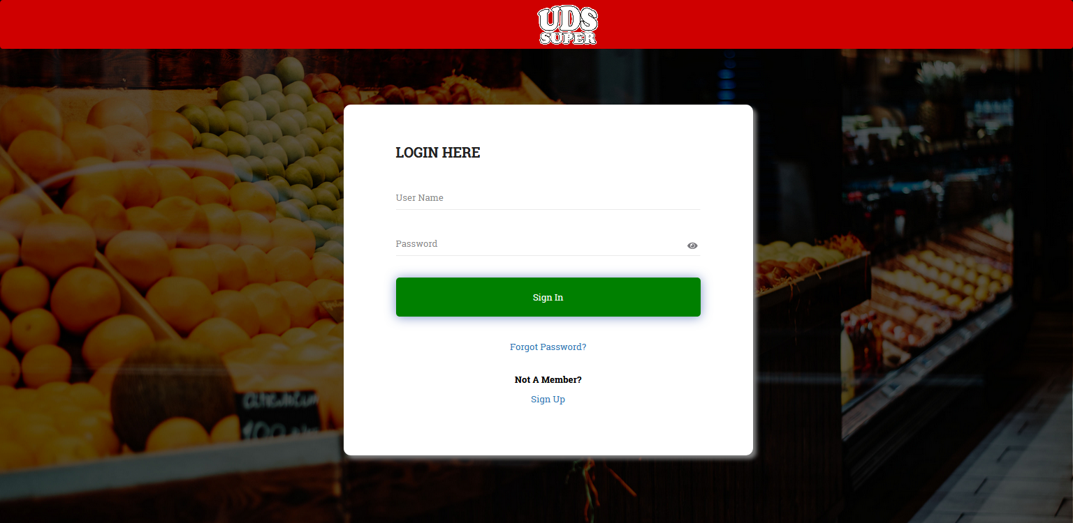**Customer Login Interface**

Figure 36

The registered customers are allowed to login to the system by providing the username and password. If any provided credentials are invalid an error alert will be displayed. On valid credentials, a success alert message will be displayed and redirect to the home page of the portal.

1. 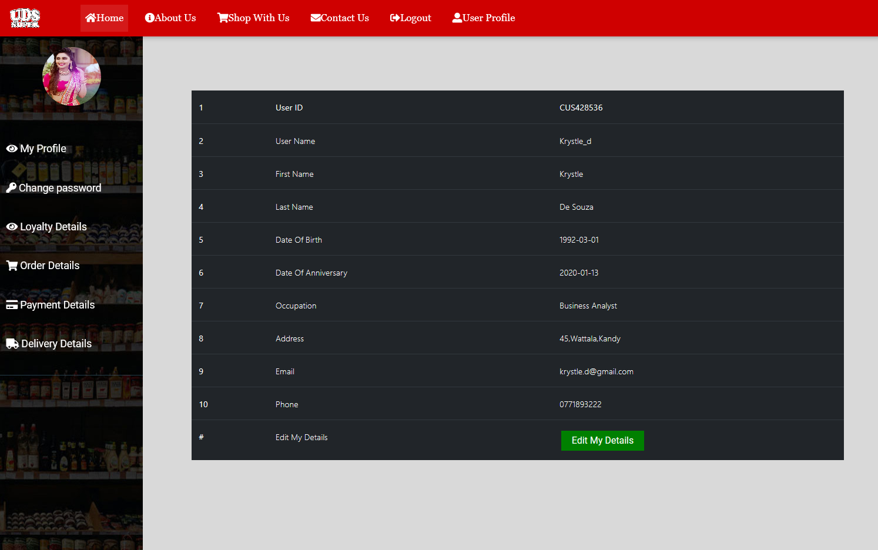**User Profile Interface**

Figure 37

Onclick of the user profile navigation menu in the header, a registered customer can view their user profile. From user profile the customer is facilitated to view his/her personal information and edit the details when required. The side bar facilitates the customer view other information like the loyalty points information, order history and delivery details and change password if required.

1. 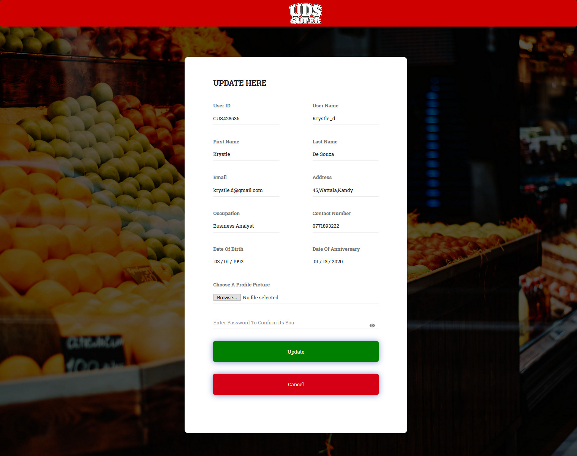**Update Interface**

Figure 38

This represents the customer interface to update the details when required. All details provided earlier will be retrieved and the customer can update the necessary fields. The user id and the username cannot be changed. The processed results will be displayed using alert messages. On successful update of details, it will redirect to user profile.

1. 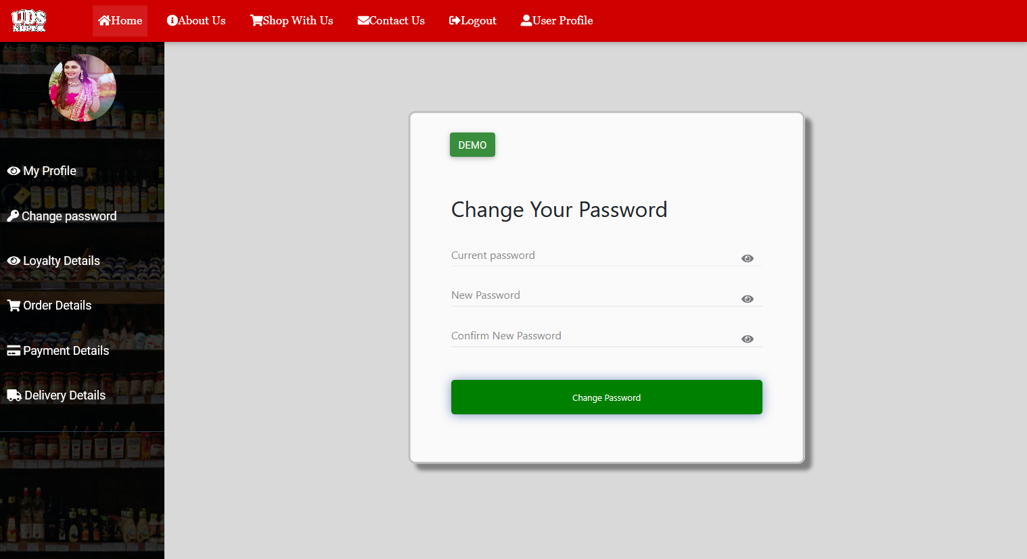**Change Password Interface**

Figure 39

When customer prefers to change his/her password, it can be done by providing the old password, the new password and reconfirming the new password. Under valid inputs the customer will be automatically logged out from the system.

1. 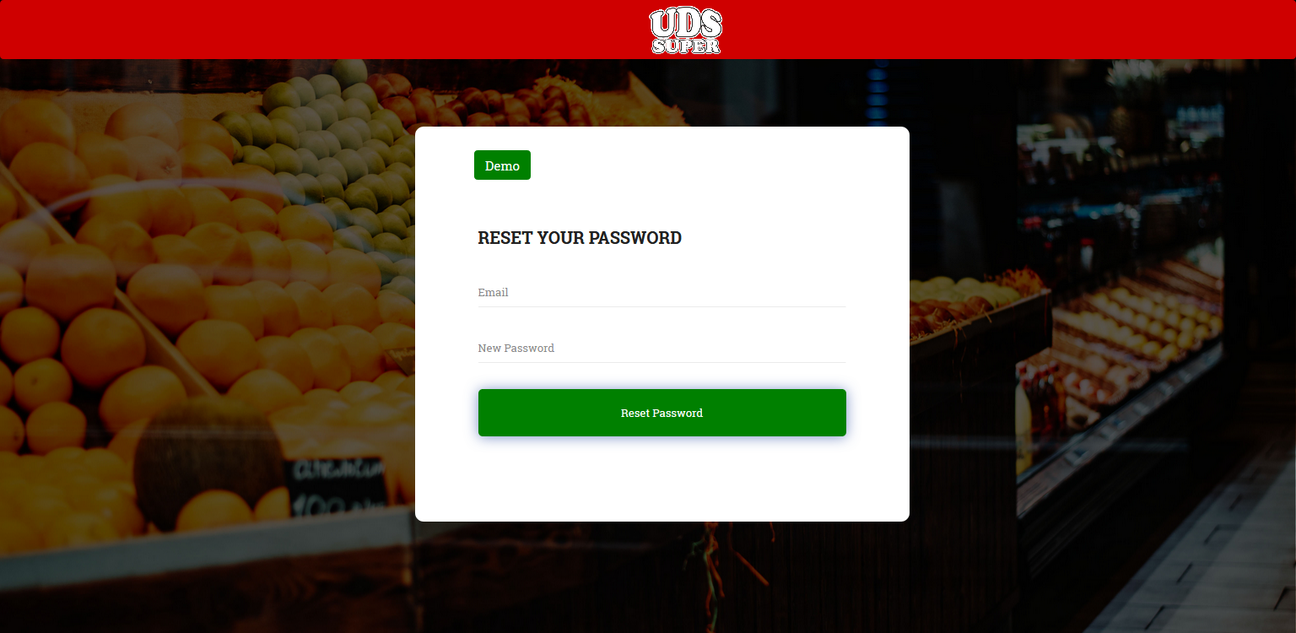**Forgot Password Interface**

Figure 40

When a customer is logged out from the system, if he/she tends to forget the password, system facilitates the customer to reset their password by providing the email and a new password. On successful reset the user will be redirected back to login page with a success alert. Else, an error alert will be displayed, and the user can re-reset the password.

1. 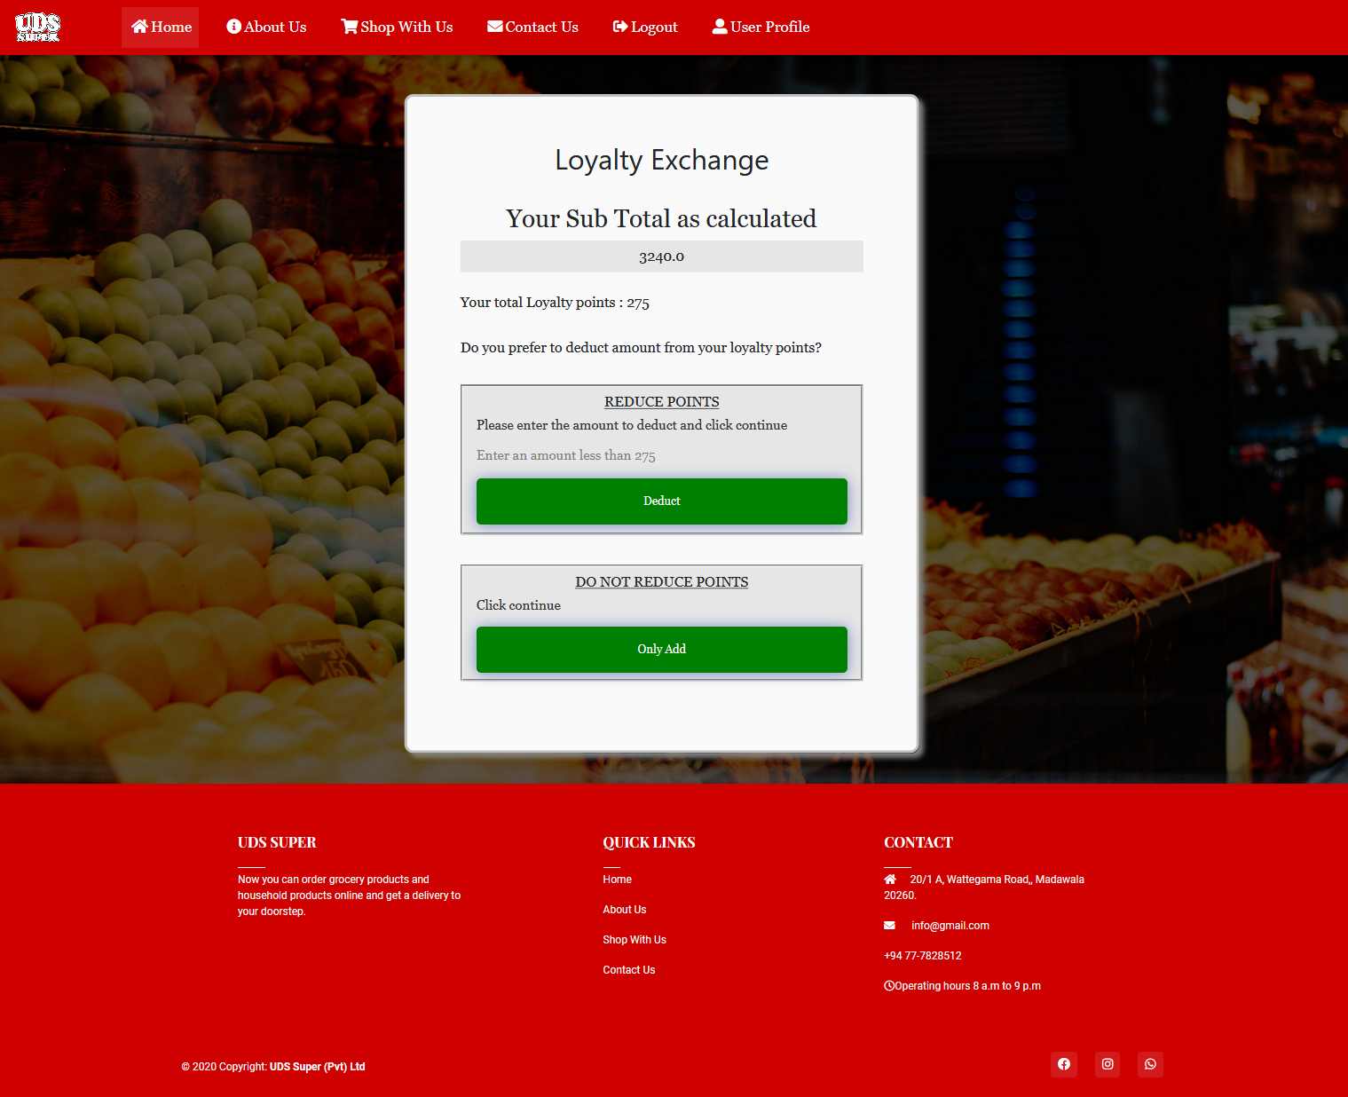**Loyalty Calculation Interface**

Figure 41

This represents the interface to get the preference of user when calculating loyalty points. If user clicks add the loyalty points to be added will be calculated and loyalty points will be increased by the calculate amount. If the user prefers to deduct bill amount by using the loyalty points the user can enter the points to deduct and the respective points will be deducted from bill, while the points will be first added for the respective bill amount and then deducted from available loyalty points.

1. 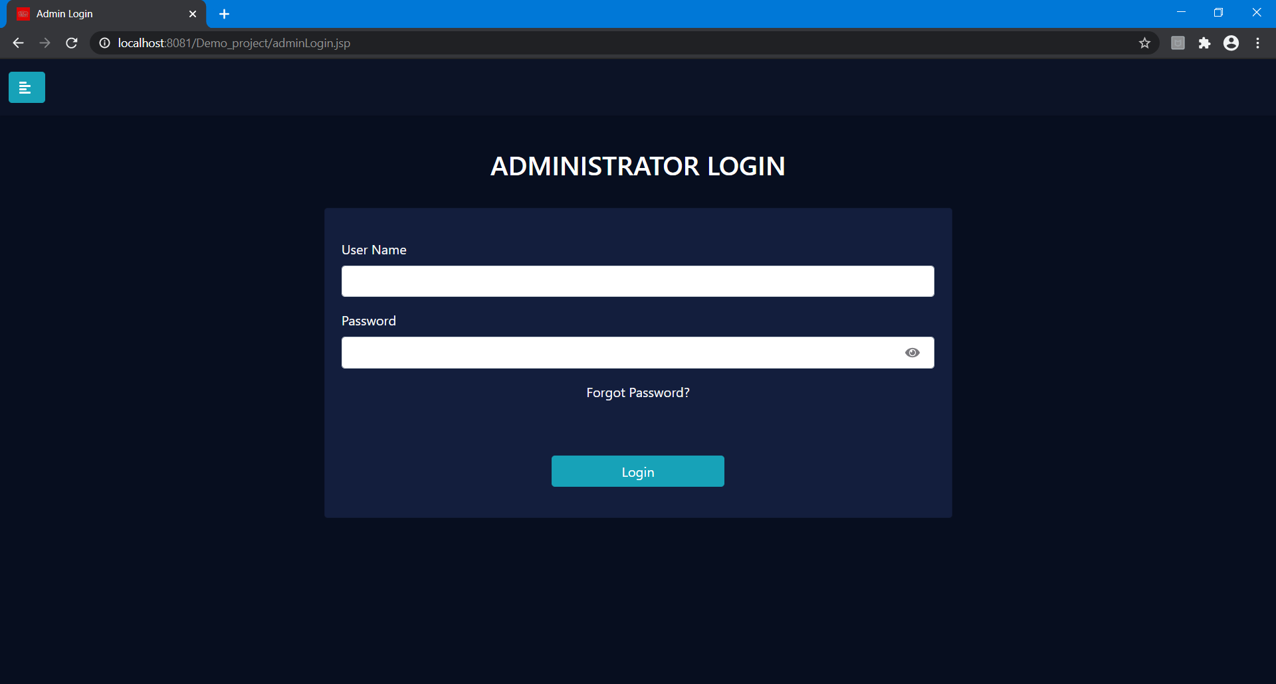**Administrator Login Interface**

Figure 42

The employee who is registered as the administrator of the system can login to the system by providing the credentials. If the credentials are valid, it will redirect to Admin dashboard after a success alert. Invalid credentials lead to the re entering of username and password after an error alert.

1. 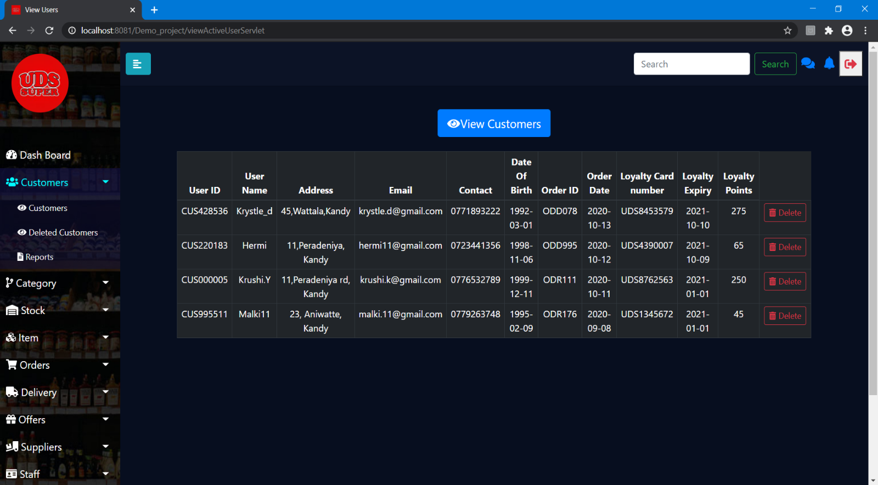**View Customers Interface**

Figure 43

The customer details will be retrieved in the interface along with the order detail of the order that was placed last. If the last ordered date is greater than 10 months the customer is considered to be inactive and the administrator can delete the information of such customers from the table. Through a trigger on deletion these details will inserted to another table for restore purposes.

1. **View Deleted Customers**

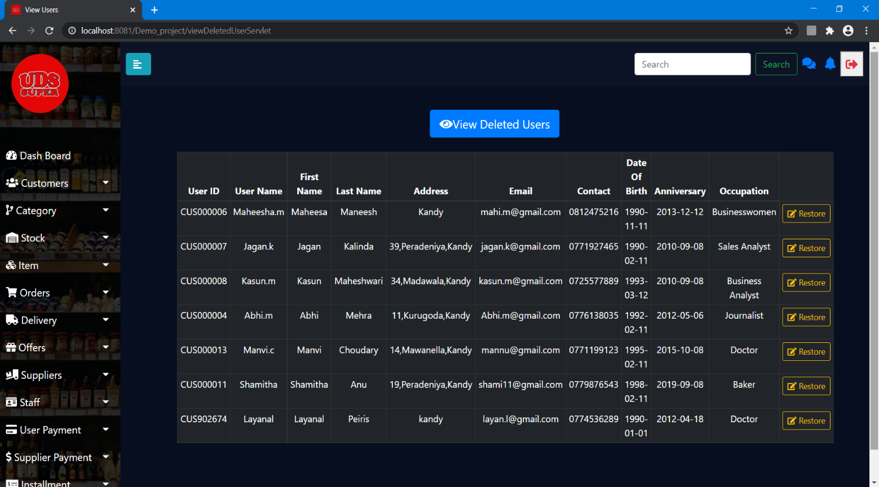

Figure 44

Administrator can view the details of the deleted customers from this interface. If the customer manually requests to restore his/her details the administrator is allowed to restore the details. This action will automatically delete the details from the table and store it back in the customer table.

1. **Search**

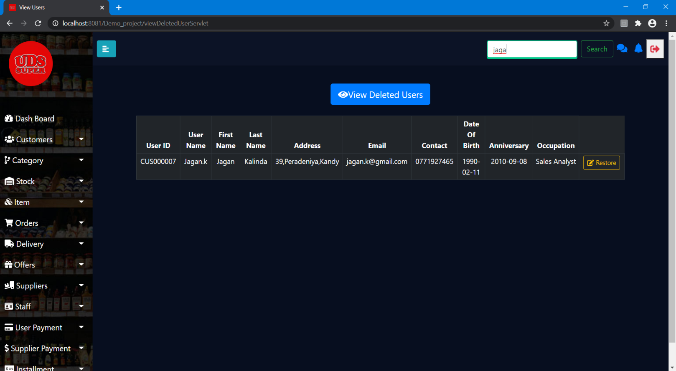

Figure 45

For restoration purposes the administrator can search the customer by providing the email.

1. **Report Interface**

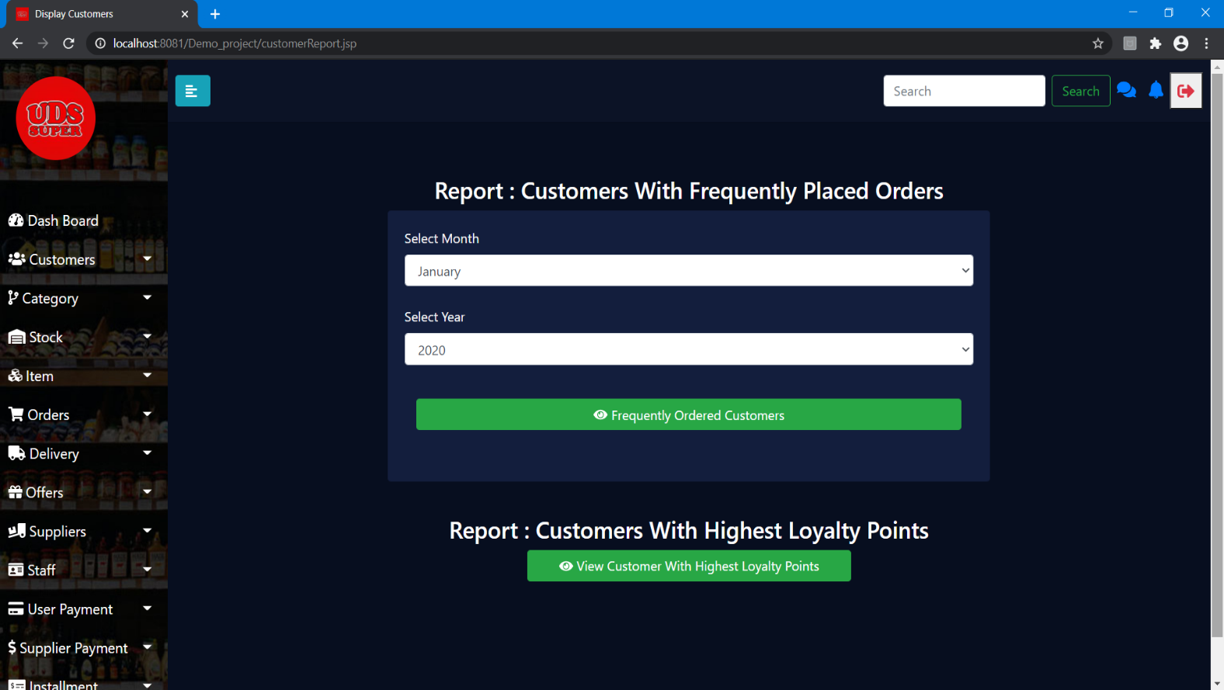

Figure 46

The administrator can generate reports of customers on the basis of two factors. The report for customers with the highest loyalty can be generated by clicking the button alone. To generate the report to find the customers who have been frequent users for a month, the administrator is required to provide the month and year before the button click.

### Order Management

1. **View orders**

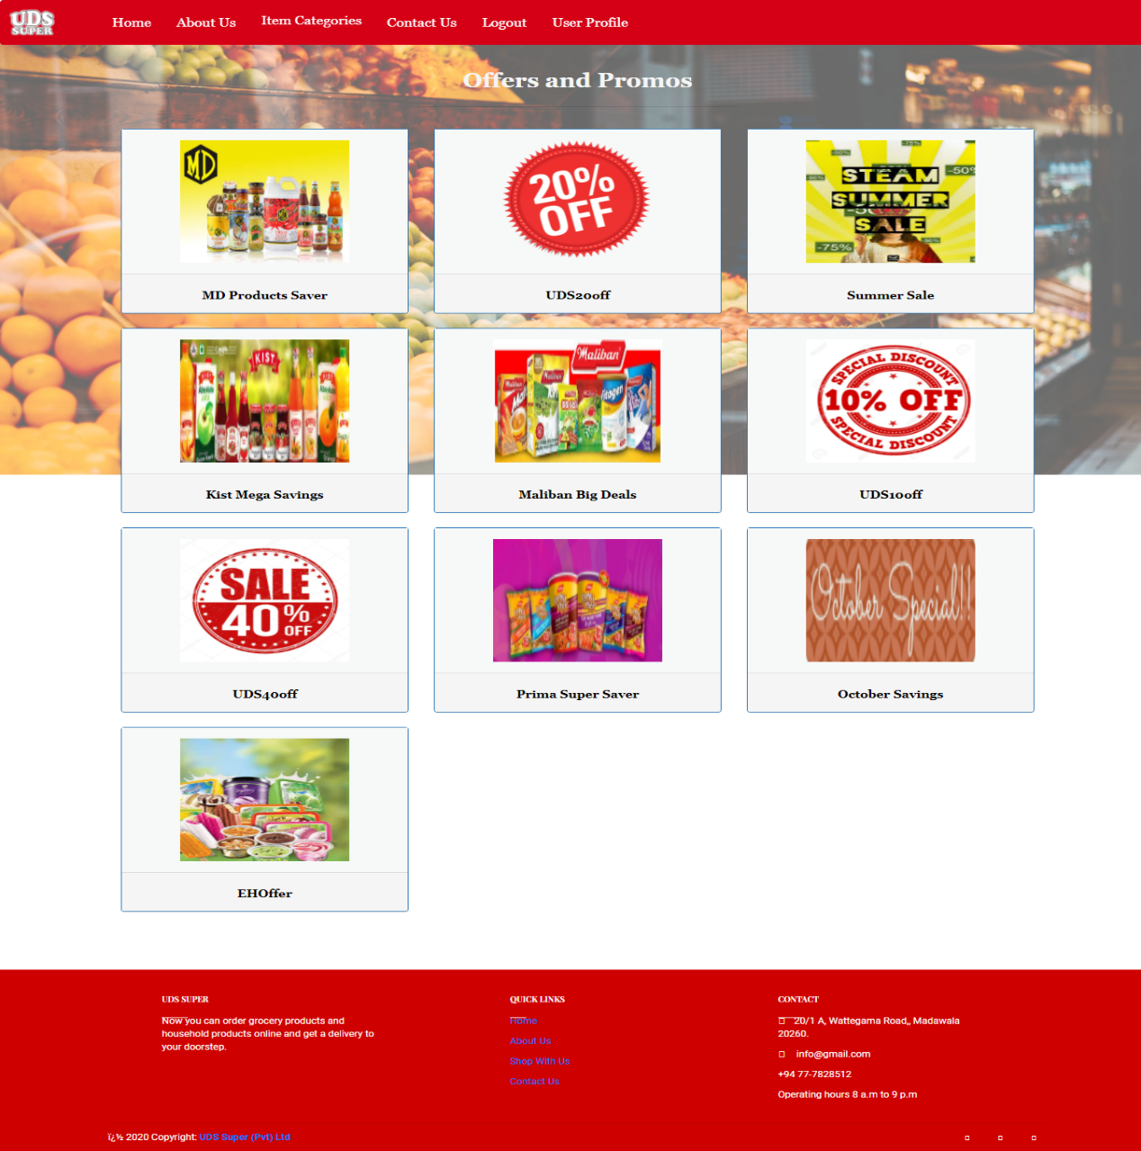

Figure 47

This is customer’s offers page where the customer can view all the offers and they can flip them to view description and the discount percentage. This page allows user to get better idea about the offers and place orders.

**2.View Categories**

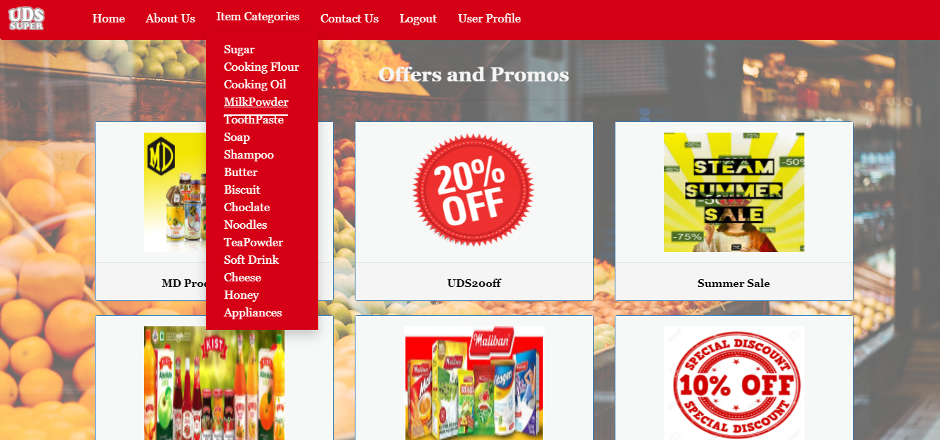

Figure 48

The offers’ page has been facilitated to view all the categories of items, so that user can select specific category to view items.

**3.View items**

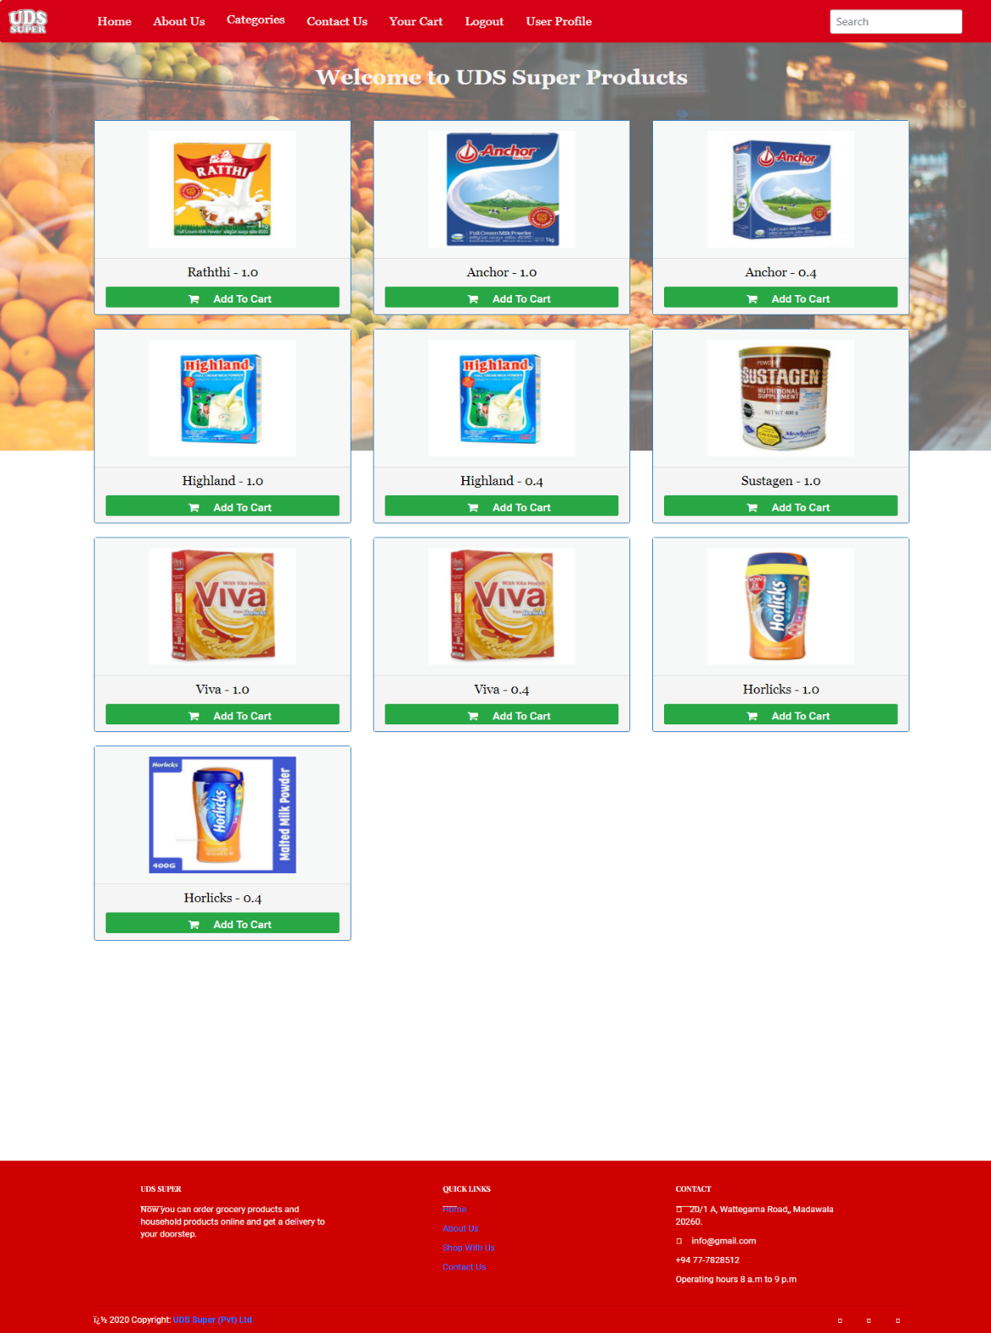

Figure 49

Users can view items, according to the user’s category selection. And, users can view the price, size, offer and discount using the flip. This page allows user to add the item to the cart with the confirmation.

**4. Search item**

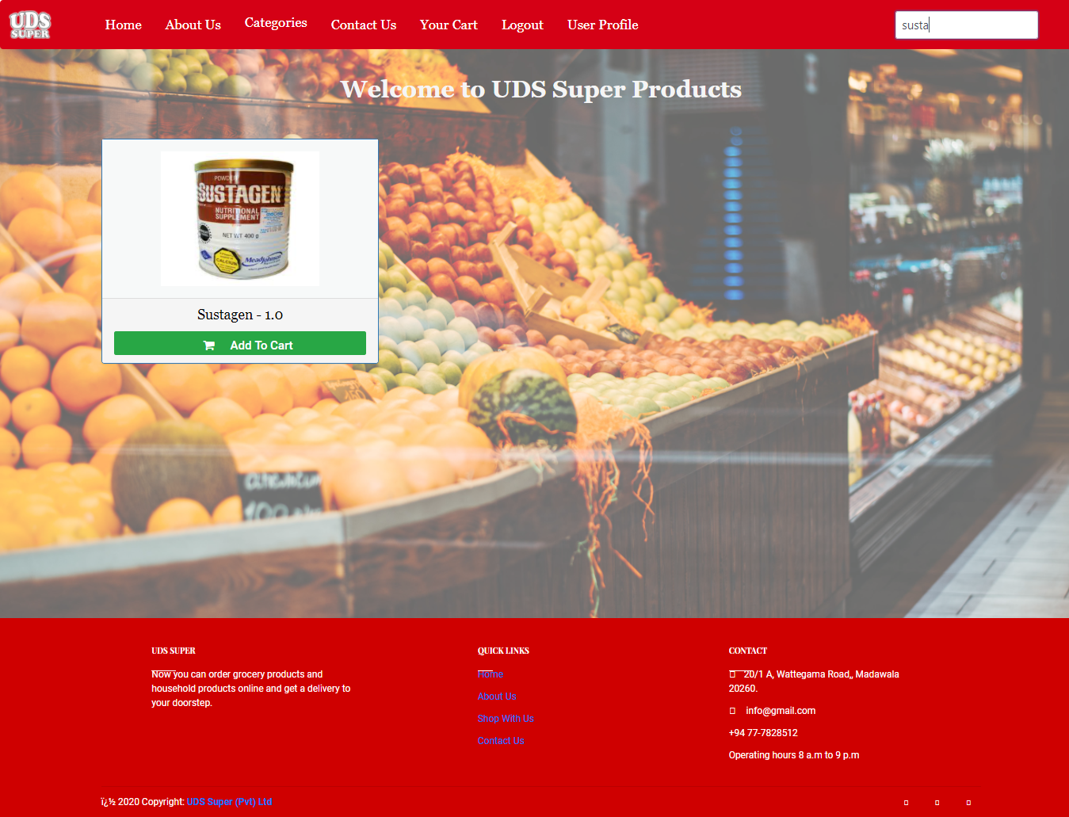

Figure 50

Figure 51

Users can search items according to the user preference and add them to cart.

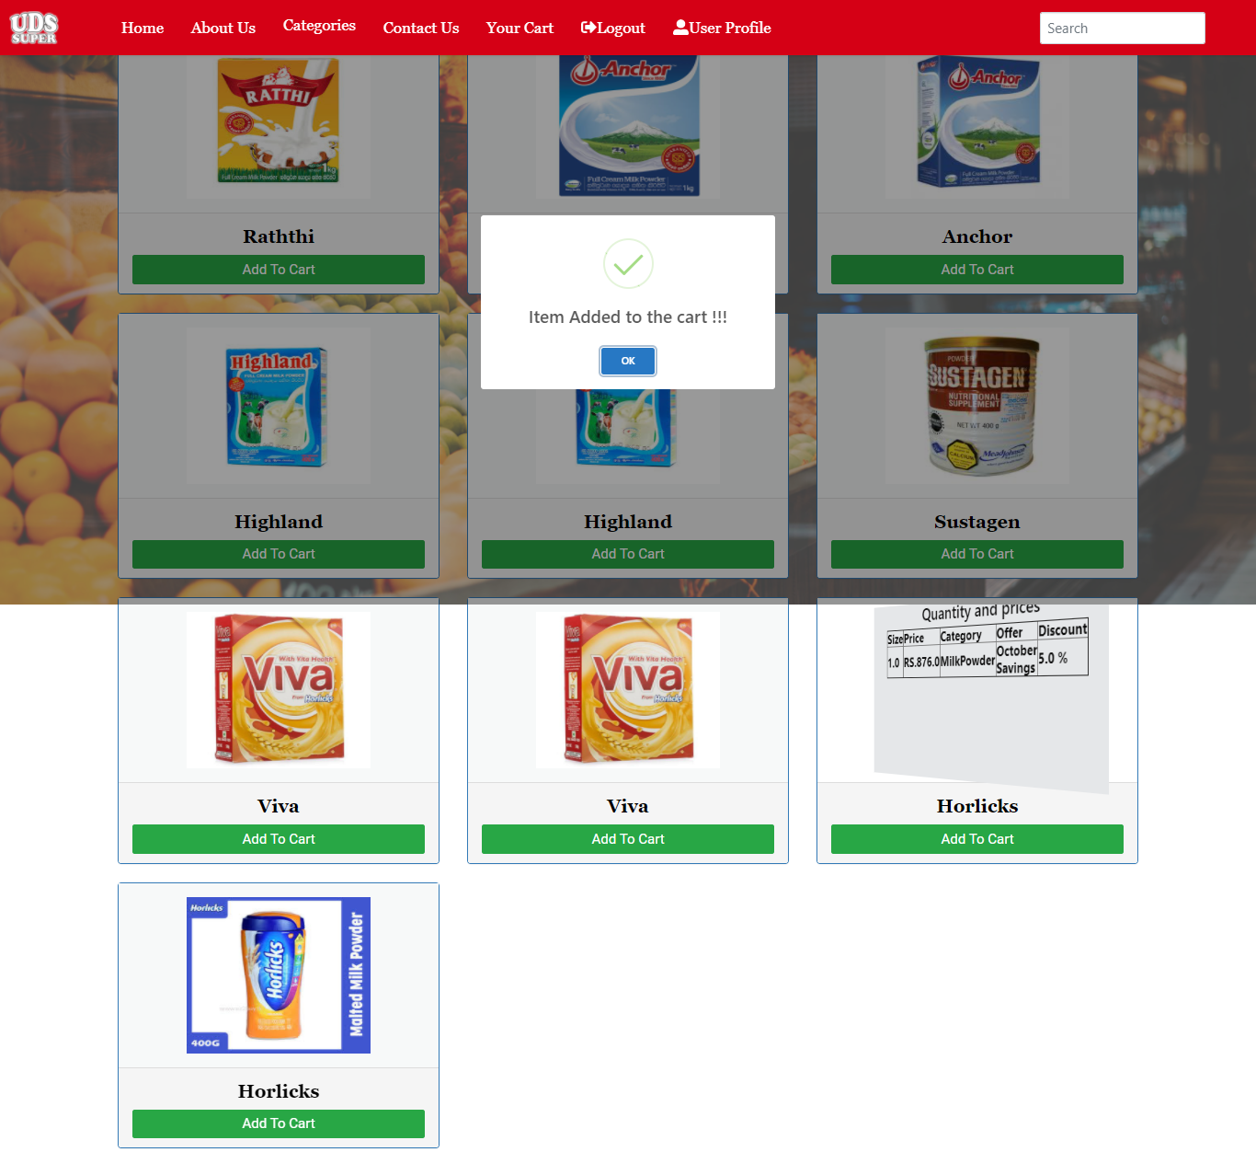**5.Add item to the cart**

Figure 52

When the user clicks ‘Add to cart’ button, success alert will be displayed to let the user know about it.

**6.Order summary**

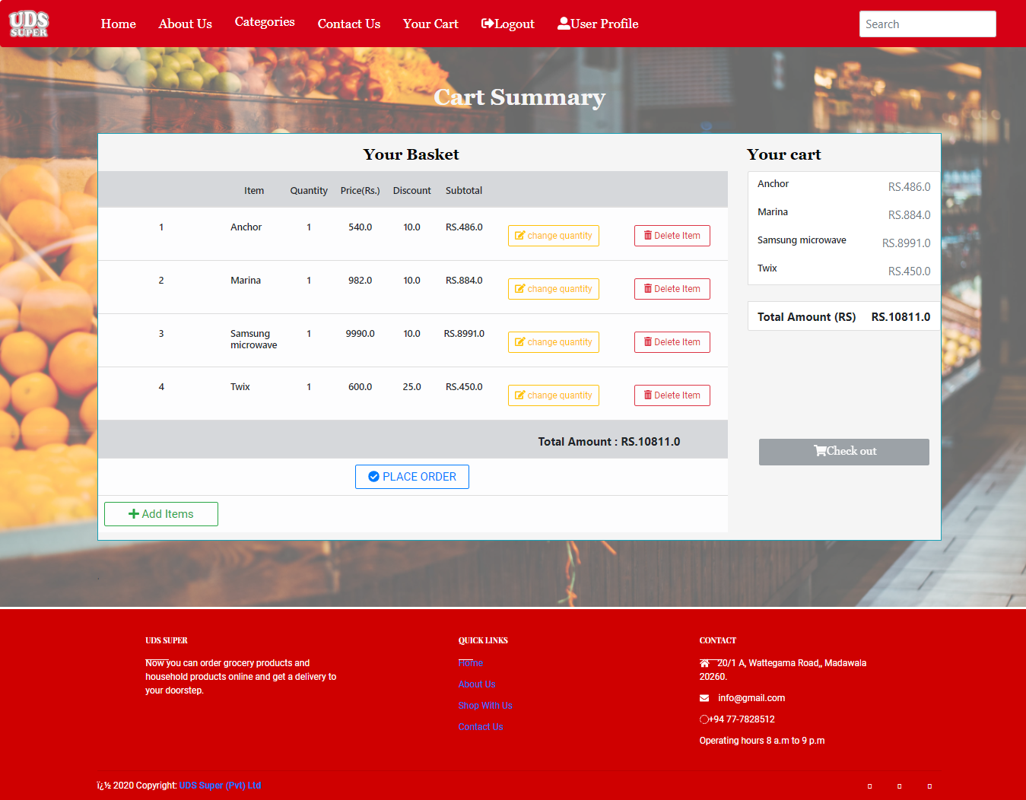

Figure 53

When the user clicks the ‘Your cart’ in the header, users can view all the added items in a single page as an order summary. This page allows user to change the quantity of an item and delete the item if the user wishes. And also, users can add more items. The total amount of the order is calculated and displayed. The place order button is provided for the user to place order.

**7.Update quantity**

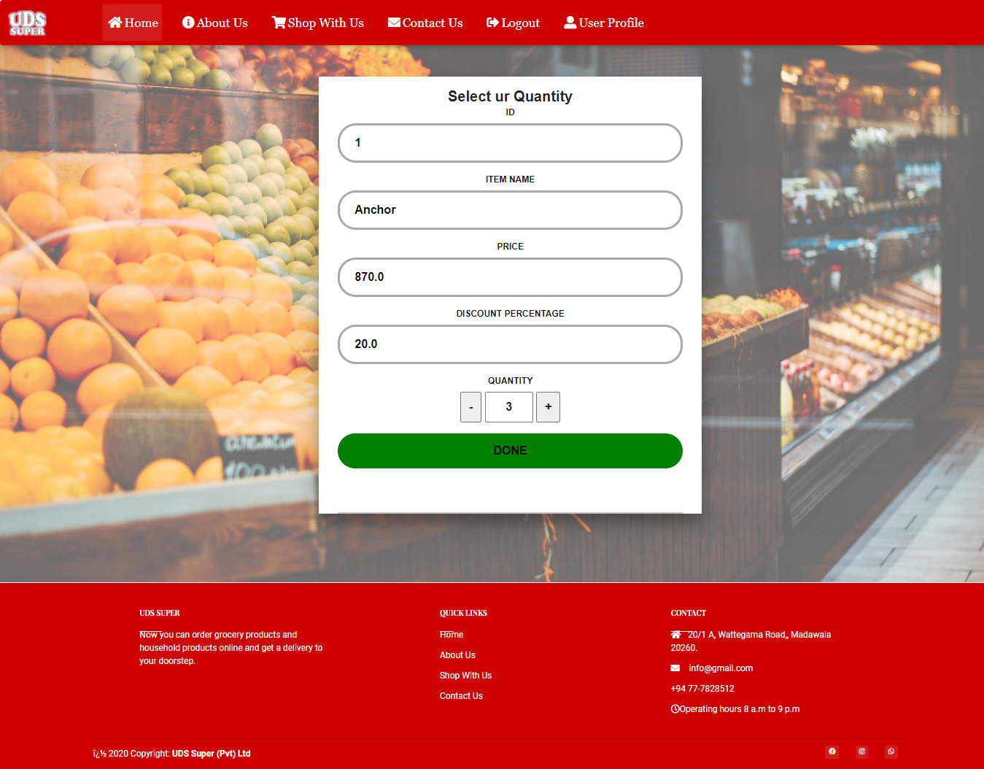

Figure 54

This page is to change the quantity of a particular item. Total amount and the net amount also will be updated when updating the quantity.

**8.Place order**

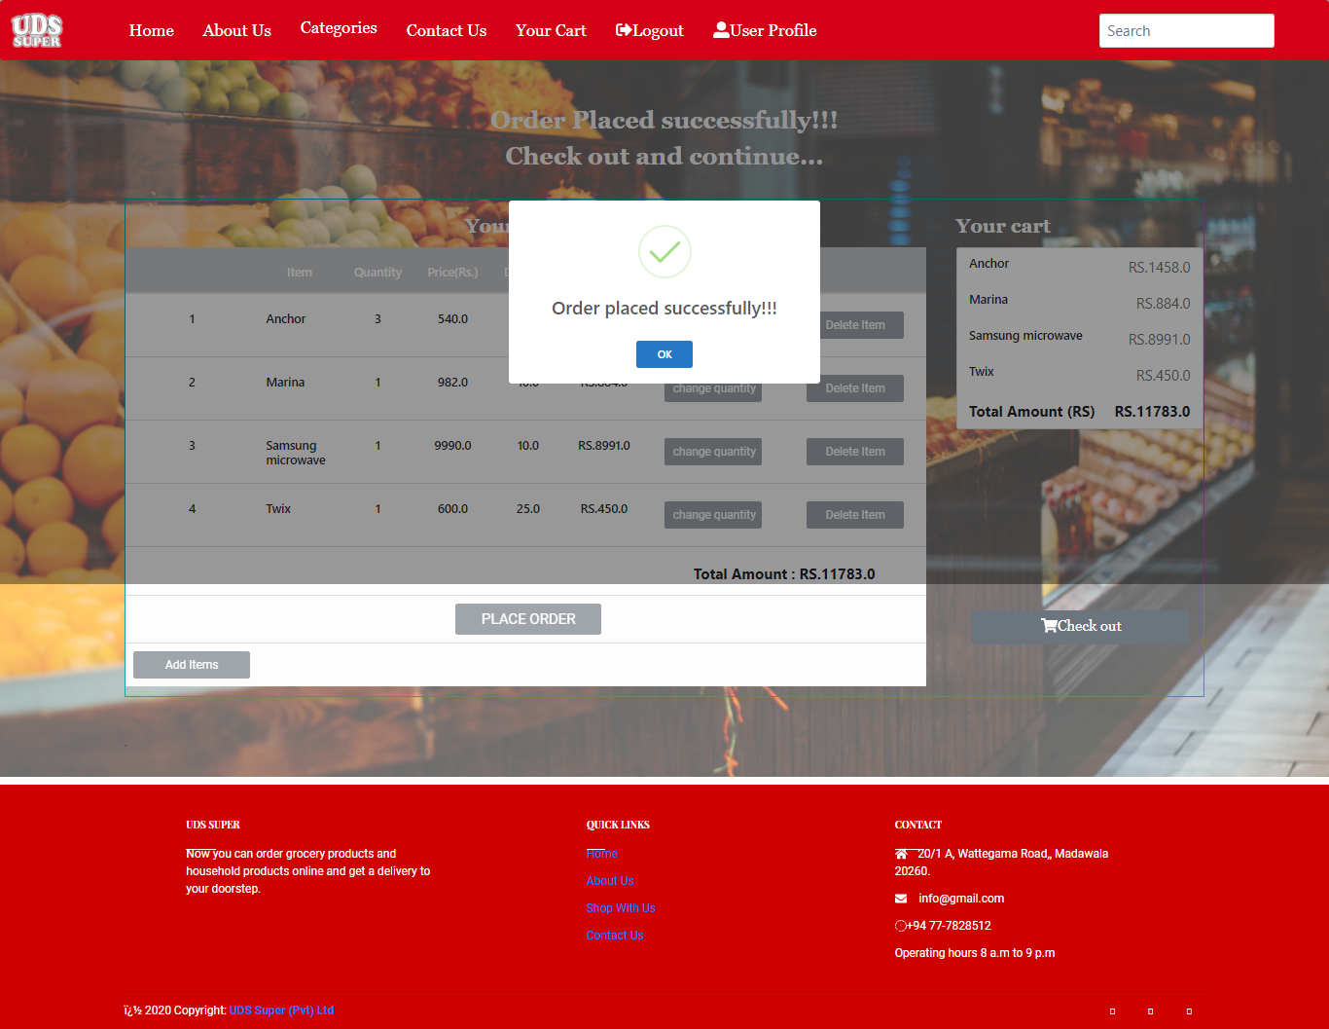

Figure 55

When the user clicks ‘Place order’ button, success alert will be displayed to let the user know about it.

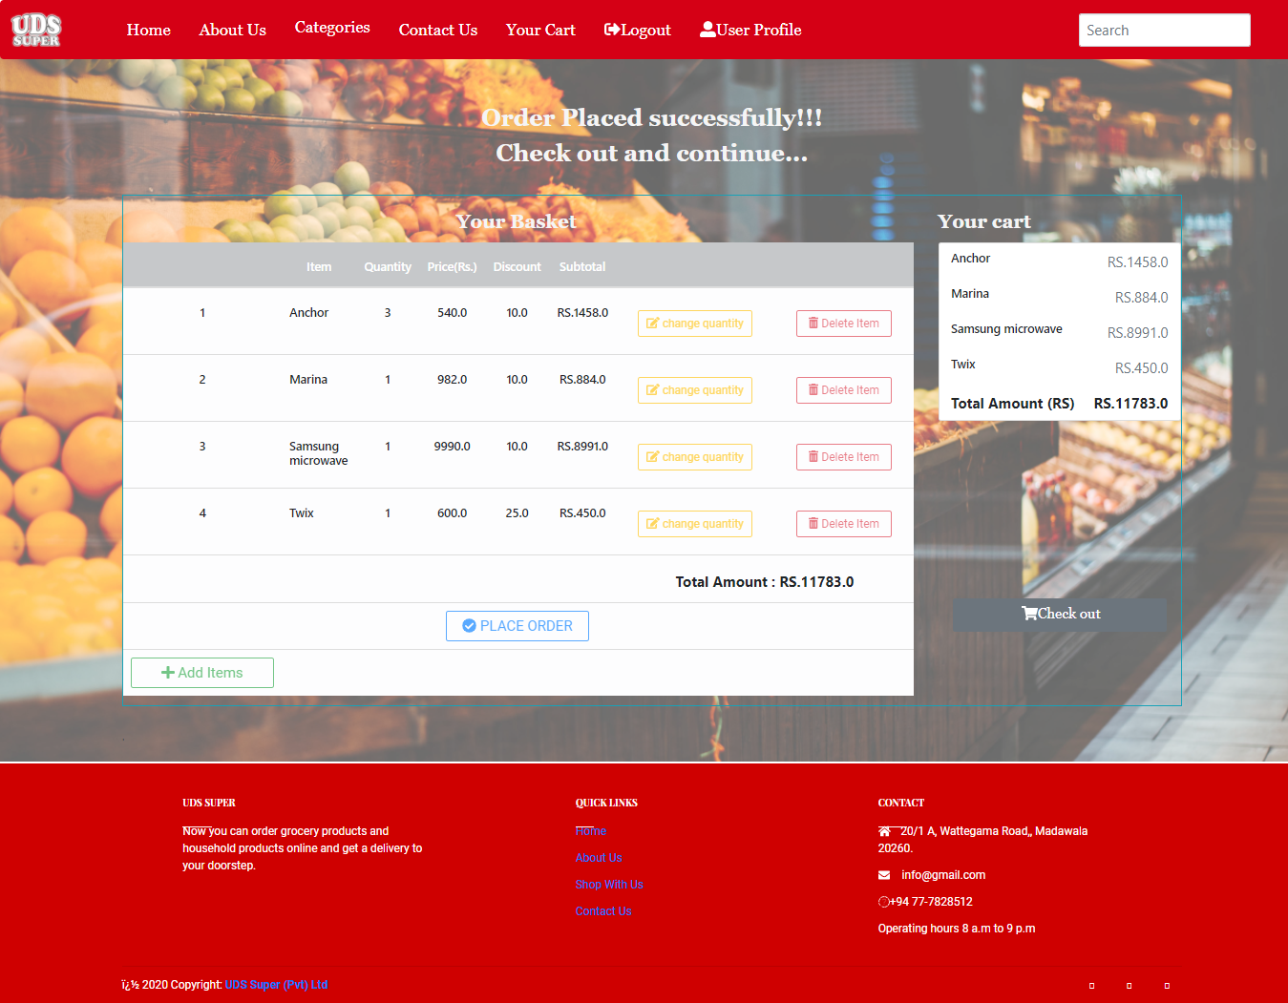

Figure 56

**9.Success order and check out**

This page provides a success message, and all the buttons will be disabled except check out button to continue with payment procedures.

1. **User profile with orders**

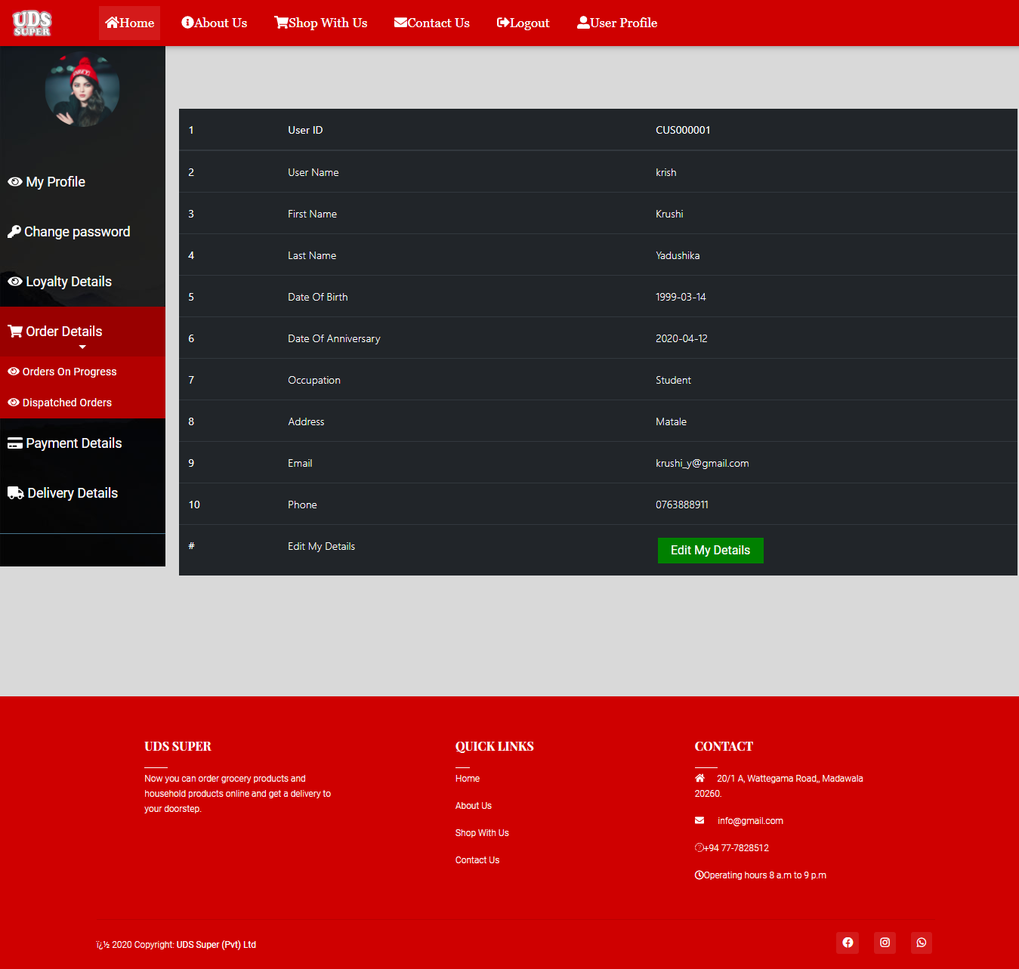

Figure 57

The user profile page is facilitated for the users to view their orders on progress as well as dispatched orders.

1. **Orders on progress for the deletion**

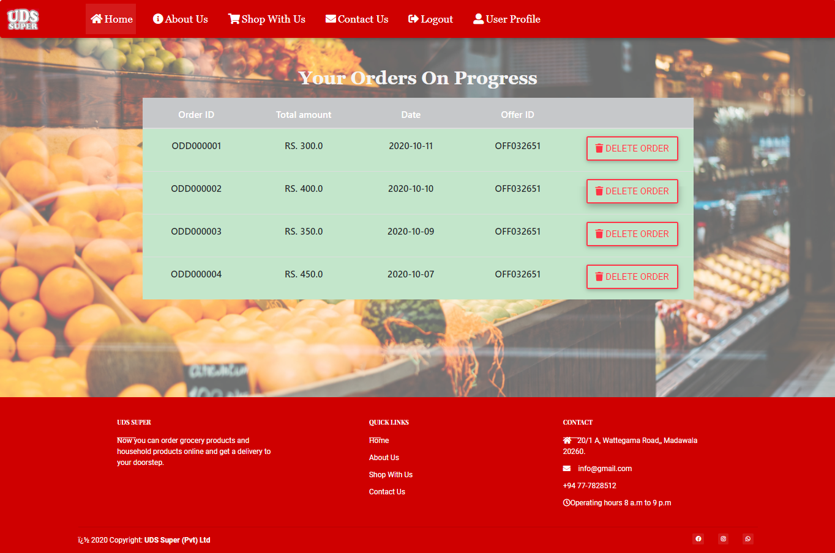

Figure 58

Users can use this page to view orders on progress and they can delete if they wish, with the confirmation.

1. **Orders Dispatched**

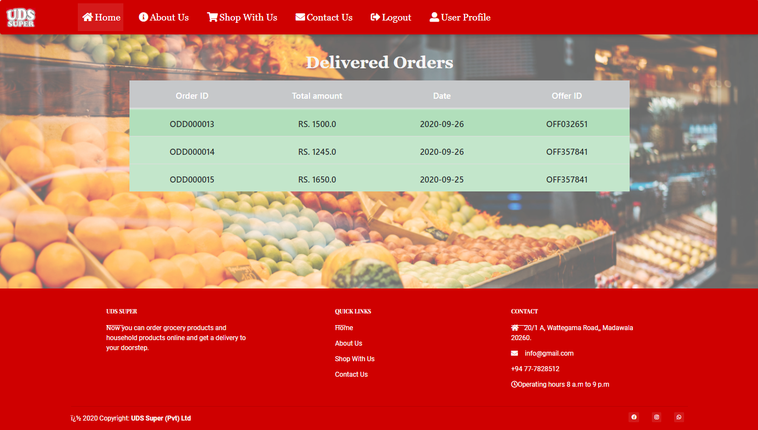

Figure 59

Users can view all their dispatched orders.

1. 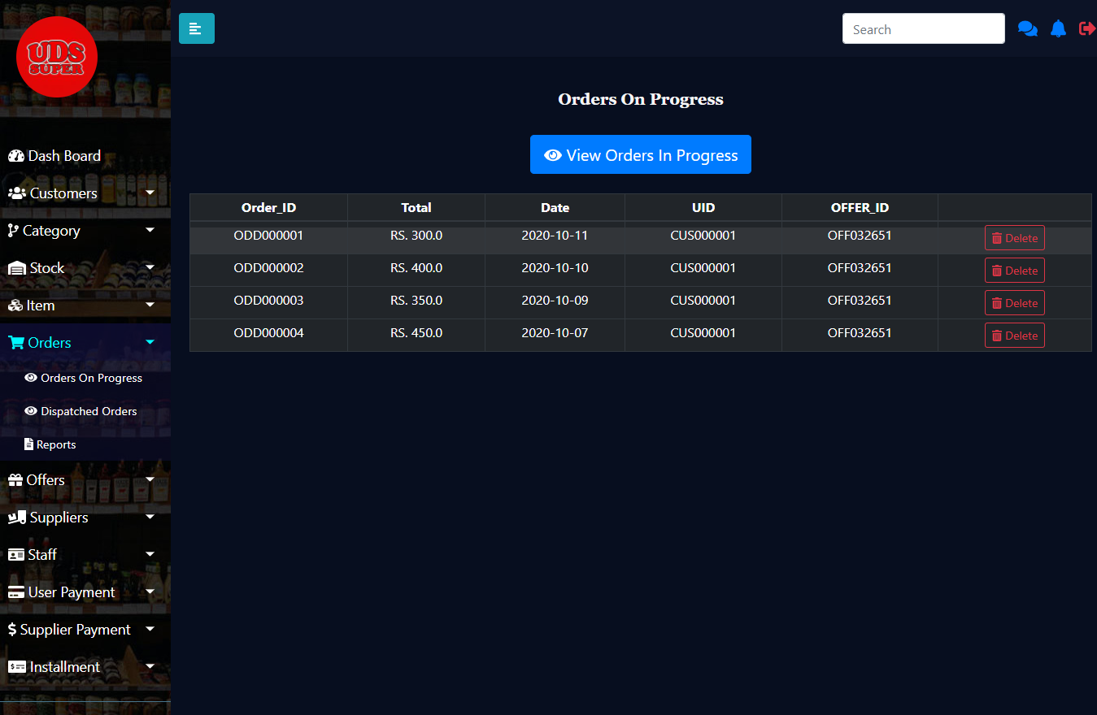**Orders on progress for Deletion (Admin)**

Figure 60

If the user request admin to delete the order, this page allows admin to delete the order, with the confirmation. Once the delete button pressed, alert will be shown about success or failure of the deletion.

1. **Search Order**

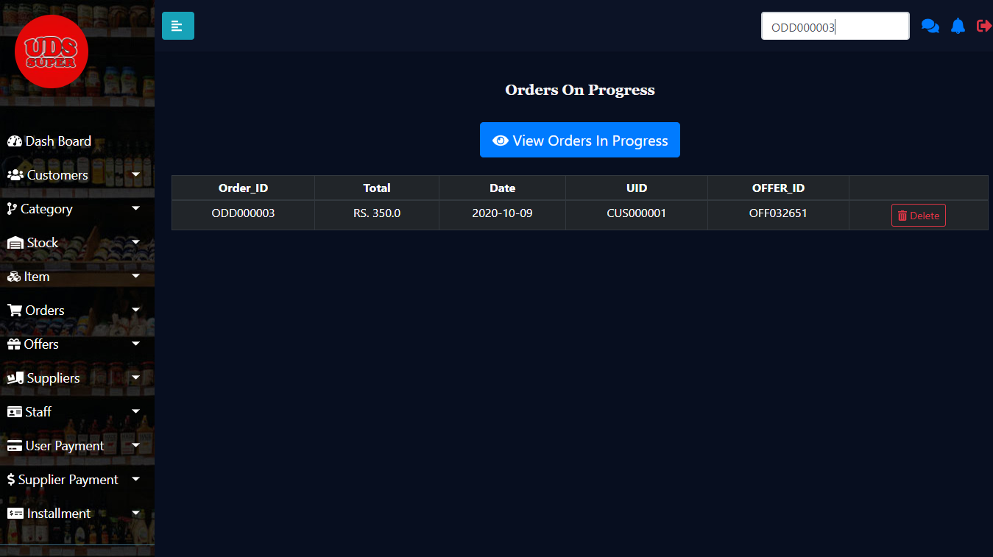

Figure 61

Admin can search a particular order for the deletion in order to make the use of ease.

1. **Dispatched orders (Admin)**

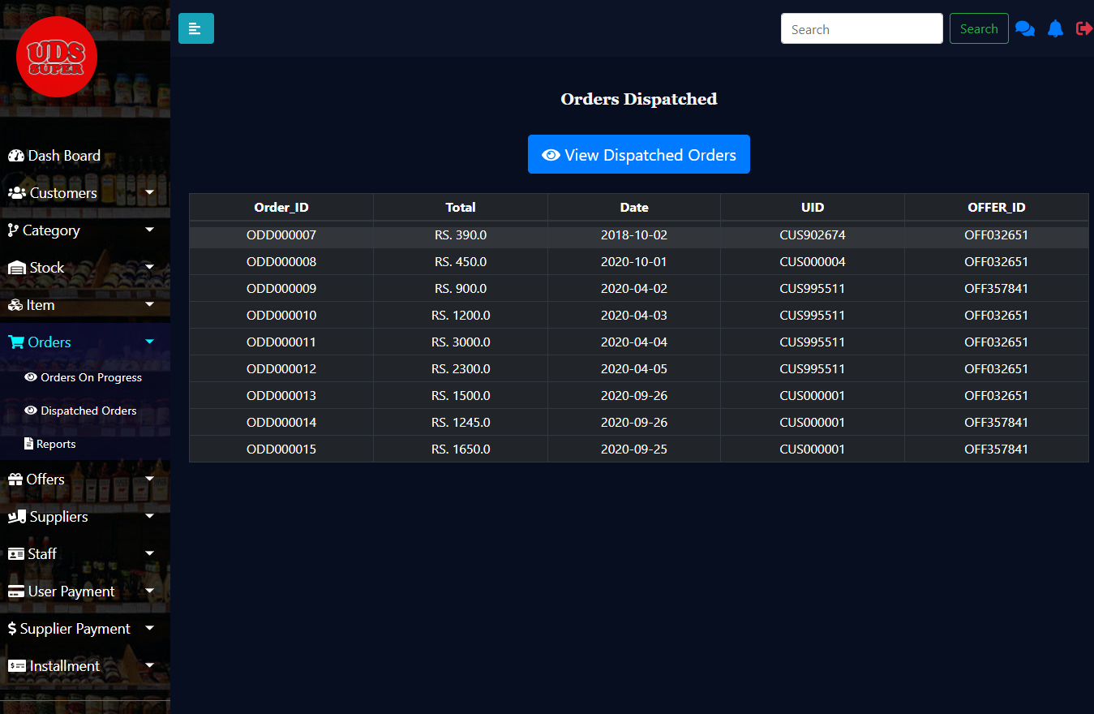

Figure 62

Admin can view all the dispatched orders of all the users.

1. **Report on orders with higher amounts**

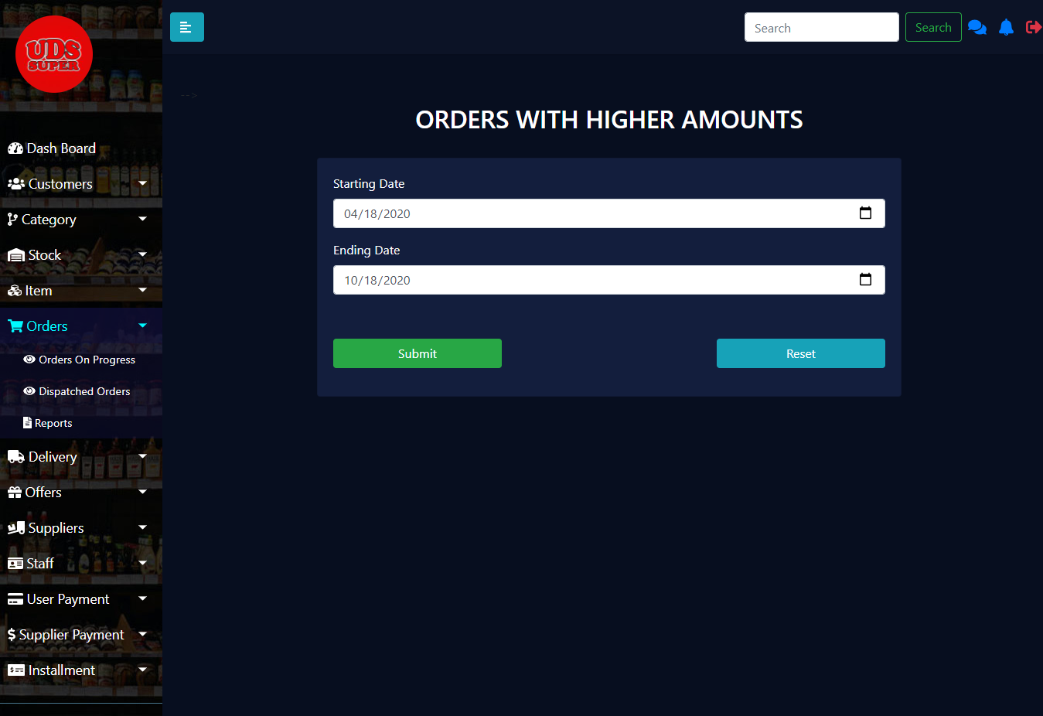

Figure 63

This page allows admin to input the start date and end date of a particular time, to view the orders with highest amounts to motivate those customers by offering them special offers to place more orders.

1. **Report Downloadable format**

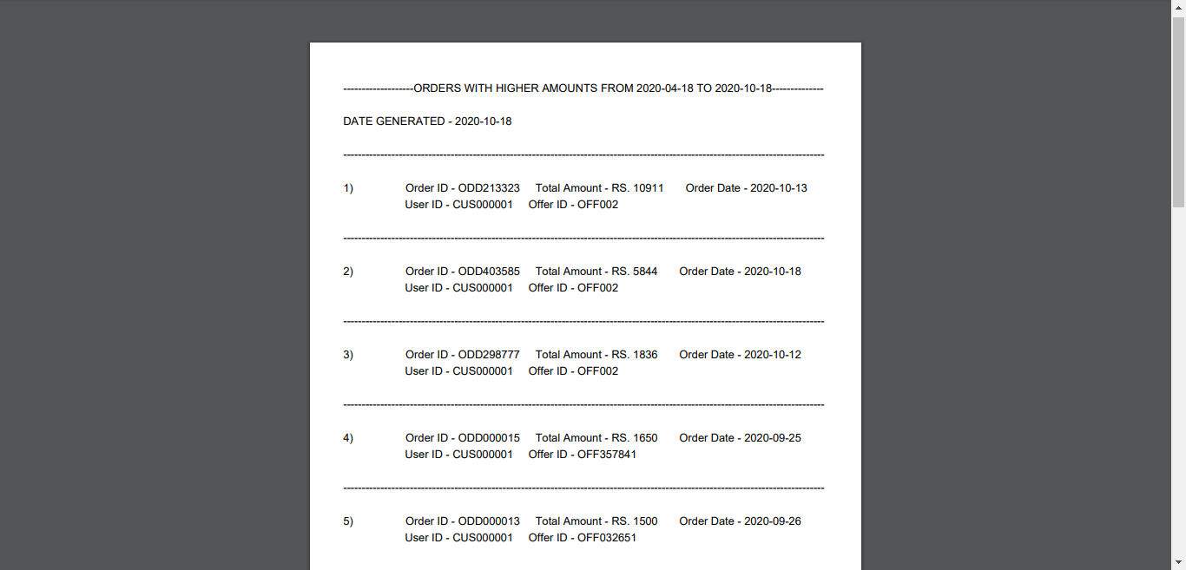

Figure 64

This page provides downloadable file which contains, a report on orders with higher amounts

### Delivery Management

**1.Add DeliveryType Form**

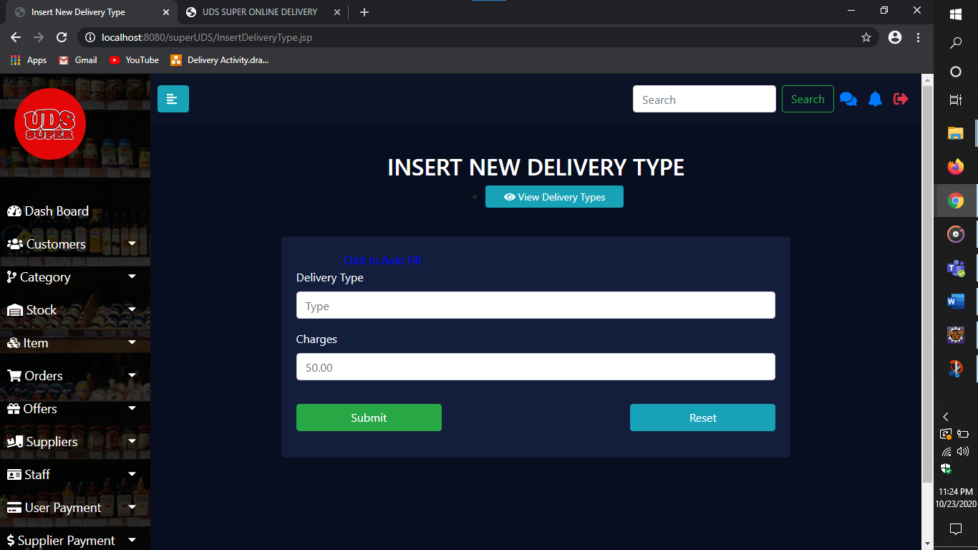

Figure 65

Here the admin can add new Delivery Type.

1. **Generate Report**

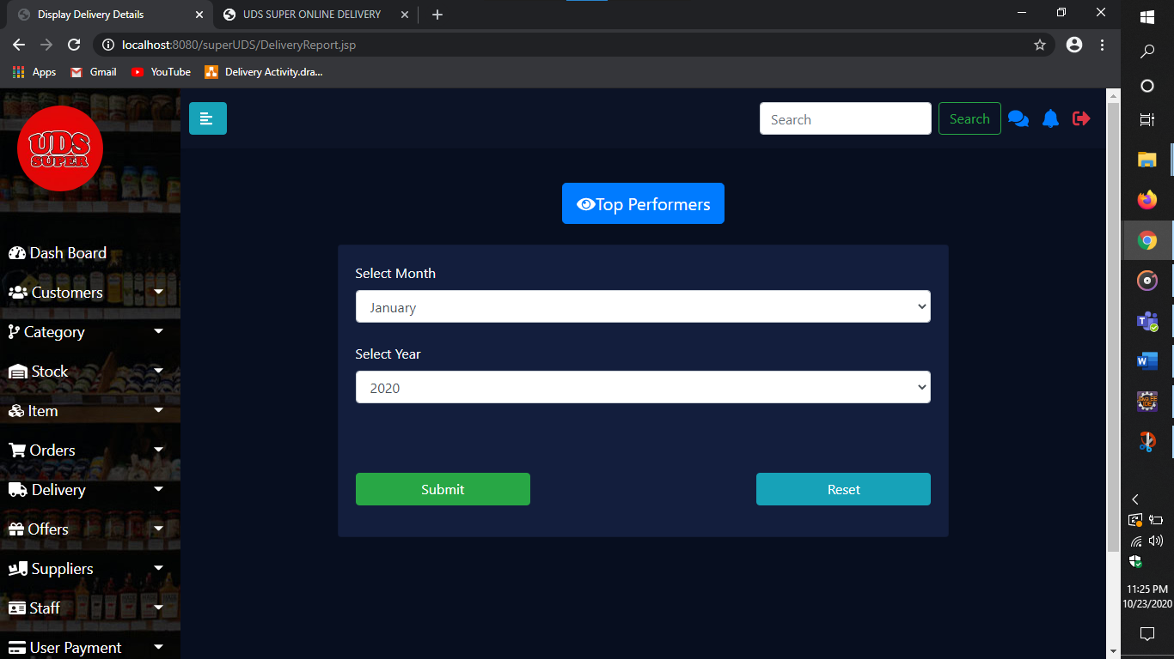

Figure 66

From the above page admin can generate the report

1. **View Delivery Details**

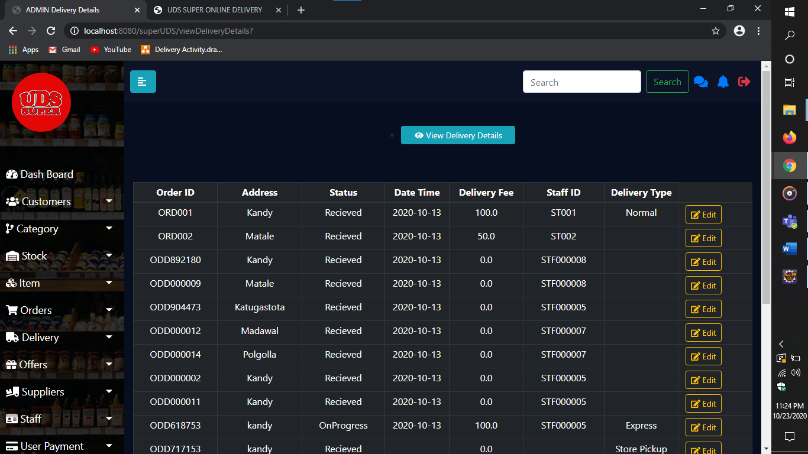

Figure 67

Admin can View All the Delivery Related details here.

1. **View Delivery Types**

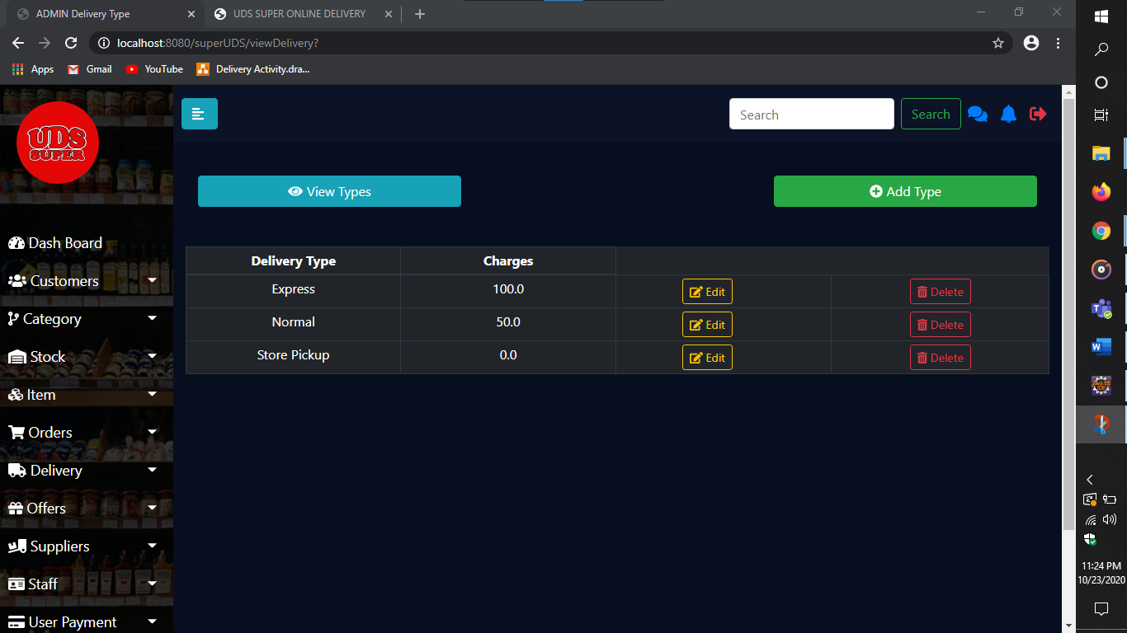

Figure 68

Admin can view the added Delivery types from here.

1. **View Delivery Staffs**

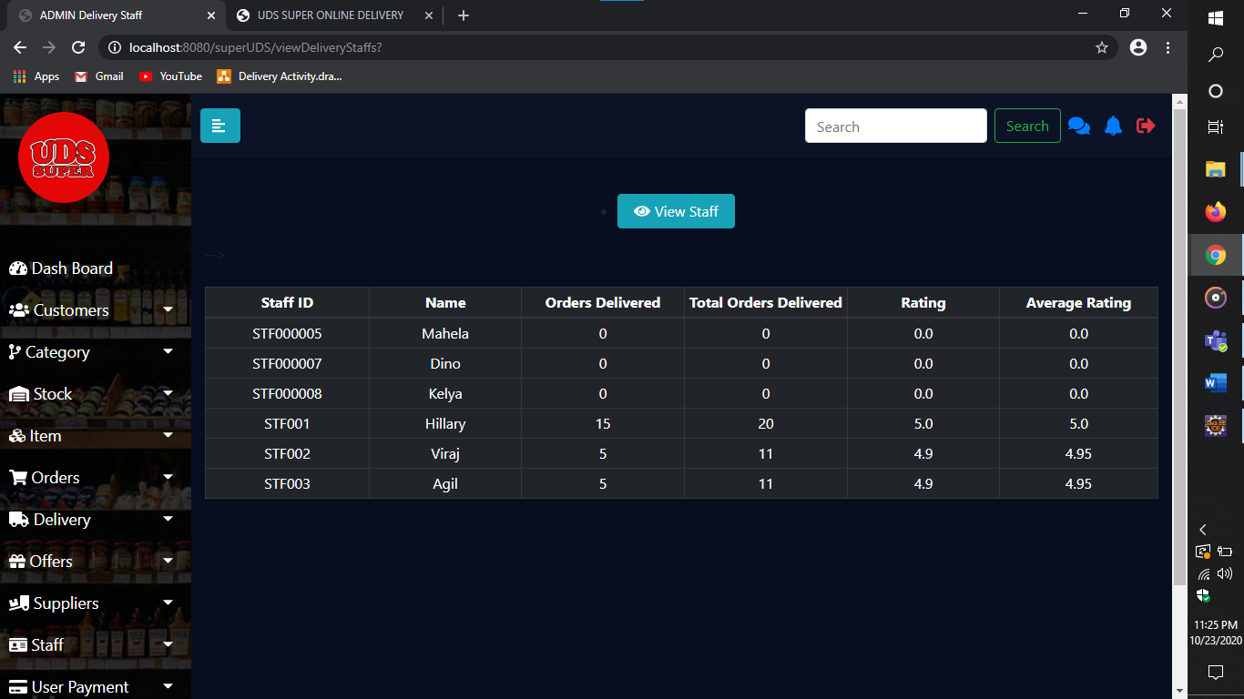

Figure 69

Here the admin can view about the Delivery Staffs

1. **Generated Report**

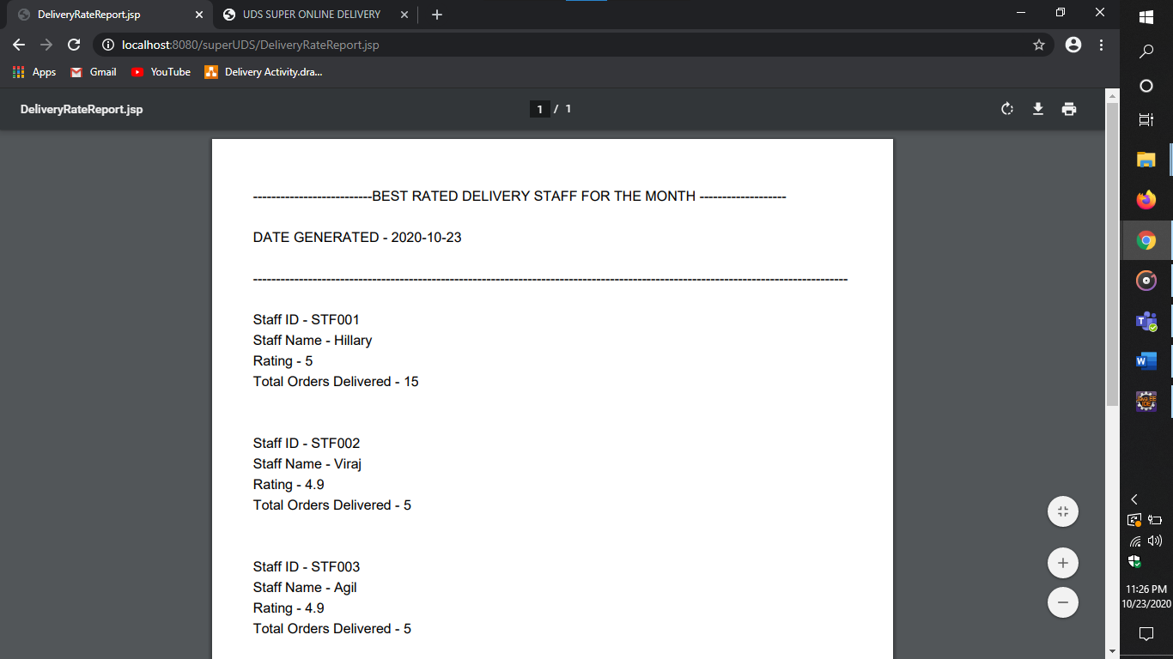

Figure 70

This is a screen shot of a generated report regarding the Delivery Staffs

**User**

1. **Add Delivery Details**

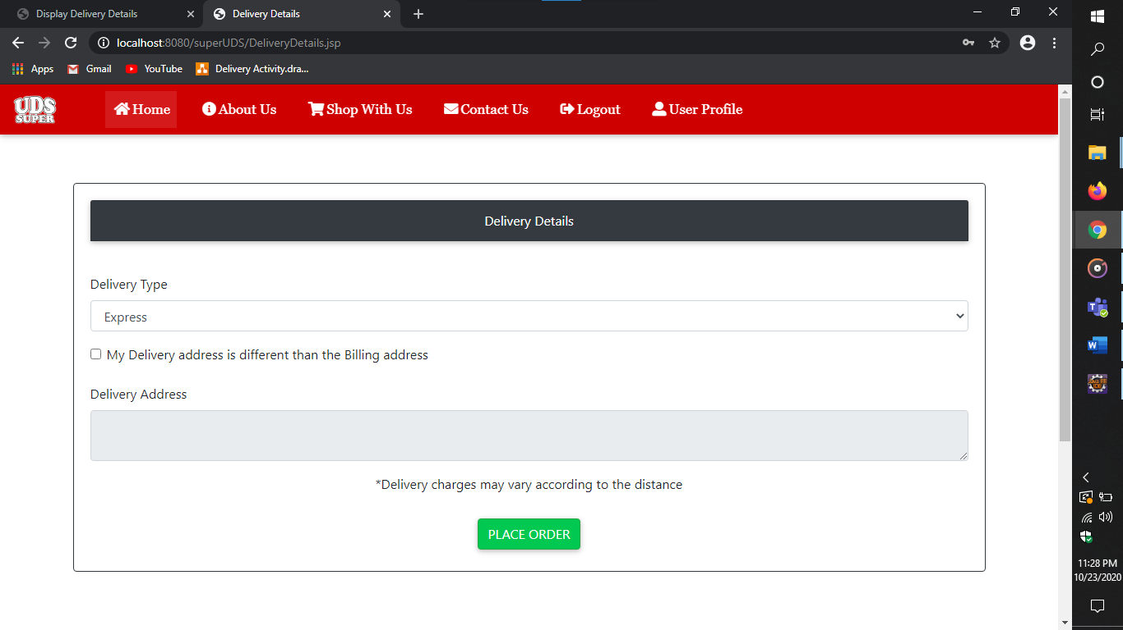

Figure 71

From the above page Customer can add his delivery by selecting the type and address.

1. **View Past Delivery Details**

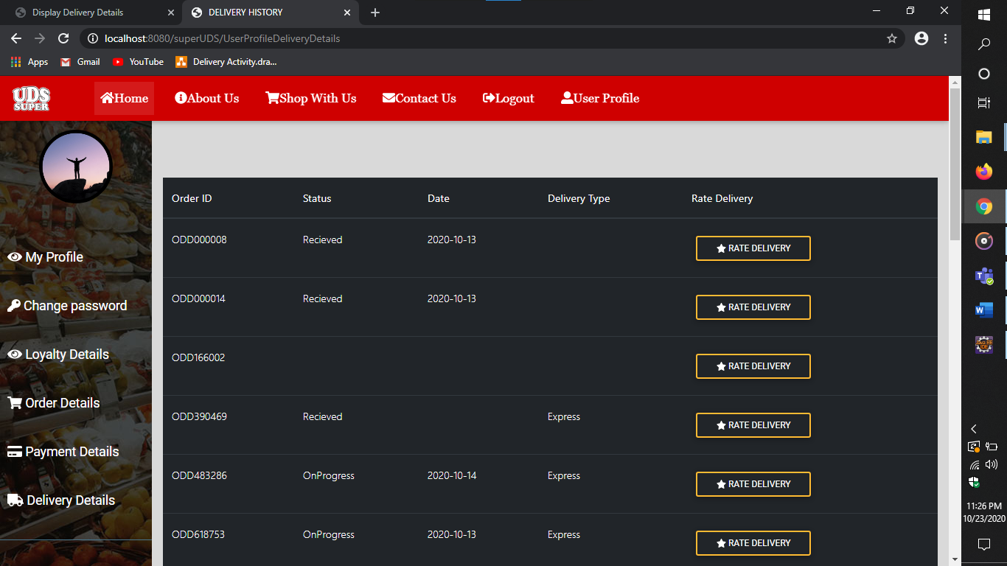

Figure 72

Here the Customer can view the past Delivery Details.

1. **Rate Delivery**

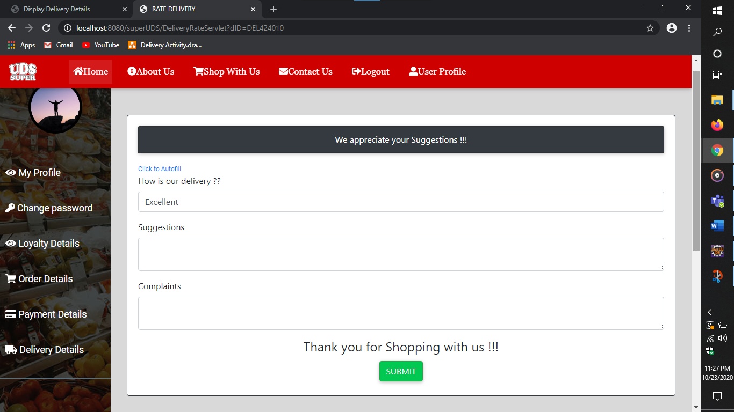

Figure 73

From the above form customer can provide feedback to the delivery staffs.

### Payment Management

1. **Select Payment Type**

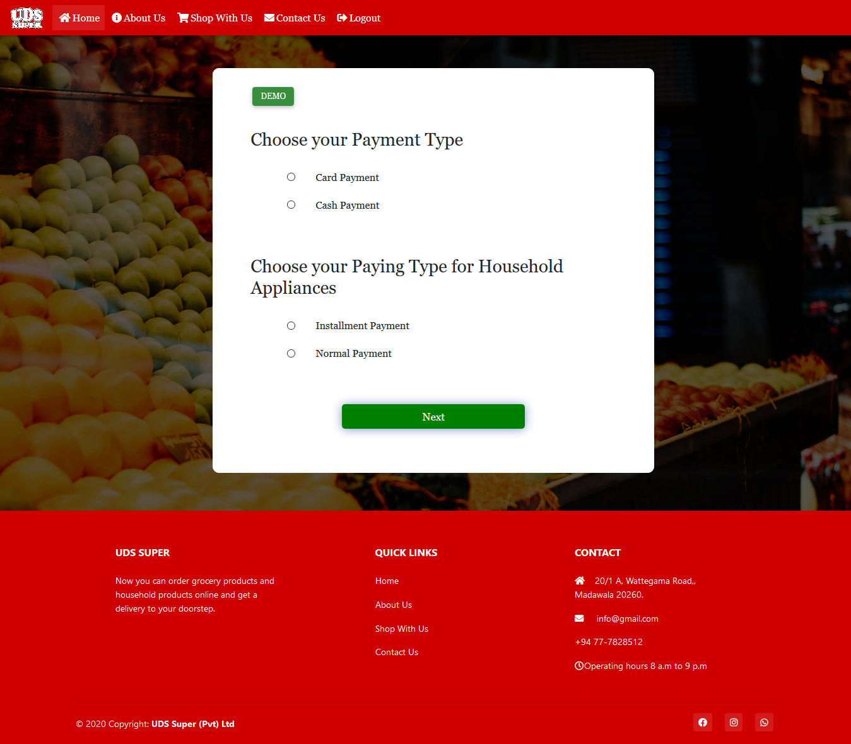

Figure 74

In this page user will select payment type for household appliances and other appliances. For household appliances user can pay with installment basis.

1. **Card Details Input**

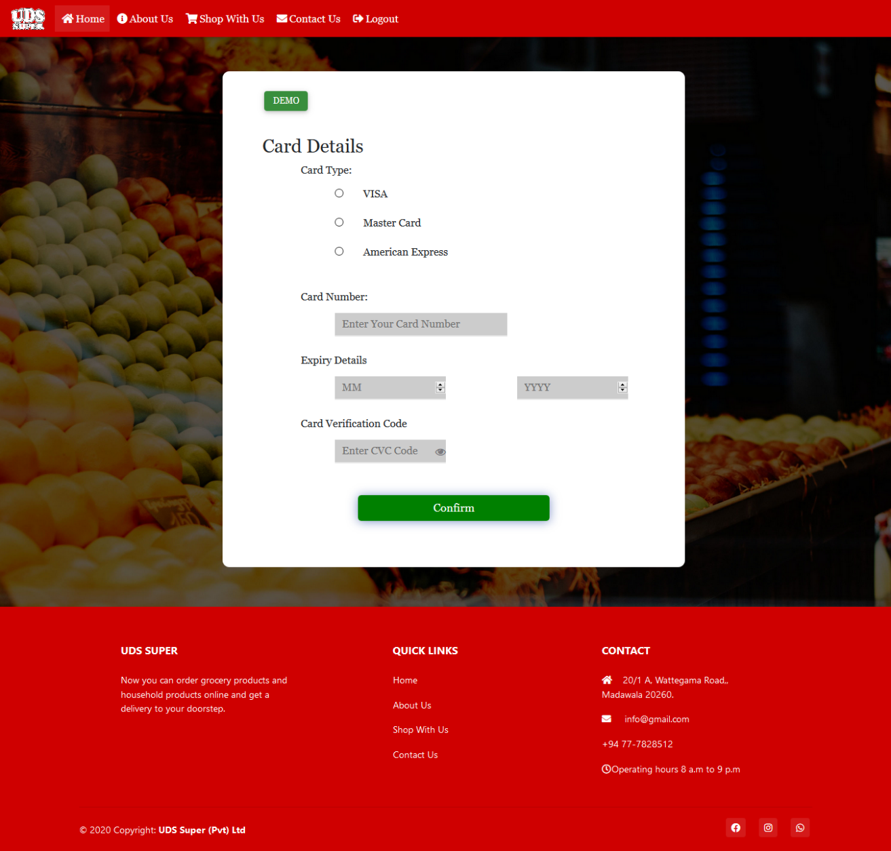

Figure 75

In this page user should enter the card details if user pays with card. And in this page card numbers is validated according to user selecting card type.

1. **Installment Details Input**

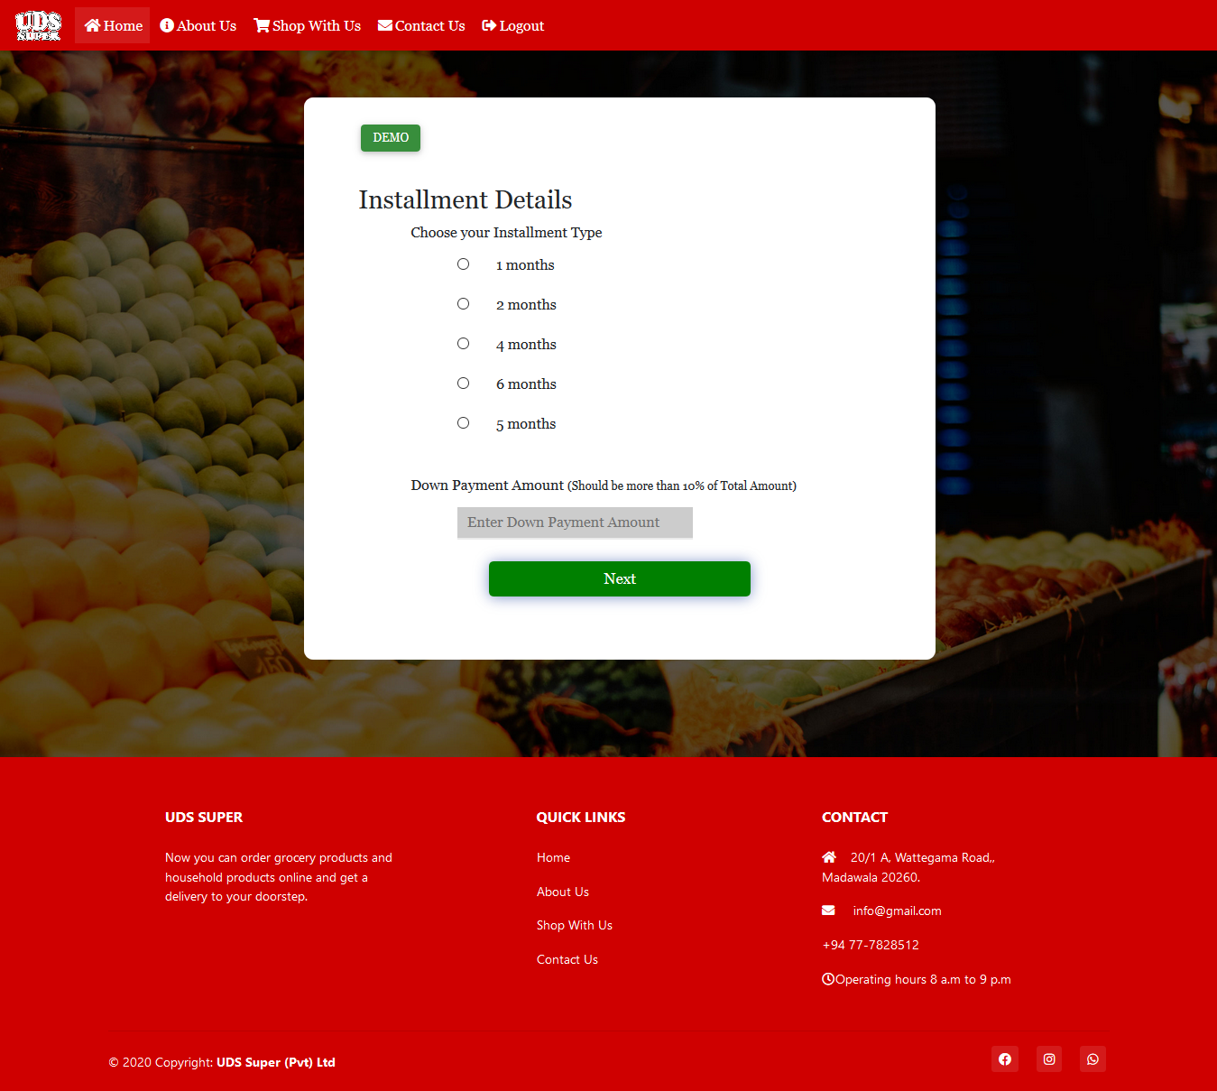

Figure 76

In this page user should enter the installment details if the user pays household appliances in installment basis. And in this I have validated that the down payment should be more than 10% of total installment amount.

1. **Installment Details Summary**

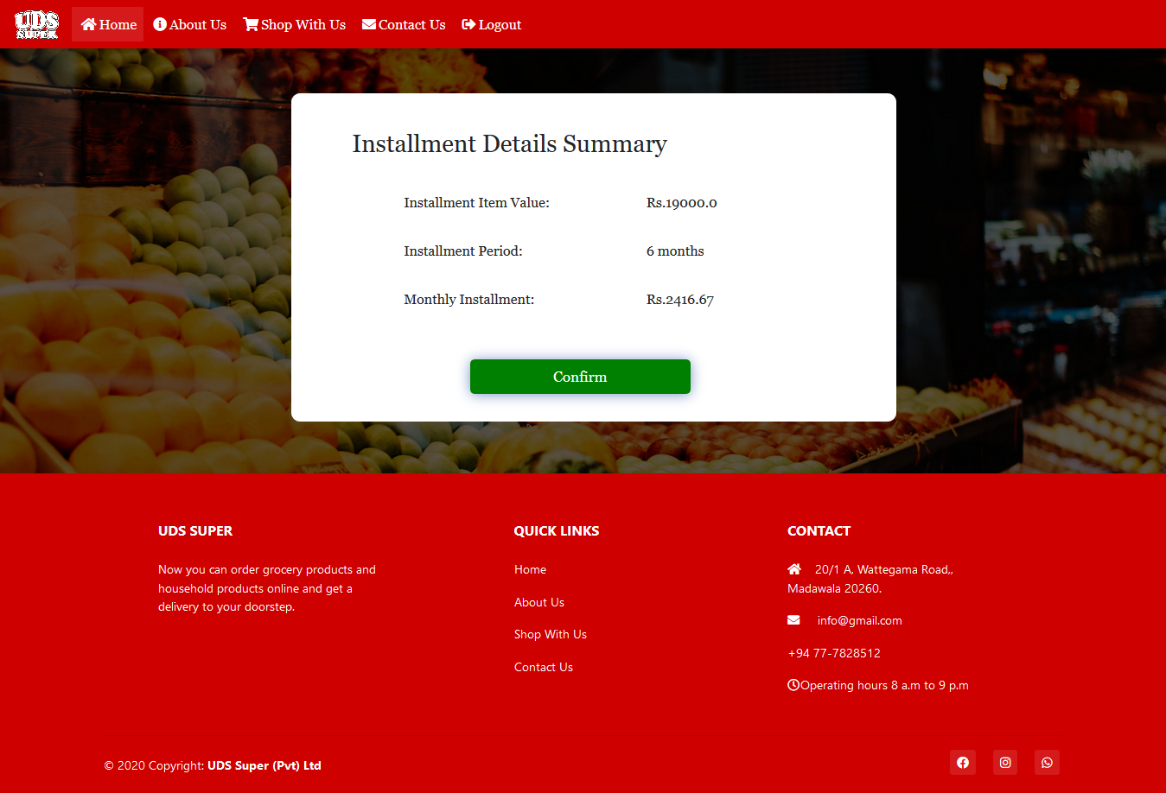

Figure 77

This page displays the installment details summary of the user’s order with monthly installment amount.

* Monthly Installment = (Total Installment amount – Down payment) / Installment type(months)

1. **Payment Details Summary**

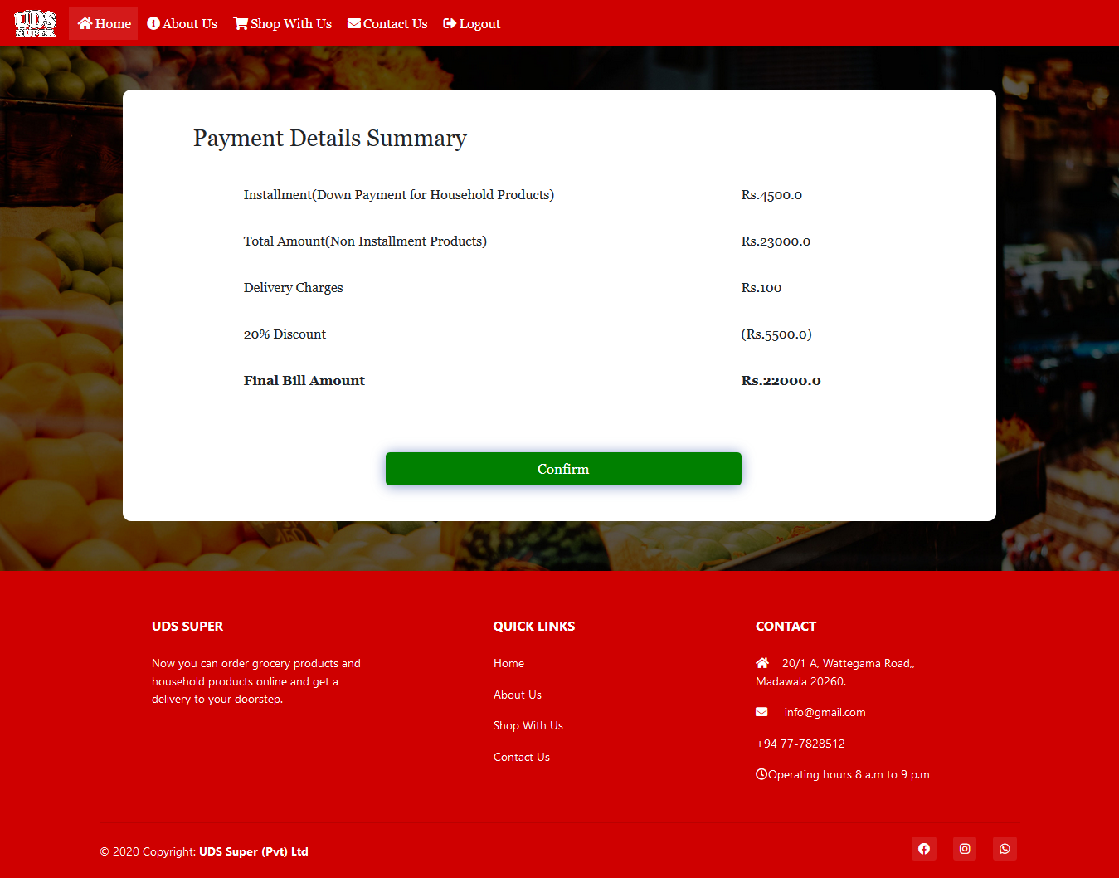

Figure 78

This page displays the payment summary for the order placed by user with down payment for installment (household products), total amount of other products, delivery charges, discount amount with percentage and the total amount.

* Final Bill amount = (Down Payment + Total Amount (Non-Installment Products) +

Delivery Charges) – Discount Amount

1. **Insert Offer**

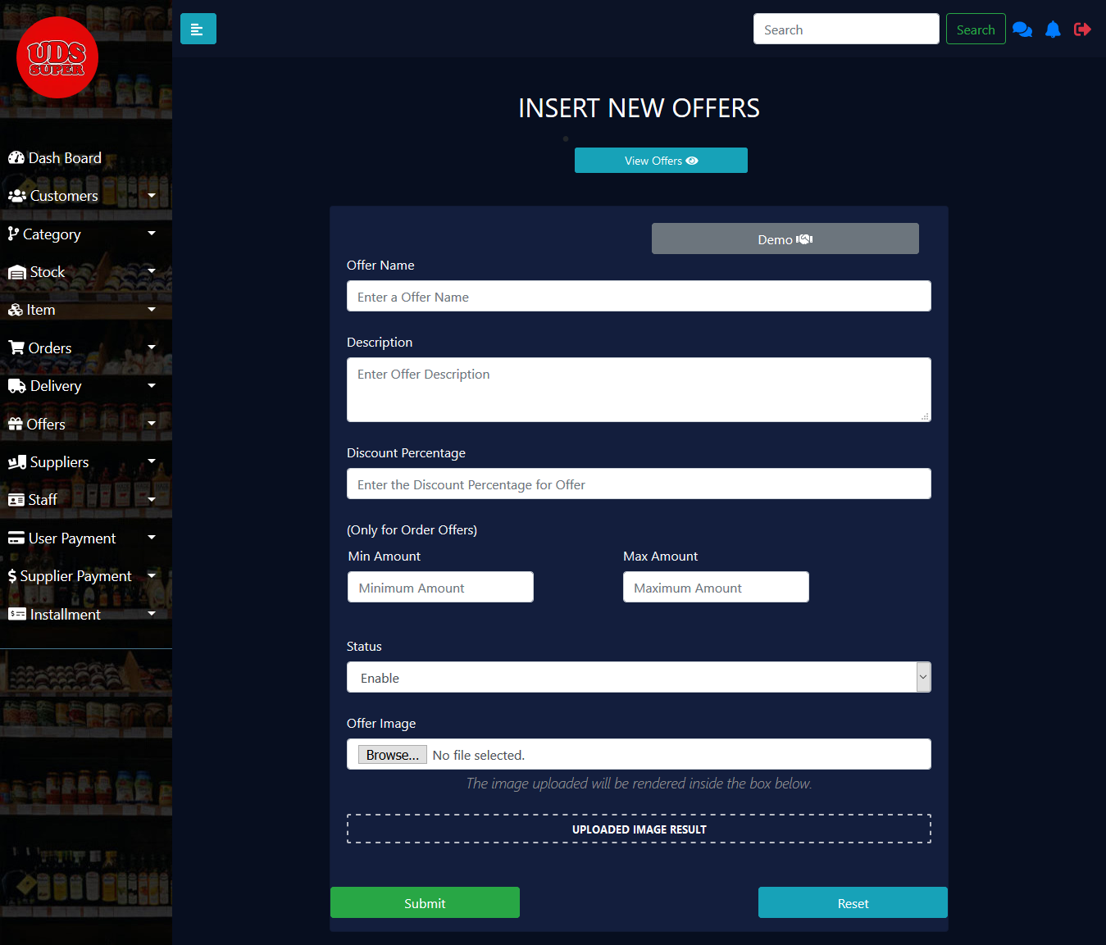

Figure 79

To add offer user should enter offer name, description, discount percentage, status and an image. And the minimum and maximum amount should be only filled for order offer not required for item offers. Admin can view the inserting image in the Upload Image Result container.

1. **View Offers**

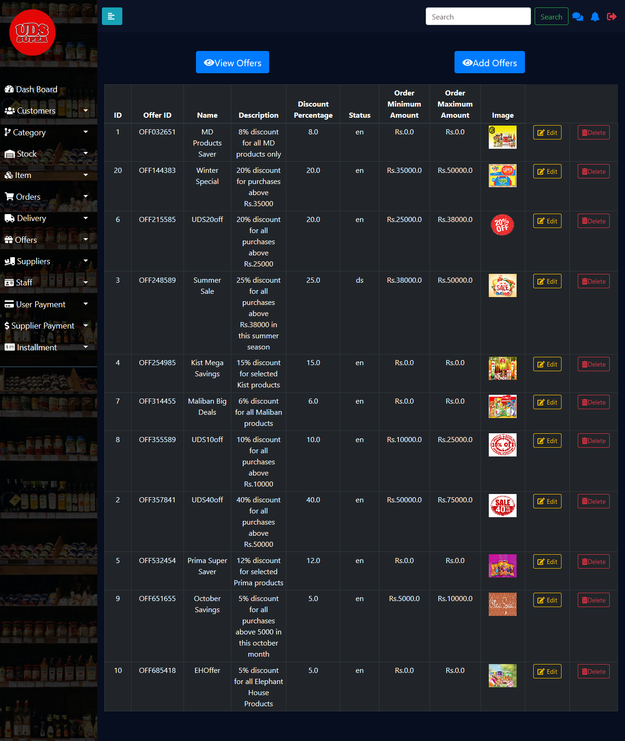

Figure 80

Admin can view the all the offer details in this page. And by clicking edit button admin can edit the relevant row’s offer details and by clicking delete button admin can delete the relevant offer. To add offer admin should click add button. And admin can search offer by entering the offer name in search bar.

1. **View User Payment**

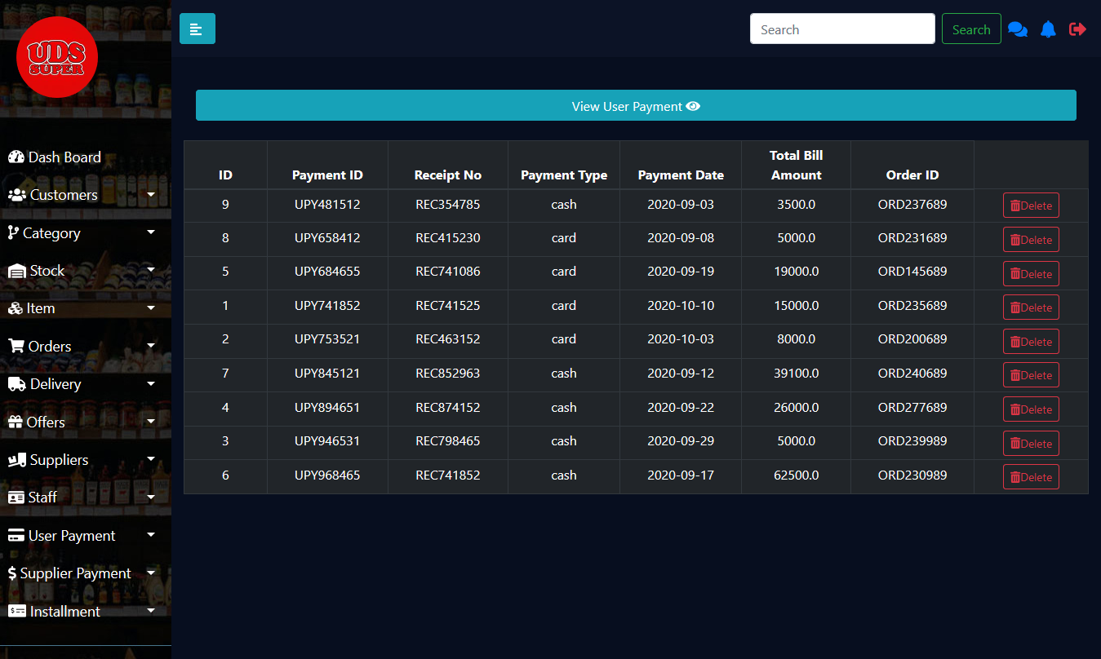

Figure 81

In this page admin can view the payment details. And by clicking delete button admin can delete the relevant payment details.

1. **View Installment Details**

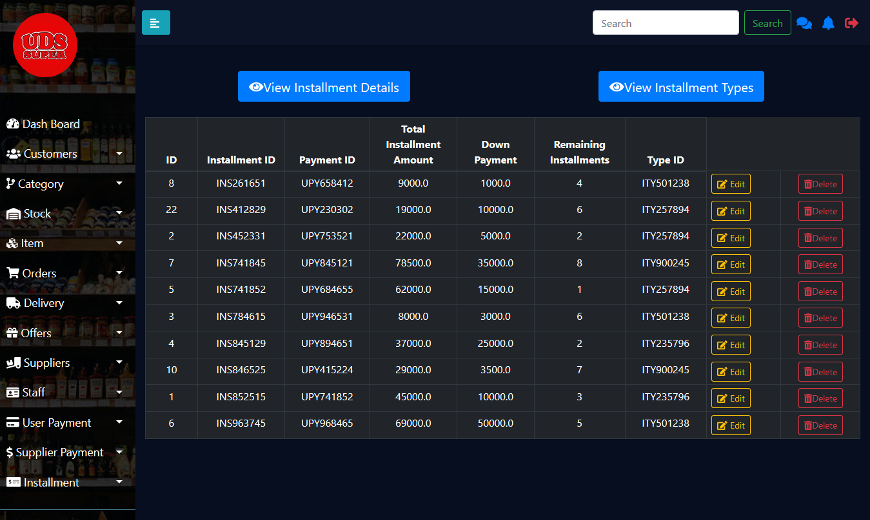

Figure 82

Admin can view the installment details in this page. And by clicking edit button admin can update installment details but admin can update remaining installments only and by clicking delete button admin can delete installment details for the relevant row. To view installment type details admin should click view installment types button.

1. **Insert Installment Types**

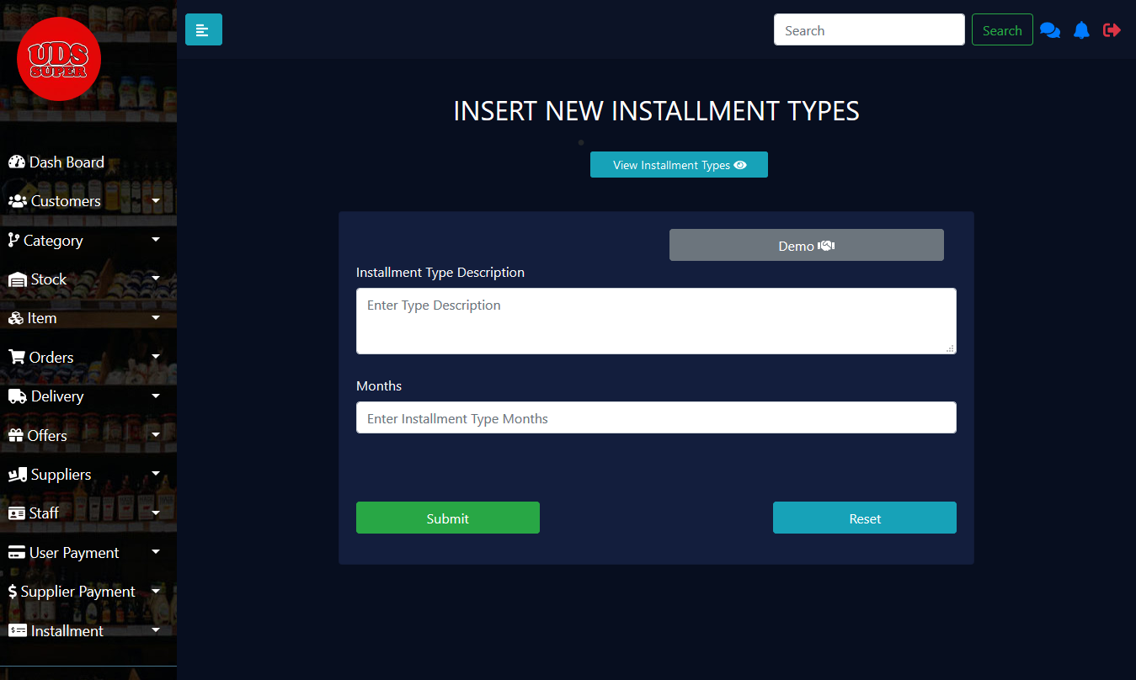

Figure 83

In this page admin can add installment type by entering the installment type description and months.

1. **Insert Installment Types**

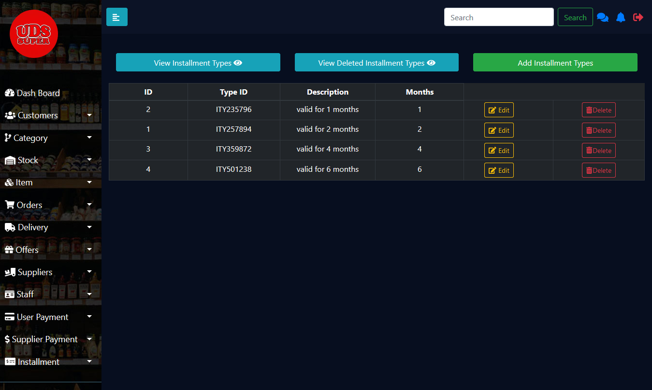

Figure 84

Admin can view installment type details in this page. And he can edit or delete by clicking the relevant button. To view deleted installment types admin should click view deleted installment types button and to add new installment types admin should click add installment types button.

1. **View Deleted Installment Types**

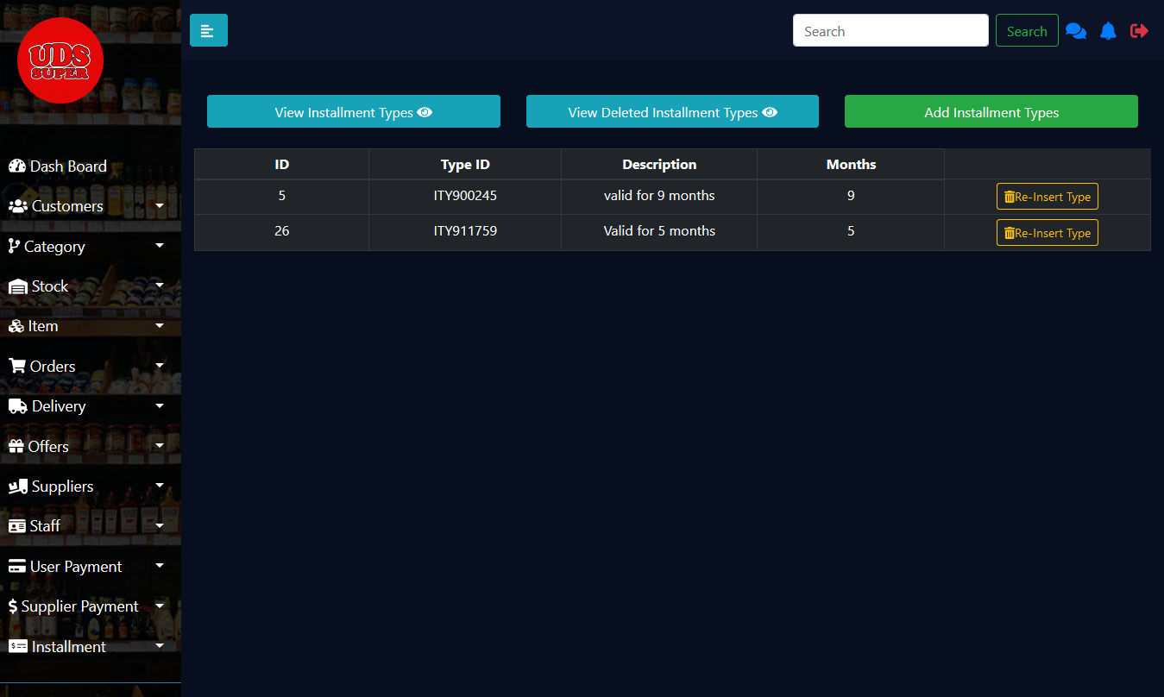

Figure 85

Admin can view deleted installment types in this page. Admin can delete the installment type in deleted installment type and can insert in view installment type by clicking re insert type button.

1. **Generate Report**

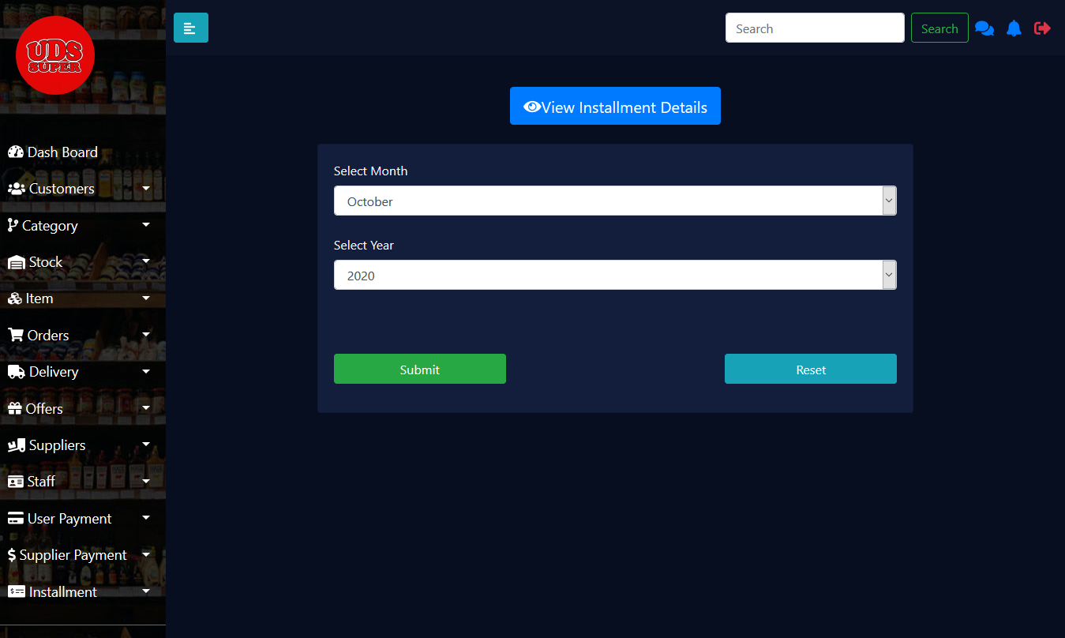

Figure 86

In this page admin should select the month and year and should click the submit button to view the frequently used installment types with the current date of report generated.

## Testing

|  |  |  |  |  |  |  |
| --- | --- | --- | --- | --- | --- | --- |
| **Function** | **Test**  **ID** | **Test Input** | **Expected**  **output** | **Actual output** | **Result**  **Pass/Fail** | **Description** |
| Supplier Management | 01 | Supplier Name:  CBL  Status: enabled  Supplier Address:  No.02/4 colombo12  Supplier Email:  [cbl@gmail.com](mailto:cbl@gmail.com)  Phone Number:  011-22113344  Other Number:  Null  Description:  Null | Display error message  “Phone number cannot exceed 10 numbers” | Display error message  “Phone number cannot exceed 10 numbers” | Pass | Test Successful |
|  | 02 | Stock Name:  Null  Discount Type:  discount  Discount Percentage:  10  Total Amount  10000 | Display error message  “Please select the stock name” | Display error message  “Please select the stock name” | Pass | Test Successful |
| Stock Management | 01 | Stock Available quantity updated to be less than stock reorder level | Notification regarding stock re shelfing added to Notification page | Notification regarding stock deficit available with details | Pass | Test successful |
|  | 02 | Admin deactivates an item which is no more available in store | Item added to deactivated items list with message “Item deactivated successfully” | Item added to items in deactivated list and “Item deactivated successfully” message appeared | Pass | Test successful |
|  | 03 | Admin checks the checkbox to set reorder level of stock | New form to set reorder level appeared and after setting reorder level “Stock update successful” message appears | Reorder level form visible after checking the checkbox and after reorder level is set “Stock update successful” message appears | Pass | Test successful |
| Staff Management | 01 | First Name: Nimal  Last Name: Kumarasinghe  Address: VC 310,Ampitiya  Email address: [nimal@gmail.com](mailto:nimal@gmail.com)  Mobile Number: 0771212121  Home Number: 0812212121  Date of Birth: 11/12/2002  Gender: Male  NIC Number: 983601995aV  Profile image: image1.jpg  Joined date: 22/03/2020  EPF number: 6  Job title: Admin  Basic Salary: 40000  User Name: ip1234  Password: niaml123 | Display error message  “NIC number does not match required format” | Display error message  “NIC number does not match required format” | Pass | Test Successful |
|  | 02 | Date: 12/02/2020  Total no of working days: NULL  Total no of leave days: 3  Total no of half days: 1 | Display error message  “Total working days cannot be empty” | Display error message  “Total working days cannot be empty” | Pass | Test Successful |
| Customer Management | 01 | Username: Krystle_d  Password: kryst123 | Display an error alert saying ‘Incorrect username or password’ | Displays an error alert saying ‘Incorrect username or password’ | Pass | This test scenario focuses functions related to a user authentication.  Test result is successful. |
|  | 02 | First name: Avon  Last name: Mark  Username: avon_m  Email: [avon.m@gmail.com](mailto:avon.m@gmail.com)  Address : 23,Branes Place, Kandy  Phone:  Date of Birth : 03/11/1990  Date of anniversary: 02/01/2011  Occupation: Businessman  Password: avon123  Repeat Password : avon123 | Display a message saying ‘Please enter phone number’ | Display a message saying ‘Please enter phone number’ | Pass | This test scenario focuses functions related to validations during registration process.  Test result is successful. |
| Order Management | 01 | Item ID: ITM000001  Item Name: Anchor  Price: 480  Discount (%): 1  Quantity: 1  Net Total: 480  Offer : summer sale  category: Milk Powder | Display success message: “Item added to the cart” | Display success message: “Item added to the cart” | Pass | Item added to the cart. values inserted to the table. |
|  | 02 | Order Id: ODD000001  Total: 480  Date: 19/21/2020  Username: krish111  Offer ID: OFF000002  Order Id: ODD000001  Item Name: Anchor  Quantity: 1 | Display success message: “Order placed successfully” | Display success message: “Order placed successfully” | Pass | Order placed and values inserted to the order table. Ordered Items inserted to the order item table. |
| Payment Management | UPY001 | Card Type: Master Card  Card No: 361588679843  Expiry month:06  Expiry year:2026  CVC:3587 | Display error message “Enter the correct Master Card Number” | Display error message “Enter the correct Master Card Number” | Pass | According to legal standard Master Card should have 16 digits and first two digits should be 51 or 52 or 53 or 54 or 55. |
|  | INS001 | Installment Amount:25000  Installment Type:6 months  Down Payment:1000 | Display error message “Invalid Down Payment Amount!!!” | Display error message “Invalid Down Payment Amount!!!” | Pass | A down payment for an installment should be more than 10% of total installment amount. |
| Delivery Management | 01 | Type Name:  Normal  Charges:  50.00 | Display error message “Delivery Type Already Exists” | Display error message “Delivery Type Already Exists” | Pass | Test Successful |
|  | 02 | Type Name:  Drone  Charges:  200.00 | Display success message “Delivery Type Added Successfully” | Display success message “Delivery Type Added Successfully” | Pass | Test Successful |

Table 1

# Evaluation

## Assessment of the project results

This system has been developed for UDS supermarket after a good analysis of the client requirements. As in general impression, the project was assessed to have covered all the client requirements, while providing some additional features. The user friendliness of the UI designs and the complete overall coverage of each of the functionalities can be quoted as the strongly evaluated points. Considering each of the individual functionalities, the group had identified seven different scopes. Each of these scopes had been implemented with all necessary logics. Moreover, the individual scopes were all achieved completely.

However, some weaknesses of the final product too could be evaluated. Based on the evaluators remarks, the system is expected to have been more professional. Further, the system was more complex to implement than expected, which paved the pathway to do minor changes in every functionality. Also, achieving a fully secured and fraudulent free product was an extremely hard challenge which can be evaluated as a project limitation.

Therefore overall, the project was at good standards and included all necessary requirements, logics and was fully functional. The identified weaknesses and limitations are planned to be resolved in the future and few additional implementations too are planned to be implemented, to make this product a complete software package

## Lessons Learned

Learning and working effectively as part of a team or group is an extremely important skill, and one that is refined and used throughout working life. Group projects are among the most valuable and rewarding learning experiences. When considering the ITP group project, many factors helped the team members to further improve and enhance the personal carrier. More importantly, understanding and sharing the diverse perspectives among the members, allowed the team to focus on many wise decisions across the various phases of the project. Also, accepting and understanding the individual works and functions which were assigned in the beginning of the project and completing it successfully played a vital role in the development process of the project. This will enable the members to do the same in the future carrier projects as well. A main learning outcome was completing project on the scheduled date and time. This learning outcome is an essential characteristic which must be a major encouraging aspect on an individual’s success. Finally, learning to compromise and communicate effectively with the team members helped the group to work productively towards a common goal.

## Future Work

Many different adaptations, tests, and experiments have been left for the future due to lack of time. Future work concerns deeper analysis of particular mechanisms, new proposals to try different methods, or simply curiosity. New proposals include displaying new arrivals and coming soon products, which will increase the customers' interest and satisfaction. Another proposal is that developing the client side interfaces in a more professional way which will ultimately increase the customers’ attraction towards our system. Moreover, a major proposal is the implementation of the tracking system for the delivery process which will safely guard a customer’s order delivery. Also implementing payment gateway methods which will facilitate online payment transactions between customer and the organization has also been proposed. Finally facilitating the customers to provide suggestions and feedbacks which will eventually help the organization to improve, develop and implement the necessities of the customers which will ultimately increase the standard of the organization.

# Conclusion

This project was designed for the client who owns the above-mentioned supermarket to automate the manual processes of handling the daily tasks of the supermarket. While gathering and analyzing the requirements, some potential issues of the prevailing system of the supermarket was discovered, and the main objective of developing this system was to automate the entire system, while providing the users of the system an interactive experience and allowing the management to facilitate their day to day tasks efficiently and easily. Furthermore, the system has been developed in correspond to customer-client requirements of the company. As the final system was presented to the client, the advocates concluded that the online system developed does enough justice to the client requirements.

However, some shortcomings like lack of professionalism and few could be identified in the system. As a team Future plans have been implemented to overcome them. Moreover, the system is fully automated but possess few limitations too. This system is developed using java language and developed using MVC architecture, while MySQL was used for database purposes, due to their flexibility, security, and performance. But these technologies are ever-changing and tends to become outdated. Also, building an entirely fool proof system is an extremely difficult task. Therefore, to overcome such limitations continuous maintenance is required.

Overall, as a conclusion it can be said that the designed system fulfils all functional and non-functional requirements of the client, provides additional features that were out of client requirements, and helps the organizations process by automation which has facilitated the minimization of errors and fraudulent activities. Therefore, the company can function more efficiently and productively.

# Appendix A: Design Diagrams

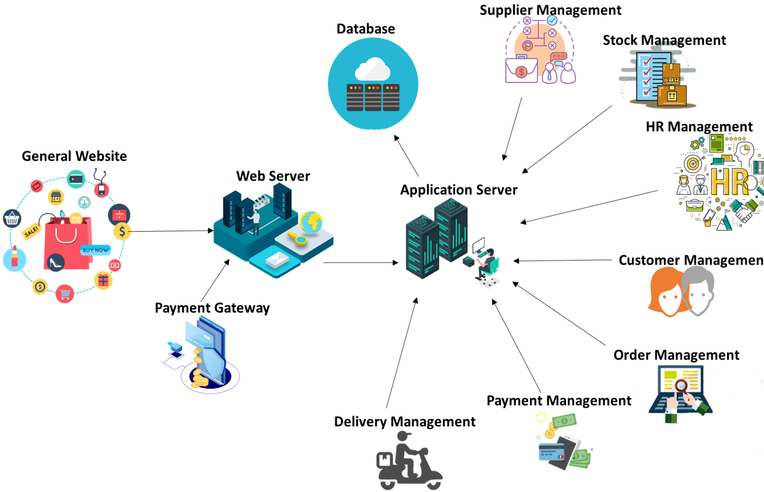

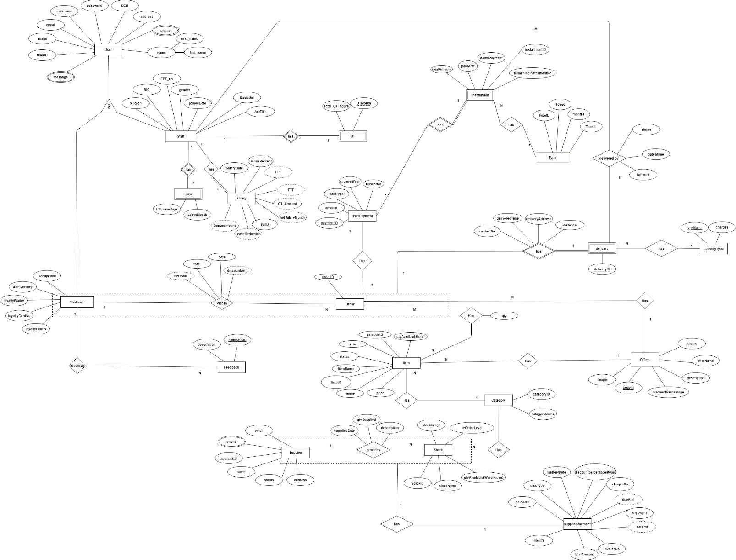

# Appendix C: Selected Code Listings

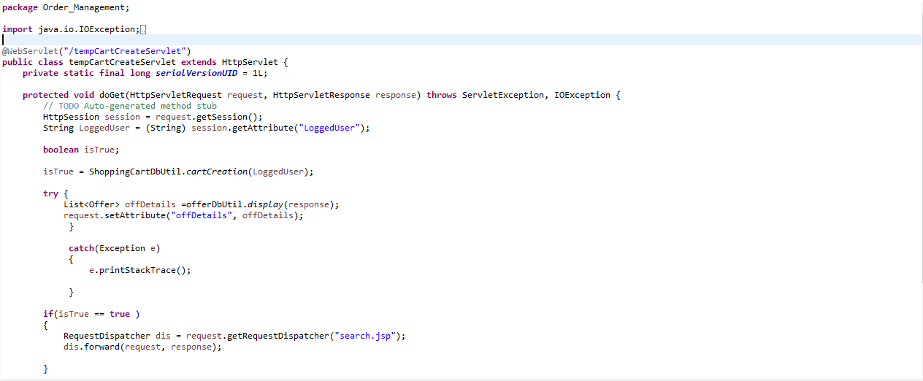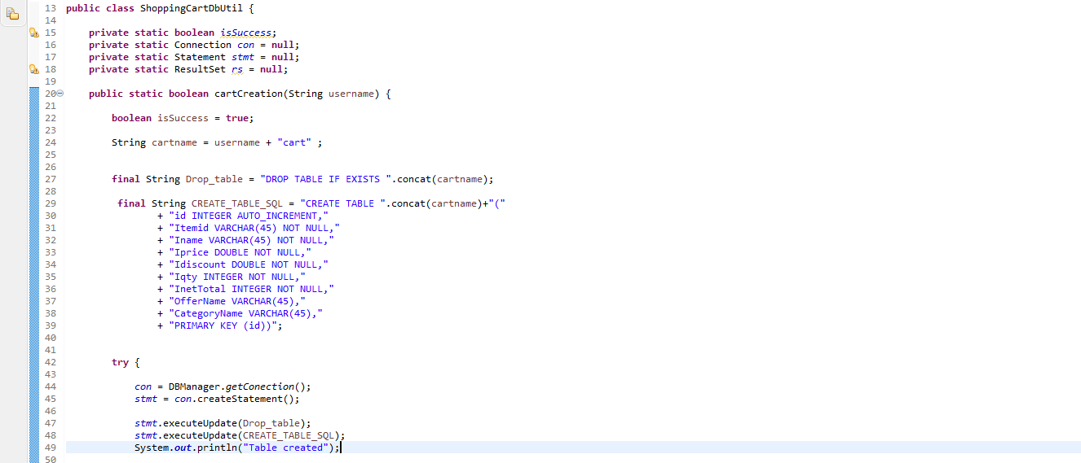

When the user logged into the system, user name will be stored in a session and when the user clicks the ‘shop with us’, the temporary cart will be created for that particular user , and when the user add items to the cart , all the items will be stored in that temporary table.

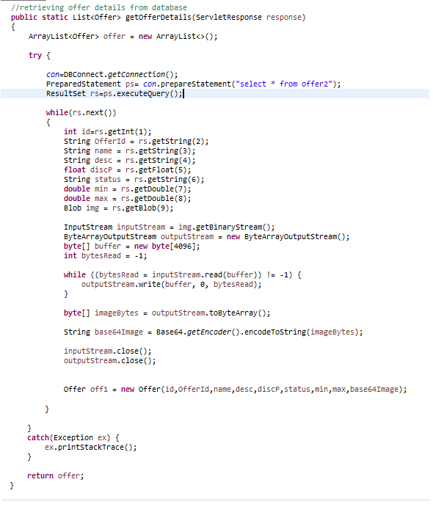

Function to retrieve offer details with converting blob image to string base64 image.